SSD Coursework A2

Woodside Community Hub

**Contents**

**Company Background** 2

**Problem Identification** 3

**Crèche** 3

**Transport** 4

**After school club** 4

**Advice** 4

**Groups** 4

**Classes** 5

**Chosen sub-system** 5

**Approach to Development and Design** 6

**Waterfall** 6

Advantages 6

Disadvantages 6

**DSDM** 6

Advantages 7

Disadvantages 7

**Scrum** 7

Advantages 7

Disadvantages 8

**Extreme Programming** 8

Advantages 8

Disadvantages 8

**RAD** 9

Advantages 9

Disadvantages 9

**Chosen Methodology** 9

**Project Plan** 11

**Requirements** 13

**User Requirements** 13

**Enhanced Requirements** 13

**Normalisation** 16

**0NF** 16

**1NF** 16

**2NF** 16

**3NF** 17

**Data Dictionary** 19

**Parent** 19

**Kid** 19

**Booking** 20

**BookedOut** 20

**Group** 21

**StaffGroup** 21

**Staff** 21

**Storyboards** 23

**Draft Storyboards** 23

**Enhanced Storyboards** 34

Global Form Template 34

Main Menu Form 37

Crèche Menu Form 39

Booking Select Child Form 42

Booking Select Dates Form 45

Add Parent Form 49

Add Child Form 51

Edit and Delete Booking Form 53

Edit Booking View Details Form 56

Edit and Delete Parent Form 58

Edit and Delete Child Form 61

Assign Staff Form 64

View Data Form 66

Report Form 69

**Testing** 71

**Introduction** 71

**Testing Strategy** 71

**Legacy Tests** 75

Legacy Test Screenshots 77

**Test Plan** 88

Test Screenshots 139

**Evaluation** 346

**Evaluation of User Requirements** 346

**Strengths** 350

**Weaknesses** 352

**Future Development** 353

**Peer Feedback** 354

**Evaluation of Approach to Development and Design** 355

**Evaluation of Project Plan** 356

**Evaluation of Testing** 357

**Evaluation of Solution** 358

**Evaluation of Personal Performance** 359

**Complex Functionality** 362

# **Company Background**

Woodside Community Hub is a business which offers a plethora of services to residents of Woodside, a major housing complex on the outskirts of Newtown. These services range from an after school club, to groups such as a mother and toddler group. Having previously been a completely rural area, the results of the development programme are understandably taking a long time to be established. For this reason, the community leaders took it upon themselves to open a community hub. After raising the sufficient funds, with the remaining funds coming from the local council, a premises was secured in an out-of-commission primary school.

Claire Downing, the administrator of the hub, oversees the management team which is made up of local politicians; council representatives; and more. The management team is looking into the possibility of expanding the hub by developing additional services, although more staff will be required if these services are put into effect. Volunteers are also being utilised, with the members of the management team pushing to get more, with the belief that they give the hub a greater sense of community.

Claire also manages the daily running of Woodside Community Hub, as well as the company’s records, with the receptionist assisting when possible. As she tasked with overseeing the reporting and funding, Claire understands that a suitable IT system would be greatly beneficial for the running of the hub.

# **Problem Identification**

As is expected with a development program with such a great undertaking, Woodside Community Hub has a plethora of issues regarding the current system of operation. The current system makes minimal use of technology, unsurprisingly leading to countless inconveniences which could be overcome with the development of a software system. This could be the central tool in running each service of the Woodside Community Hub.

The success of this development has led to an immense difficulty in managing things such as payments and records, with the staff members having to do extra work as a result; rather than searching through a database for a specific record, they must go to where the record sheet is stored and ensure that they place it back in the correct place after they are finished with it. This is just one of the problems caused by this outdated and inefficient system of operation used by the hub. Each service has an array of problems which I shall highlight in the following paragraphs.

## **Crèche**

A smaller scale yet immediate problem that arises in the crèche service is the difficulty of managing the number of children booked in for each slot, ensuring that children are not booked into already full slots. This would not be a problem if it were managed using a bespoke program which would prevent the user from making another booking when there are no more spaces available. However, with the current system there is a distinct possibility that a child could be booked into an already booked-out group by mistake.

Another problem that arises is that there have been cases in which some children have been unable to acquire a nursery place a four year old and they have been allowed to stay on until a primary school place becomes available. This creates problems as a decision must be made on which children get priority; should the same first come, first serve approach be taken, regardless of whether the booking is for a repeating child or a regular child?

Perhaps one of the most devastating problems which arises due to the way the crèche is run is in the waiting list for booking slots. Those who book attempt to book a slot for their child when that group is booked-out are put next-in-line on the waiting list for that group. A notification is supposed to be sent out to the next parent on the waiting list, however inaccurate records filed by staff members have caused availability notifications to not be sent out on occasion, leading to complaints from parents.

Fourthly, the crèche is incredibly busy, with there always being more applicants than places. This leads to problems such as forms being lost, and incomplete forms being passed through the system. This will be completely fixed in my system due to all data being stored in a database, therefore ruling out the possibility of data being lost due to simple human error.

Mornings are so busy that sometimes money is not collected from each parent and records are not properly maintained. Often parents say that they will pay the following day but no record of this is retained, making it incredibly difficult to keep up with who is yet to pay. This poses a huge problem for the central administration at Woodside Community Hub, with finance being critical in maintaining the development.

Finally, statistical information is required for the central administration regarding numbers and retention, however this information is often incomplete and not available when immediately required.

## **Transport**

In the case of the transport service, a few notable problems arise. In the case of an emergency, the seven-seater bus will make a special journey to the hospital to help a customer. This provokes the problem of knowing which emergencies are urgent enough to justify making a special journey and possibly skewing the schedule. The question also comes to mind of how what will happen to the set schedule after a special journey has been made.

Complications with the schedule of the seven-seater also arise with cancellations. The receptionist sometimes overlooks a request to cancel a booking, leading to delays and inaccurate reports.

## **After school club**

As is seen as a general problem throughout nearly every service at Woodside Community Hub, the use of paper-based records instead of storing the records in a database poses great difficulties. The receptionist is extremely busy maintaining books and managing payments, yet they must deal with all of the record sheets and ensure that they are stored safely and don’t get lost. This, of course, would never be a problem if there were a software system that allowed for the storing of customer data in a database.

## **Advice**

While there may not be a long list of problems found in the advice service, the few problems it does have clearly harm the service a lot and must be fixed. This service is also in very high demand, with there being a constant demand for all types of meetings offered. For this reason, it is a big problem that some appointment slots are wasted when an appointment is cancelled and the next customer on the waiting list accepts the slot offer, but the appointment previously allocated to them is not deleted and reallocated. It is often that appointment slots are wasted for this reason, and this is a problem that costs the hub precious customers.

## **Groups**

The same sort of problems seem to repeat themselves in the group service offered by the hub. A resource booking diary must be completed indicating the type of equipment, date, time and purpose. This is frequently not completed and poses a problem for the hub, presenting a poor and unprofessional image for those responsible.

## **Classes**

The classes service is managed poorly by Woodside Community Hub, with an array of problem presenting themselves due to the management of bookings and fees. The health visitor must decide how the places are distributed to those on the waiting list: a tedious process which takes up valuable time which could otherwise be spent on other work. This could be fixed by implementing a software system. It is very difficult to keep track of those who have been able to secure a proper place with the current paper-based system; this problem would also be fixed by an automated system.

## **Chosen sub-system**

Due to the number of sub-systems within Woodside Community Hub, it would be a near impossible task to develop a system for each service in detail. For this reason, I have decided to focus on a developing a program for single sub-system, allowing me to dedicate all my time and effort into crafting the highest quality piece of software possible.

# **Approach to Development and Design**

## **Waterfall**

Perhaps the most straightforward of approaches to development is the waterfall methodology. This is without doubt the most linear approach to developing a system, in which each task is tackled one-by-one with no deviation from the task at hand. Development can only begin on the next phase once the current is completely finished, making it a very straightforward approach; perfect for smaller projects which are better to keep simple. Although it may be argued that there are better methodologies in today’s industry for a variety of reasons, the simple nature of the waterfall approach makes it the go-to methodology for many.

### Advantages

* Its simple structure makes it perfect for beginners
* It is arguably the only applicable methodology to use in smaller projects; the use of a more complex approach would be unnecessary
* Not much can go wrong when developing using this methodology, possibly saving time and therefore money
* It is the only methodology that facilitates lone development

### Disadvantages

* This is not an efficient way to develop bigger projects due to its lack of flexibility
* There are high amounts of risk involved when using this approach; no software is developed until late into the project so unexpected errors may mean the deadline is not met
* It is difficult to go back and change something carried out earlier when the project is at the testing stage

## **DSDM**

Dynamic Systems Development Model is an agile model which each stage of development is treated as an isolated task; a project in its own right. It is based off the RAD methodology; however, its aim was to add more structure and discipline to its predecessor. DSDM makes it easy to go back to a previous release if something goes wrong as development is seen as a continuous procedure.

DSDM is has eight key principals;

1. Ensure that the needs of the business are met
2. Deliver all word on time
3. Collaborate with other team members
4. Prioritise quality
5. Build incrementally from solid foundations
6. Develop iteratively
7. Communicate with team members clearly and regularly throughout the development process
8. Demonstrate a high level of control

### Advantages

* The user has constant access to the system during development, meaning that possible misunderstandings can be corrected early on
* There is the possibility that the user could utilize some aspects of the software before the entire program has been completely finished, which would benefit Woodside Community Hub, who are in need of an updated system
* Development is more structured than in other methodologies such as RAD, meaning it is more likely that the system developed is high in quality

### Disadvantages

* Development is not as fast as in other methodologies due to the constant need to update the user and get feedback
* There is a need for the user to set time aside and commit to the process, whereas in other methodologies the user would be able to leave everything up to those developing the software

## **Scrum**

The scrum methodology, like DSDM, is an agile and iterative approach to development which places a greater emphasis on collaboration and communication than other development models. The characterising feature of this methodology is the creation of teams which meet face-to-face on a daily basis in order to discuss development.

Scrum is characterised by five requirements;

1. A backlog of prioritised work must be done beforehand
2. A largely fixed set of backlog items must be completed in short iterations
3. There is a brief daily meeting where progress is discussed and upcoming work is planned, also called a scrum
4. There is a planning session at which the backlog items are defined
5. A retrospective meeting is had for the reflection about the past sprint

### Advantages

* It is clear what all team members must do at all times due to the constant meetings
* The development is fast, reducing the cost of the project
* The flexible nature of the development process makes it possible to change requirements at a later date
* The customer has the opportunity to use the program before it has been fully completed due to the fact that the development process is iterative

### Disadvantages

* A level of user commitment is required, meaning someone at Woodside Community Hub would have to set aside time for the development of the program
* This approach can only be taken in larger teams due to the fact that there needs to be a larger number of members to make a team

## **Extreme Programming**

Extreme Programming (also known as XP) is a methodology which aims to improve software quality and responsiveness in an unstable environment, allowing a high level of flexibility within the modelling process. As an agile model, development is carried out in short release cycles, with the intention of improving productivity.

The seven principal elements within XP are;

1. Paired Programming
2. Test driven development
3. Continuous integration
4. Sustainable pace
5. Team-wide involvement
6. Incremental releases
7. Collective code-ownership

### Advantages

* The strong focus on development compromises an efficient approach, saving time and reducing the cost of the project
* There is a high level of adaptability to the project for which the XP methodology has been used due to the agile nature of the approach lending itself to the ability to make changes to the application well into the development cycle
* The element of Paired Programming leads to a high quality system that has less bugs from the beginning, due to the increased likelihood that errors are spotted in the development process

### Disadvantages

* The fact that requirements are not outlined at the beginning of the process makes it difficult to predict an accurate cost for the project
* The constant focus on quality-control (e.g. Paired Programming and test-driven development) means more money has to be spent on facilitating the extra resources used
* The aspect of user involvement means the user will have to set-aside time to inspect the program

## **RAD**

Rapid Application Development is a methodology which uses a Rapid Development Language, a term which refers to any programming language which offers faster implementation than traditional third-generation languages, such as C++. Development is done in cycles with the RAD approach, ensuring that work is done as quickly as possible by focusing on meeting this deadline even if it means producing lower quality work which must be altered at a later date.

RAD ensures that development is done as quickly as possible while retaining high levels of quality by;

1. Using workshops or focusing on groups to gather requirements
2. Doing prototyping of the system and user tested designs
3. Reusing components of previously used software
4. Following a consistent schedule which defers software improvements to the next version of software
5. Having informal review meetings

### Advantages

* It is likely that the end product is of a higher quality than that of other methodologies, which would advantage Woodside Community Hub as they wouldn’t have to deal with as many bugs in their system
* The final system is usually completed at a faster rate than with other approaches, which would be very advantageous for Woodside Community Hub, who desperately need to upgrade their system of running
* As with many other methodologies, RAD’s flexibility allows for changes to be made once the project is already underway

### Disadvantages

* This methodology only works well for bigger projects in which are home to a lot of functionality; Woodside Community Hub arguably doesn’t have enough functionality for components to be reused
* This is a less organised approach than others such as DSDM; the focus on getting work done as quickly as possible could lead to a less disciplined development cycle

## **Chosen Methodology**

Although each of the methodologies outlined above have a number of appealing aspects which make them suitable in the right circumstances, the only approach which I feel would allow me to conveniently develop a high quality system for Woodside Community Hub is Waterfall.

The systematic and simple nature of this methodology make it perfect for me; documentation is made easily manageable by the clear stages of development. This means I can focus more on creating high quality work, without having to worry about developing in a complex manner.

Additionally, the fact that I will not be able to stay in contact with my client at Woodside Community Hub rules out every other methodology in itself. This means that, even without the plethora of advantages of the Waterfall, it is likely that I would be forced to take that approach anyway.

# **Project Plan**

|  |  |  |  |  |  |  |
| --- | --- | --- | --- | --- | --- | --- |
| Task | Description | Dependencies | Duration (days) | Resources | Start Date | End Date |
| 1 | Break down and analyse crèche subsystem | - | 2 |  | 05/11/2018 | 07/11/2018 |
| 2 | Formulate user requirements | 1 | 1 | Microsoft Word | 07/11/2018 | 08/11/2018 |
| 3 | Create enhanced requirements | 1 | 1 | Microsoft Word | 07/11/2018 | 08/11/2018 |
| 4 | Choose development methodology | 1 | 1 | Microsoft Word | 07/11/2018 | 08/11/2018 |
| 5 | Learn how to normalise | - | 1 | Tutorials | 05/11/2018 | 06/11/2018 |
| 6 | Learn SQL | - | 8 | Tutorials | 05/11/2018 | 13/11/2018 |
| 7 | Create storyboards | 2, 3 | 10 | Balsamiq | 08/11/2018 | 18/11/2018 |
| 8 | Design normalised tables | 3, 5 | 4 | Microsoft Word | 08/11/2018 | 12/11/2018 |
| 9 | Create ER diagram | 8 | 2 | Microsoft Word, Draw.io | 12/11/2018 | 14/11/2018 |
| 10 | Create tables in program | 8 | 1 | Visual Studio | 12/11/2018 | 13/11/2018 |
| 11 | Create forms in program | 7 | 10 | Visual Studio | 18/11/2018 | 28/11/2018 |
| 12 | Program system | 10, 11 | 33 | Visual Studio | 28/11/2018 | 31/12/2018 |
| 13 | Create test plan | 12 | 8 | Microsoft Word | 31/12/2018 | 08/01/2019 |
| 14 | Test system | 13 | 9 | Visual Studio | 08/01/2019 | 17/01/2019 |
| 15 | Create user guide | 14 | 6 | Microsoft Word | 17/01/2019 | 23/01/2019 |
| 16 | Write up evaluation | 15 | 11 | Microsoft Word | 23/01/2019 | 03/02/2019 |

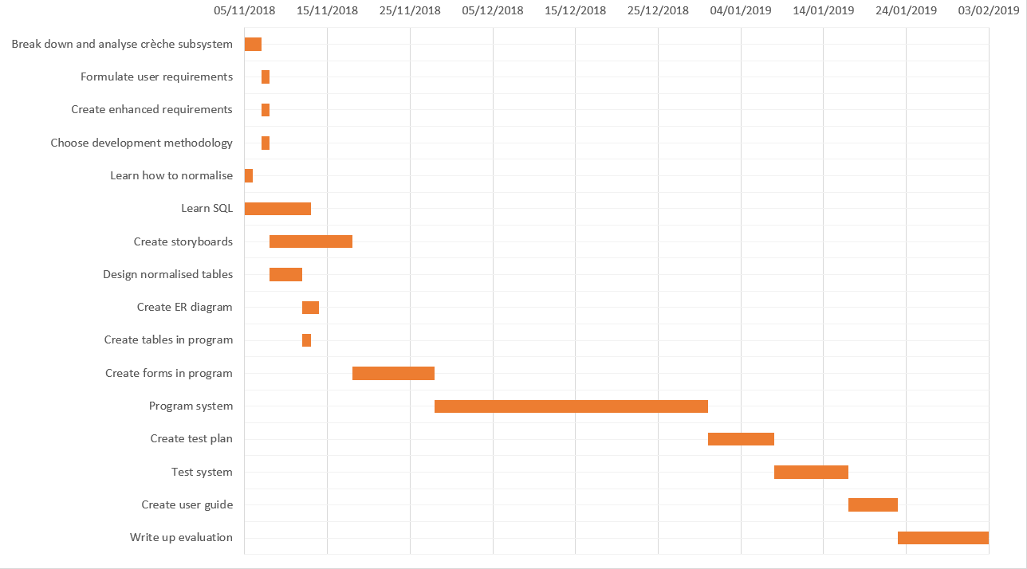

# **Requirements**

## **User Requirements**

1. The user should be able to add, edit and delete parents
2. The user should be able to add, edit and delete children
3. The user should be able to add, edit and delete bookings
4. When adding a child, the user must be able to select the parent by searching their name, as well as browsing a list of all parents
5. Bookings must be able to be made, with the ability to select which weekdays are booked and which aren’t
6. Bookings should not be able to be made with an admission time of less than one month
7. A discount of 5% is applied if the booking is made six months in advance and a discount of 3% is applied if the booking is made three months in advance
8. Children must be automatically placed in a group based on their age
9. Children must be automatically moved up in group once they become too old for their current group
10. There should be a maximum of: six children in the six to eighteen month group, ten in the eighteen to thirty month group and nine in the thirty months to four years group
11. The user must have the ability to assign staff members to each group, with two members of staff assigned to each group on each day
12. Access must be provided to the user to view parents, children, bookings, staff members and groups
13. The program should be easy to navigate, with no ambiguity concerning the function of each button
14. There should be a crèche menu screen in which the user can navigate to all areas of the system
15. Deleted parents, children and bookings should still be viewable on the view data screen in case a record of them is needed
16. A menu bar must be in place at the top of the program at all times, giving the user instant access to every screen in the program
17. The program should be aesthetically pleasing, with no clashing colours making text difficult to read
18. The colour scheme must be consistent, with dark green as the background colour and text colour mostly being turquoise, orange, violet and black
19. Each screen must be approachable and easy to understand, with a good mixture between a clean and a functional aesthetic, avoiding a clutter

## **Enhanced Requirements**

1. On the main menu of the entire Woodside Community Hub, there must be six buttons that will provide access to each service at the hub
2. There must be a creche menu form, in which there will be buttons to: add booking, add parent, add child, add staff, edit booking, edit parent, edit child, edit staff, assign staff, view tables of data, view a report and return to Woodside Community Hub menu
3. The database connection should be established on the main menu form as the user can navigate to any form via the menu toolstrip from there
4. The add parent and add child forms will require that all information has been filled in, all information is valid (e.g. a name cannot contain numbers and a phone number must be a valid length) and the information added is not all identical to an existing parent or child
5. On the add parent form, there will be options to either just save a parent (in which the data entered is saved and all data in the text boxes is removed) or save a parent and add a child (in which the parent is saved and the user is brought directly to the add child form with the parent already selected as the one that was just created)
6. There should be a text box with which the user can search for parents in the add child form, with the results of the search appearing in a list box below
7. The user must be able to add a new parent and children to their respective tables on the first form in the create booking process
8. In the first form of the make booking process, there must be separate parent and child panels, in which either new parent/child info is input, or existing parents/children are selected through searches
9. When a parent has been selected in the add/select parent and child form of the create booking section, only the children with the same ParentID as the selected parent should be available to be searched and selected
10. The child panel in the add parent/child form in the create booking section should be disabled until a valid parent has been selected, whether that be an existing one or a newly created one
11. The second form in the make booking process should require the user to input the start and end dates, as well as the selected week days which they are booking
12. The weekdays selected for booking must be chosen from check boxes, with there being a check box for each day of the week
13. Labels must show the user the duration of the current booking, the number of days booked and the cost of the booking, showing the user if a discount has been applied
14. The dates which have been booked out for the group of the selected child must be emboldened on both the calendar to select the start date and the calendar to select the end date
15. There must be a list box which displays every date booked out date that the current booking overlaps with
16. Records of bookings, parents and children should never be deleted; they should simply have a Boolean field which identifies them as deleted or not so that the record of them is always accessible
17. There should be a form for the assigning of staff members to groups. A calendar will allow the user to select a day and they will be able to select two staff members for each group
18. Once a staff member has been selected on a specific date, they should not be able to be selected for another group on that date
19. The user must be able to deselect staff members by clicking an ‘x’ beside the selected staff member
20. There should be edit and delete forms for bookings, parents and children, in which the user has the ability to edit and mark bookings, parents and children as deleted
21. The user must be able to view every table in the database in the view data form, with the ability to select the desired table from a selection of radio buttons
22. There must be constant access to the ability to close the program in the menu strip
23. There should be a help button in the menu toolbar which opens the user guide when clicked
24. The user must have the option to view bookings, parents and children marked as deleted
25. The user must be able to view a report which calculates and displays the number of bookings made and the average duration of the bookings
26. Each form must be permanently centred to the screen with the CenterToScreen() method
27. The code must be structured and easy to follow, using regions to split it up
28. The system should be highly efficient, using each method of increasing efficiency possible. This is because I believe a high level of polish is a vital trait of a high quality piece of software

# **Normalisation**

## **0NF**

BOOKING(*BookingID, StartDate, EndDate, Mon, Tue, Wed, Thurs, Fri, {KidID, KidName, DateOfBirth, ParentID, ParentName, ParentTelNo, City, Postcode, Address, GroupID, MaxNoKids, AgeRange, StaffID, StaffName, StaffTelNo, Date}*)

This isn’t in 1NF as *KidName*, *ParentName*, and *StaffName* are non-atomic and there is a repeating group.

## **1NF**

BOOKING(*BookingID, GroupID*, ParentID, ParentForename, ParentSurname, ParentTelNo, City, Postcode, Address, KidID, KidForename, KidSurname, DateOfBirth, StartDate, EndDate, Mon, Tue, Wed, Thurs, Fri*)

BOOKINGDETAILS(*GroupID, MaxNoKids, AgeRange, StaffID, StaffForename, StaffSurname, StaffTelNo, Date*)

0NF to 1NF:

Data is made atomic by splitting the name fields into separate forename and surname fields and there is an established composite key separating the booking details of the users and the booking info itself.

This isn’t 2NF as there isn’t total dependency on the composite key. For example, GroupID isn’t depended on by fields such as *ParentForename*.

## **2NF**

PARENT(*ParentID, Forename, Surname, TelNo, City, Postcode, Address*)

BOOKING(*BookingID, GroupID*, ParentID*, KidID, KidForename, KidSurname, DateOfBirth, StartDate, EndDate, Mon, Tue, Wed, Thurs, Fri*)

BOOKINGDETAILS(*GroupID, MaxNoKids, AgeRange, StaffID, Forename, Surname, TelNo)*

1NF to 2NF:

I removed the non-composite key dependencies of the parent’s info, and made the *ParentID* field a foreign key in the booking table

This is not in 3NF because not all fields are non-transitively dependent on the primary key. This is seen with *KidForename*, *KidSurname* and *DateOfBirth* fields in the BOOKING table, which are all transitively dependent on the primary key through *KidID*.

)

## **3NF**

PARENT(*ParentID, Forename, Surname, TelNo, City, Postcode, Address*)

KID(*KidID, ParentID*, Forename, Surname, DateOfBirth*)

BOOKING(*BookingID, KidID*, GroupID*, StartDate, EndDate, Mon, Tue, Wed, Thurs, Fri*)

BOOKEDOUT(*BookedOutID, BookingID*, Date*)

GROUP(*GroupID, AgeRange, MaxNoKids*)

STAFFGROUP(*StaffGroupID, StaffID*, GroupID*, Date*)

STAFF(*StaffID, Forename, Surname, TelNo*)

2NF to 3NF:

I removed the non key dependencies in the forms of the staff info, child info and group info, putting this information into their own tables as well as using foreign keys.

Instead of using a composite key in the BOOKING table, I used a dedicated primary key, as this will make programming the solution easier to do.

I also created a table, BOOKEDOUT, in order to classify a Date for Crèche as fully booked. This makes the process of finding non-booked crèche dates easier.

The STAFFGROUP table is used to clearly display the staff members’ shifts for each date, including which group they will be staffing.

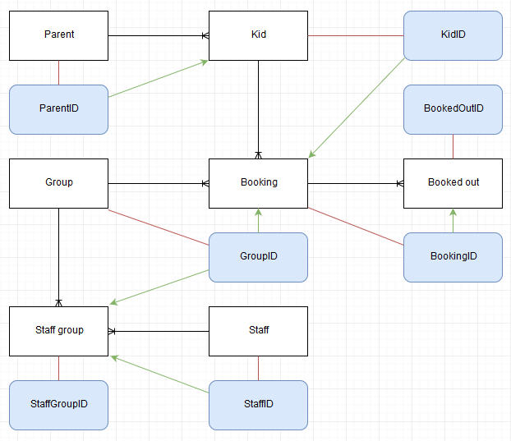

# **Data Dictionary**

## **Parent**

|  |  |  |  |  |  |
| --- | --- | --- | --- | --- | --- |
| Attribute | Data Type | Field Size | Validation | Required? | Key |
| ParentID | int |  | Must be greater than greatest existing ParentID | Yes | Primary |
| Forename | varchar | 30 | Must not contain numbers | Yes |  |
| Surname | varchar | 30 | Must not contain numbers | Yes |  |
| TelNo | varchar | 30 | Must only contain numbers | Yes |  |
| City | varchar | 30 | Must not contain numbers | Yes |  |
| Postcode | varchar | 30 | Must be between 5 and 8 characters | Yes |  |
| Address | varchar | 50 |  | Yes |  |

## **Kid**

|  |  |  |  |  |  |
| --- | --- | --- | --- | --- | --- |
| KidID | int |  | Must be greater than greatest existing KidID | Yes | Primary |
| ParentID | int |  | Must be greater than greatest existing ParentID | Yes | Foreign (references Parent table) |
| Forename | varchar | 30 | Must not contain numbers | Yes |  |
| Surname | varchar | 30 | Must not contain numbers | Yes |  |
| DateOfBirth | varchar | 30 | Must be between 6 months and 4 years before today’s date | Yes |  |

## **Booking**

|  |  |  |  |  |  |
| --- | --- | --- | --- | --- | --- |
| BookingID | int |  | Must be greater than greatest existing BookingID | Yes | Primary |
| KidID | int |  | Must be greater than greatest existing KidID | Yes | Foreign (references Kid table) |
| GroupID | int |  | Must be greater than greatest existing GroupID | Yes | Foreign (references Group table) |
| StartDate | varchar | 30 | Cannot be in past | Yes |  |
| EndDate | varchar | 30 | Must be at least a full month from today’s date | Yes |  |
| Mon | bit |  |  | Yes |  |
| Tue | bit |  |  | Yes |  |
| Wed | bit |  |  | Yes |  |
| Thurs | bit |  |  | Yes |  |
| Fri | bit |  |  | Yes |  |

## **BookedOut**

|  |  |  |  |  |  |
| --- | --- | --- | --- | --- | --- |
| BookedOutID | int |  | Must be greater than greatest existing BookedOutID | Yes | Primary |
| BookingID | int |  | Must be greater than greatest existing BookingID | Yes | Foreign (references Booking table) |
| Date | varchar | 30 |  | Yes |  |

## **Group**

|  |  |  |  |  |  |
| --- | --- | --- | --- | --- | --- |
| GroupID | int |  | Must be greater than greatest existing GroupID | Yes | Primary |
| MaxNoKids | int |  |  | Yes |  |
| AgeRange | varchar | 30 |  | Yes |  |

## **StaffGroup**

|  |  |  |  |  |  |
| --- | --- | --- | --- | --- | --- |
| StaffGroupID | int |  | Must be greater than greatest existing StaffGroupID | Yes | Primary |
| StaffID | int |  | Must be greater than greatest existing StaffID | Yes | Foreign (references Staff table) |
| GroupID | int |  | Must be greater than greatest existing GroupID | Yes | Foreign (references Gorup table) |
| Date | varchar | 30 | Must not be in past | Yes |  |

## **Staff**

|  |  |  |  |  |  |
| --- | --- | --- | --- | --- | --- |
| StaffID | int |  | Must be greater than greatest existing StaffID | Yes | Primary |
| Forename | varchar | 30 | Must not contain numbers | Yes |  |
| Surname | varchar | 30 | Must not contain numbers | Yes |  |
| TelNo | varchar | 30 | Must only contain numbers | Yes |  |

# **Storyboards**

## **Draft Storyboards**

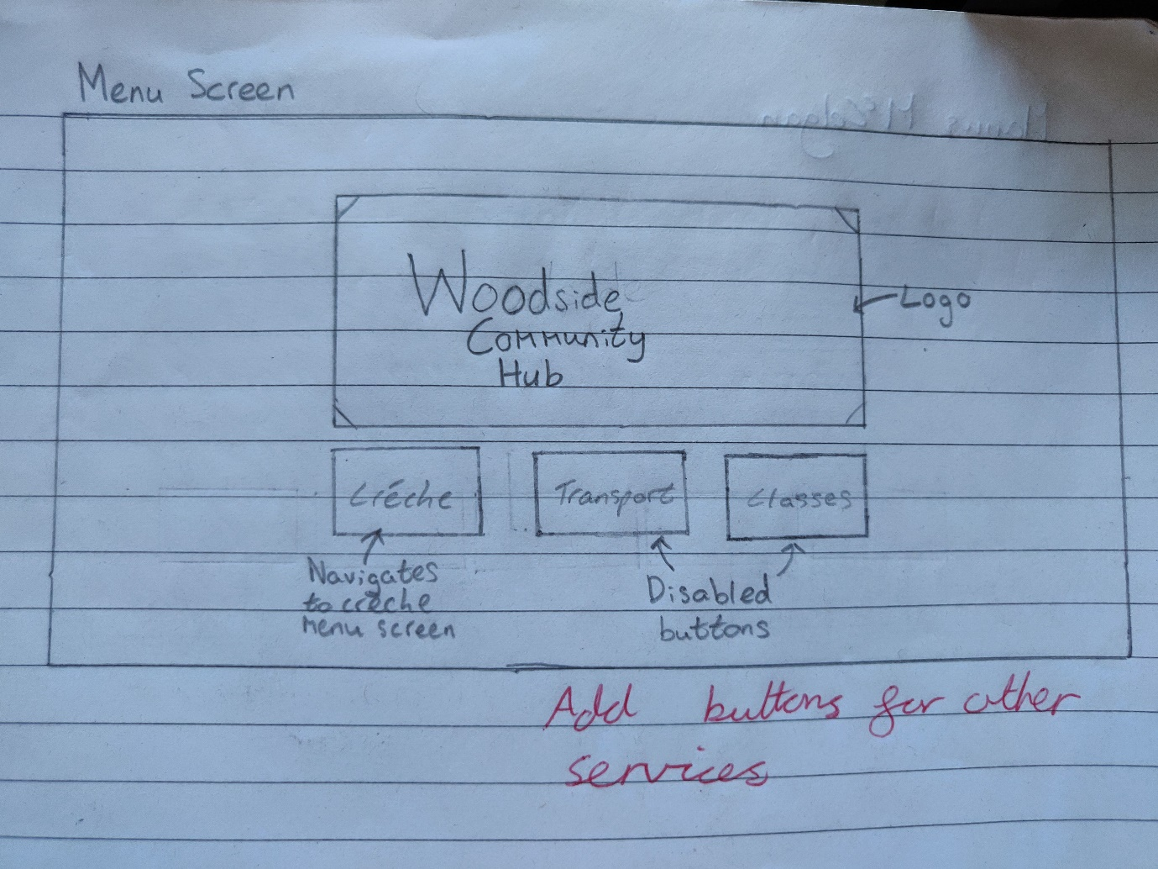

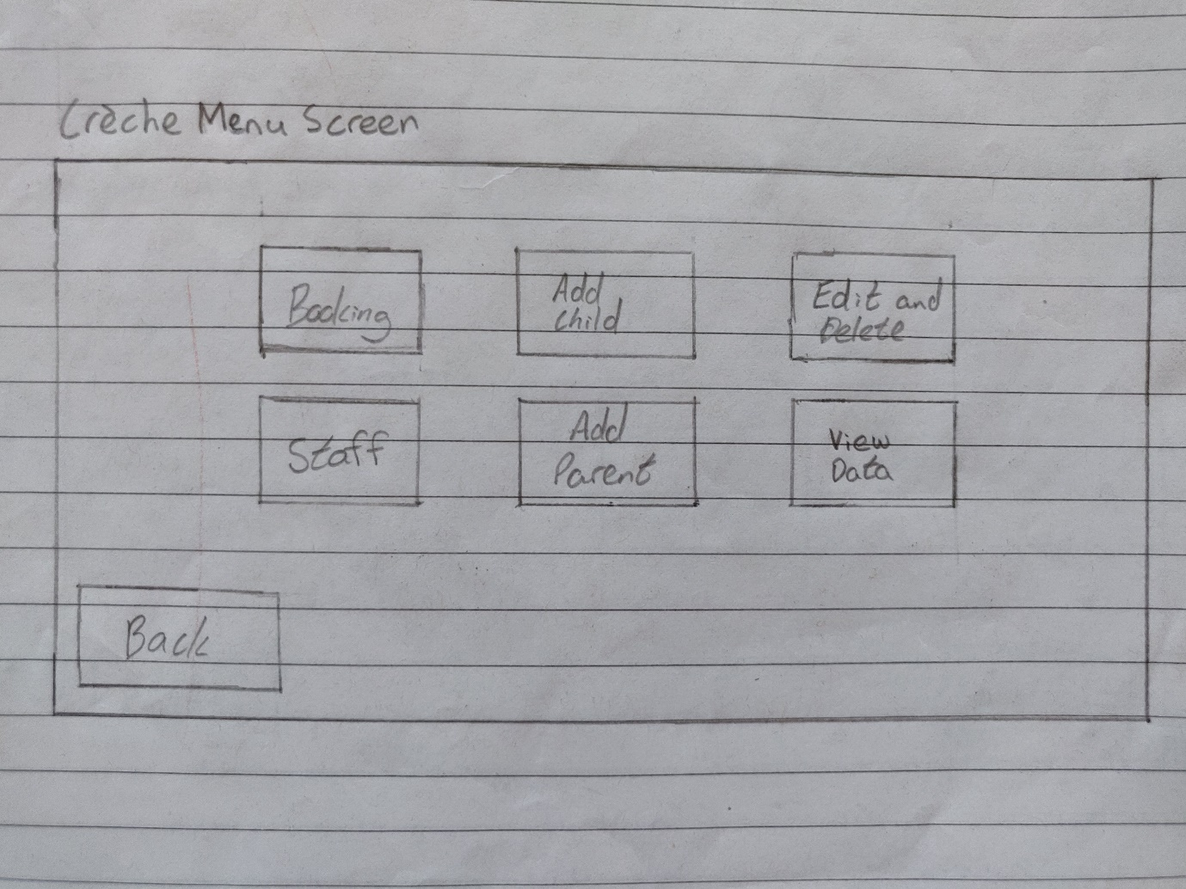

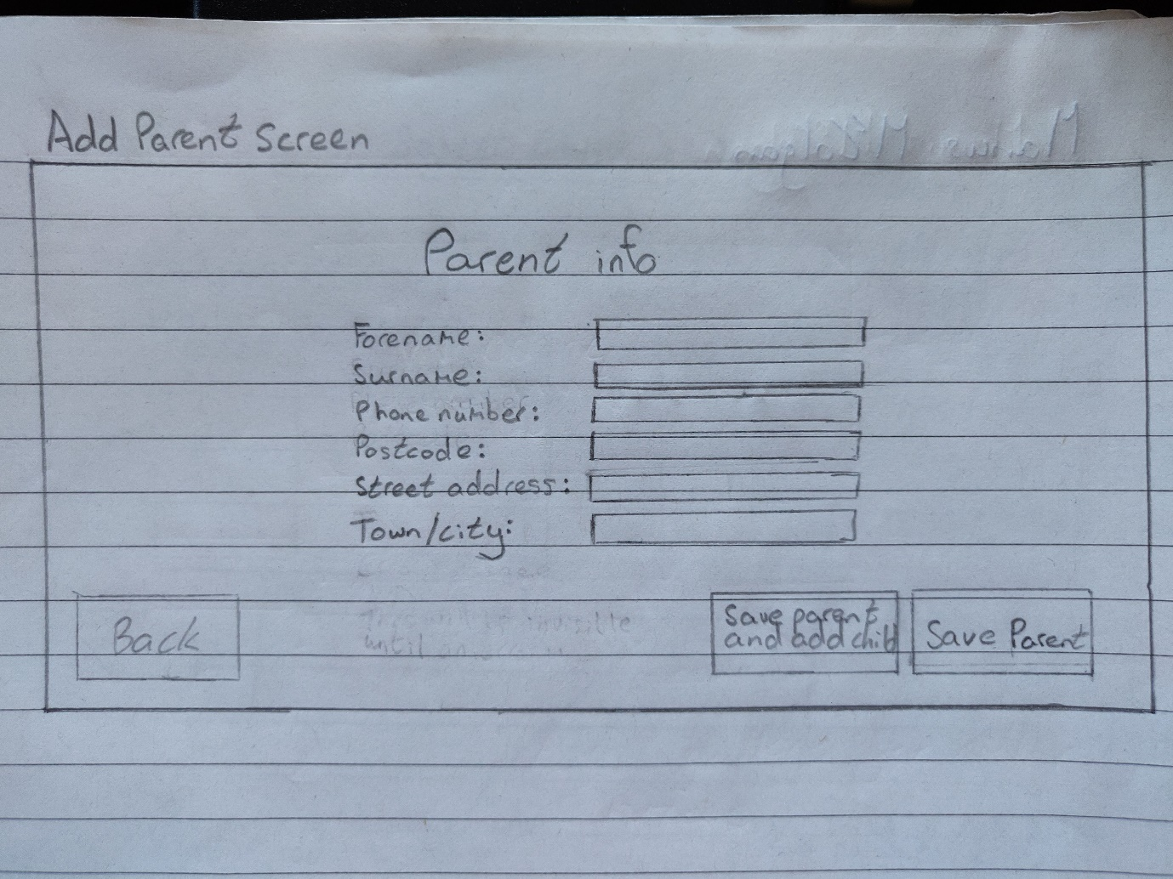

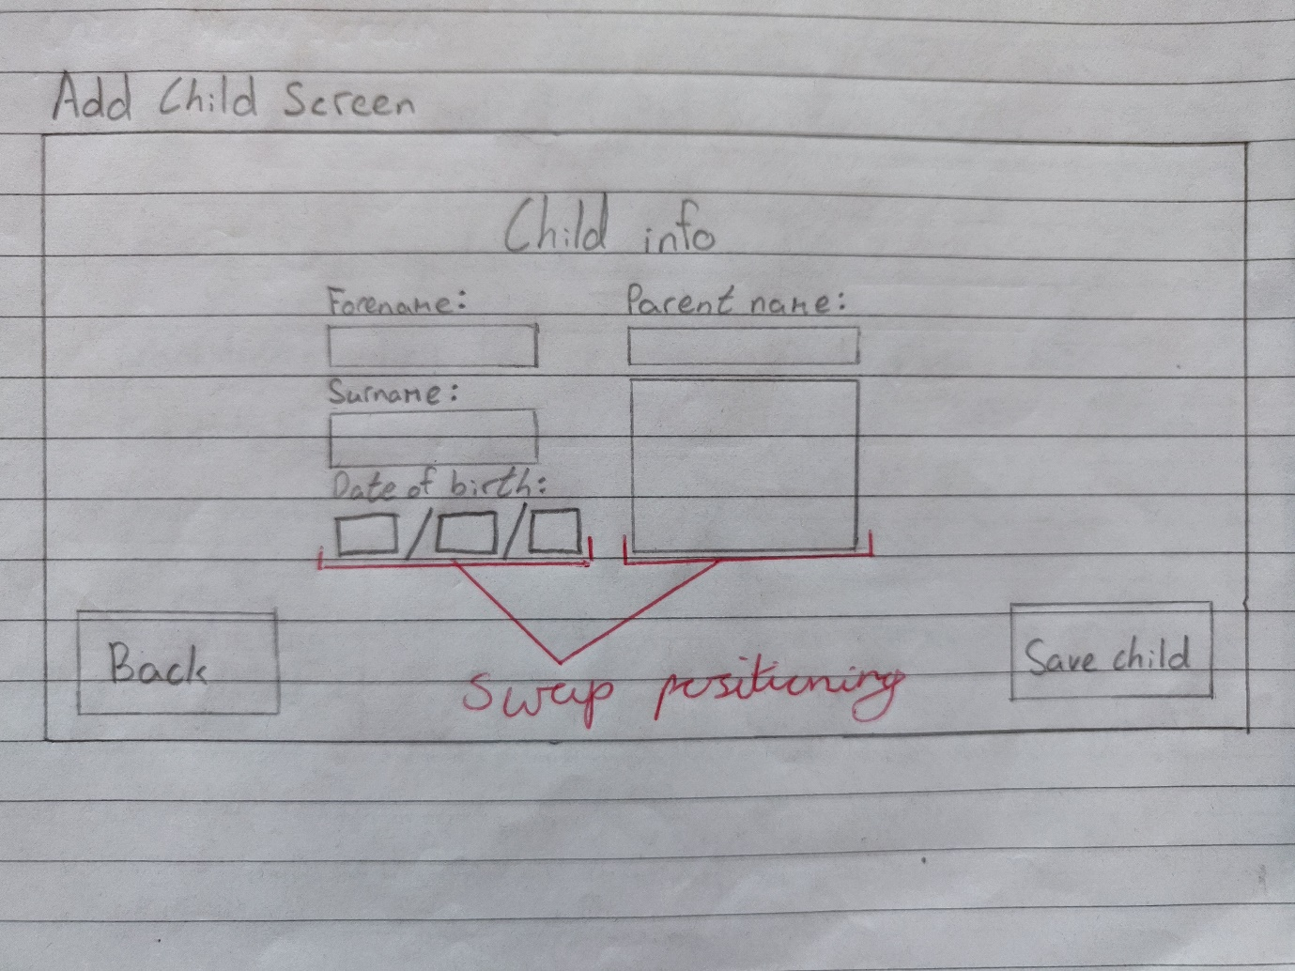

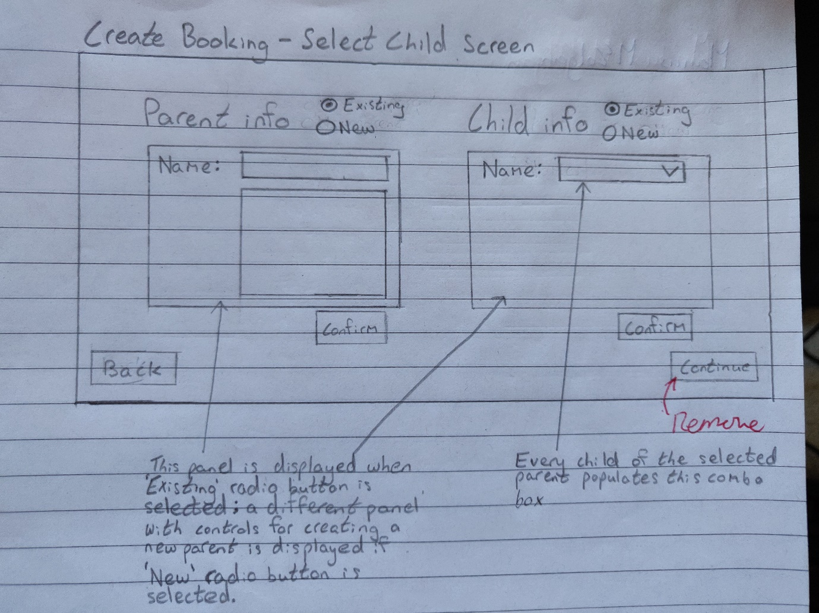

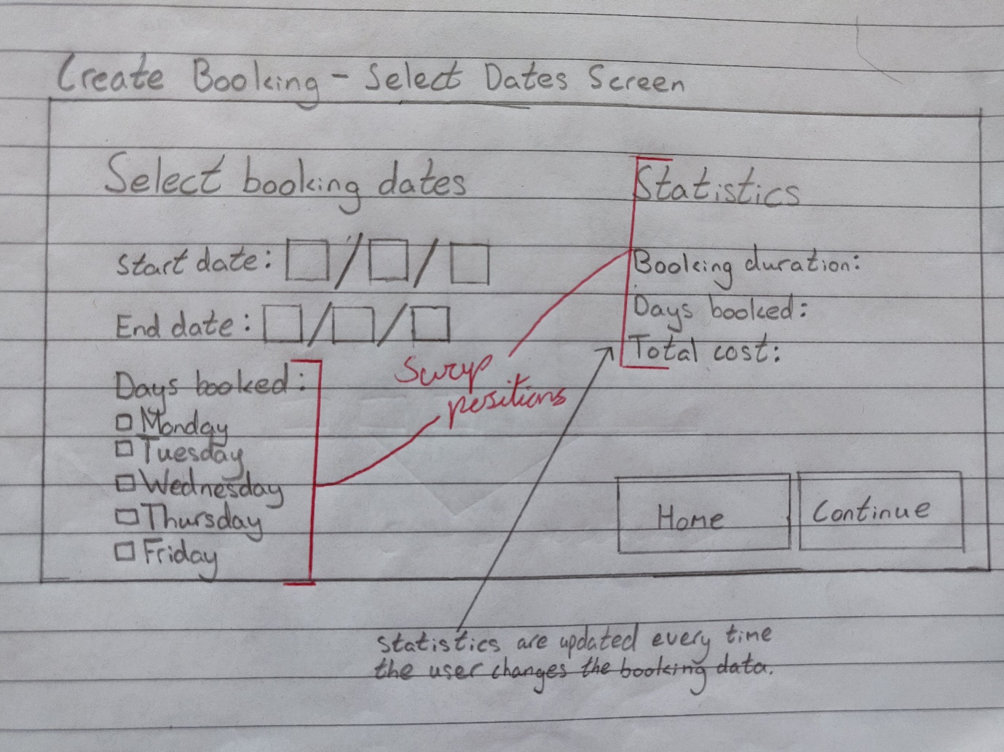

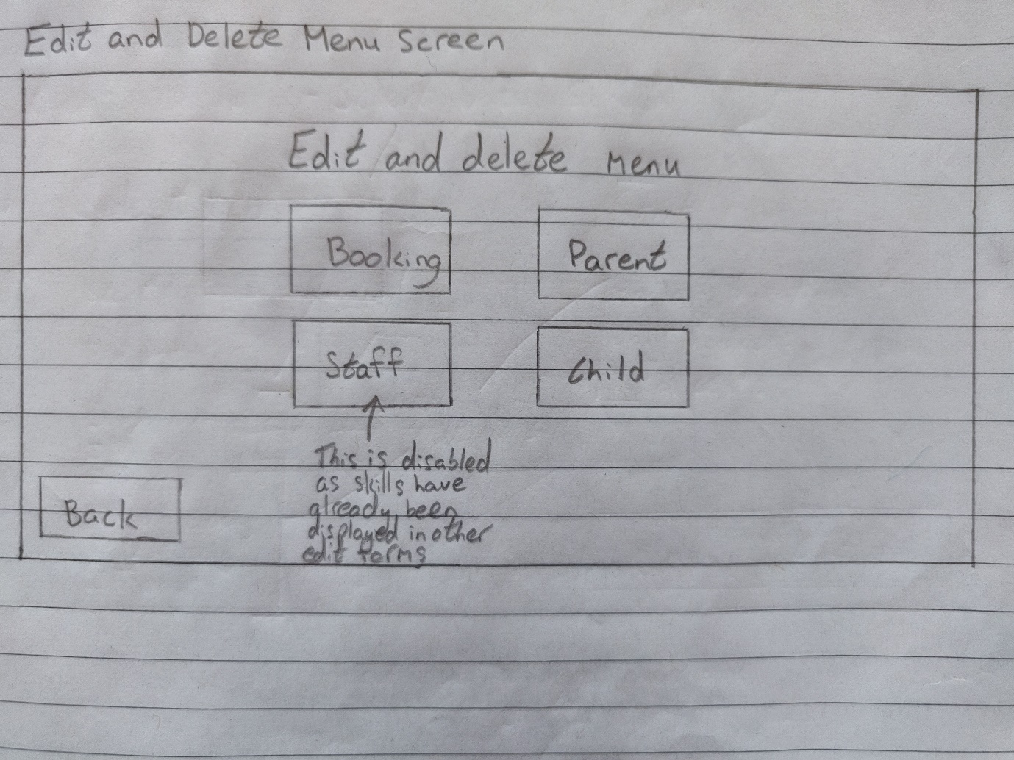

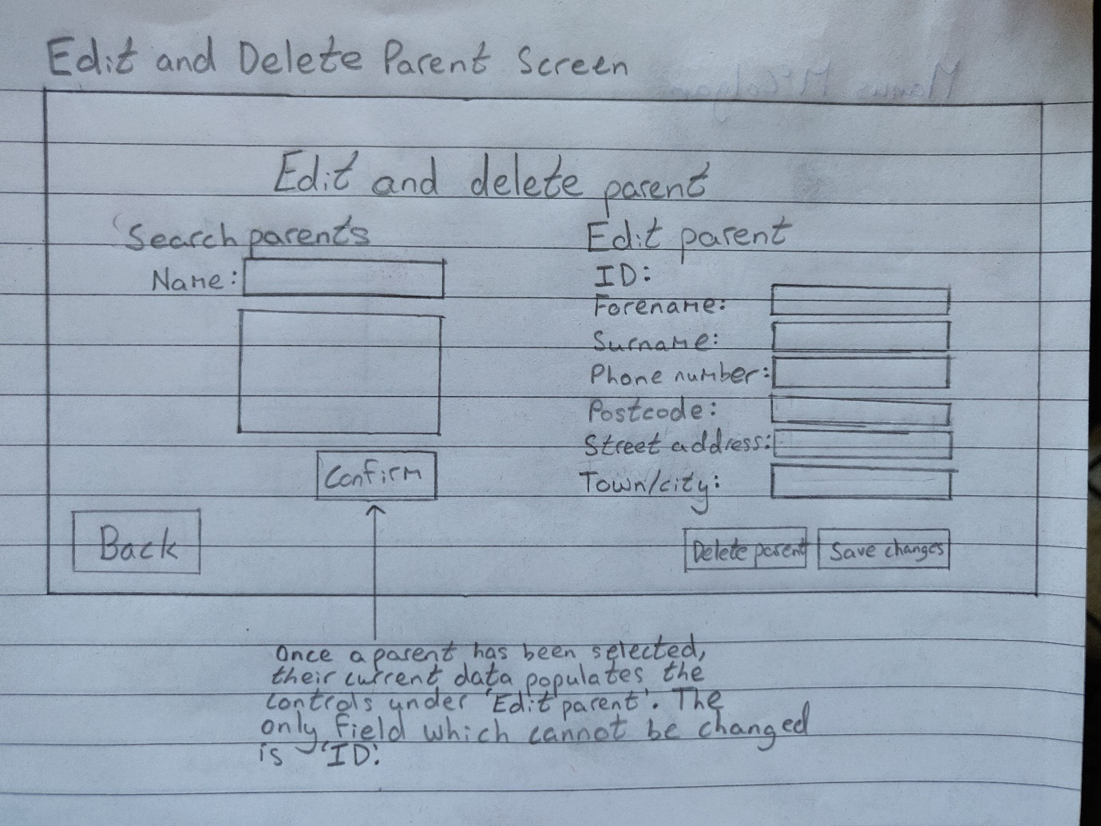

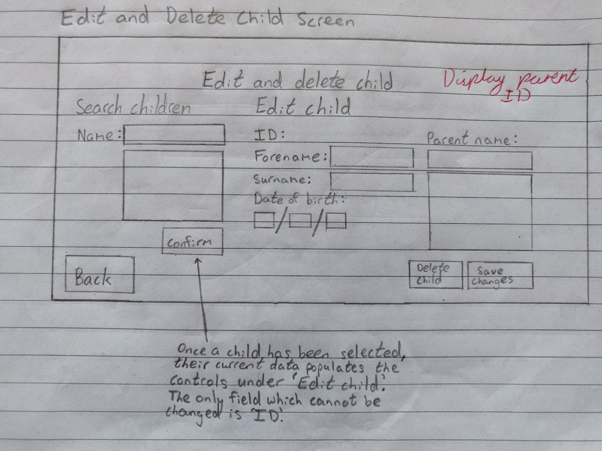

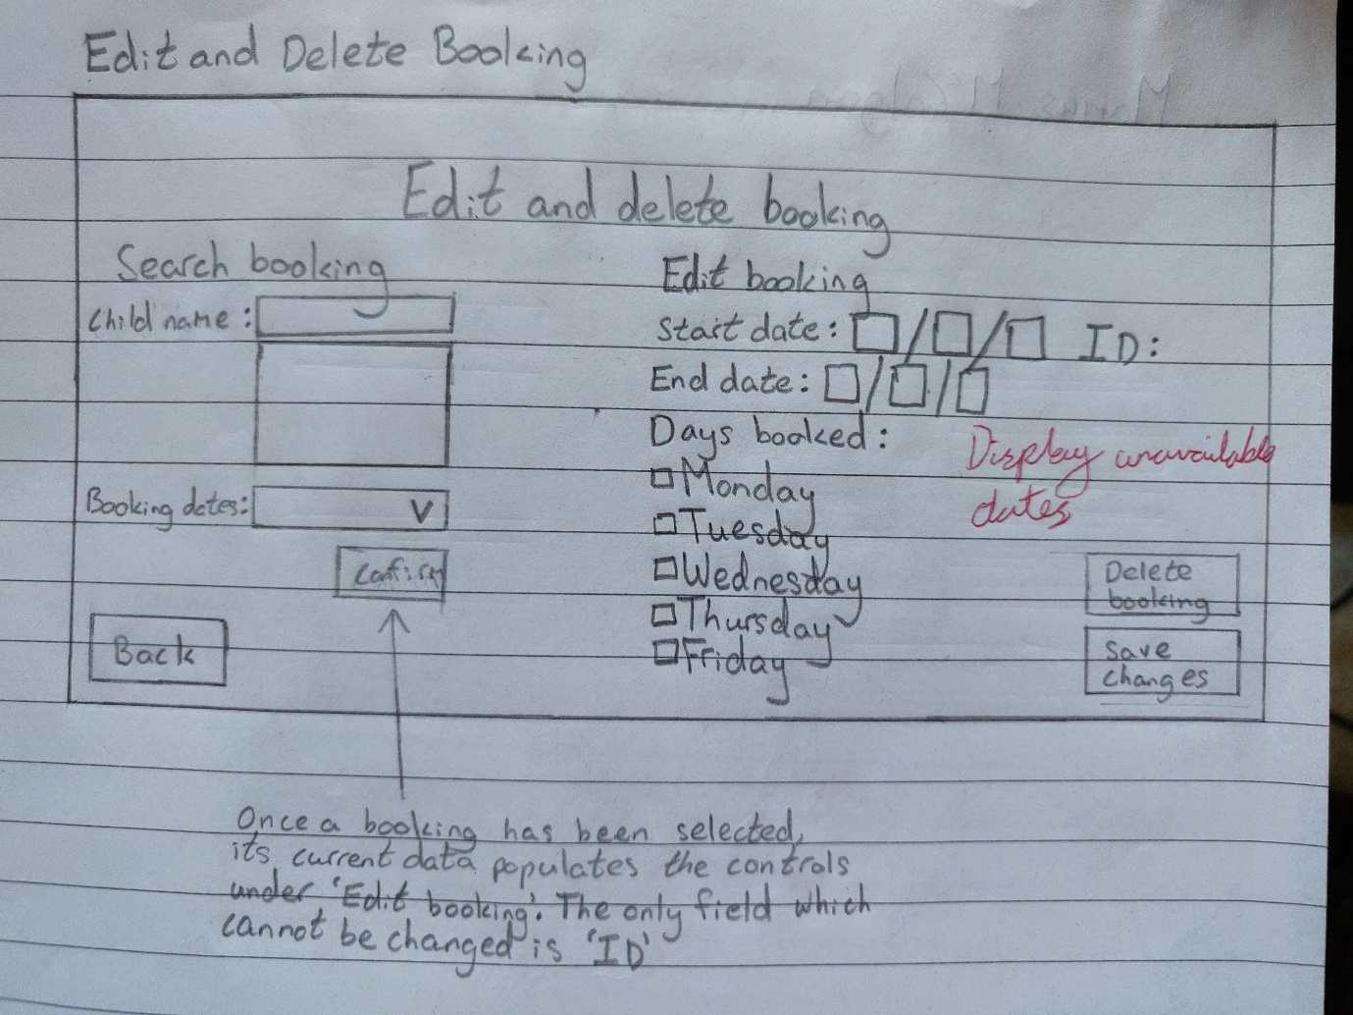

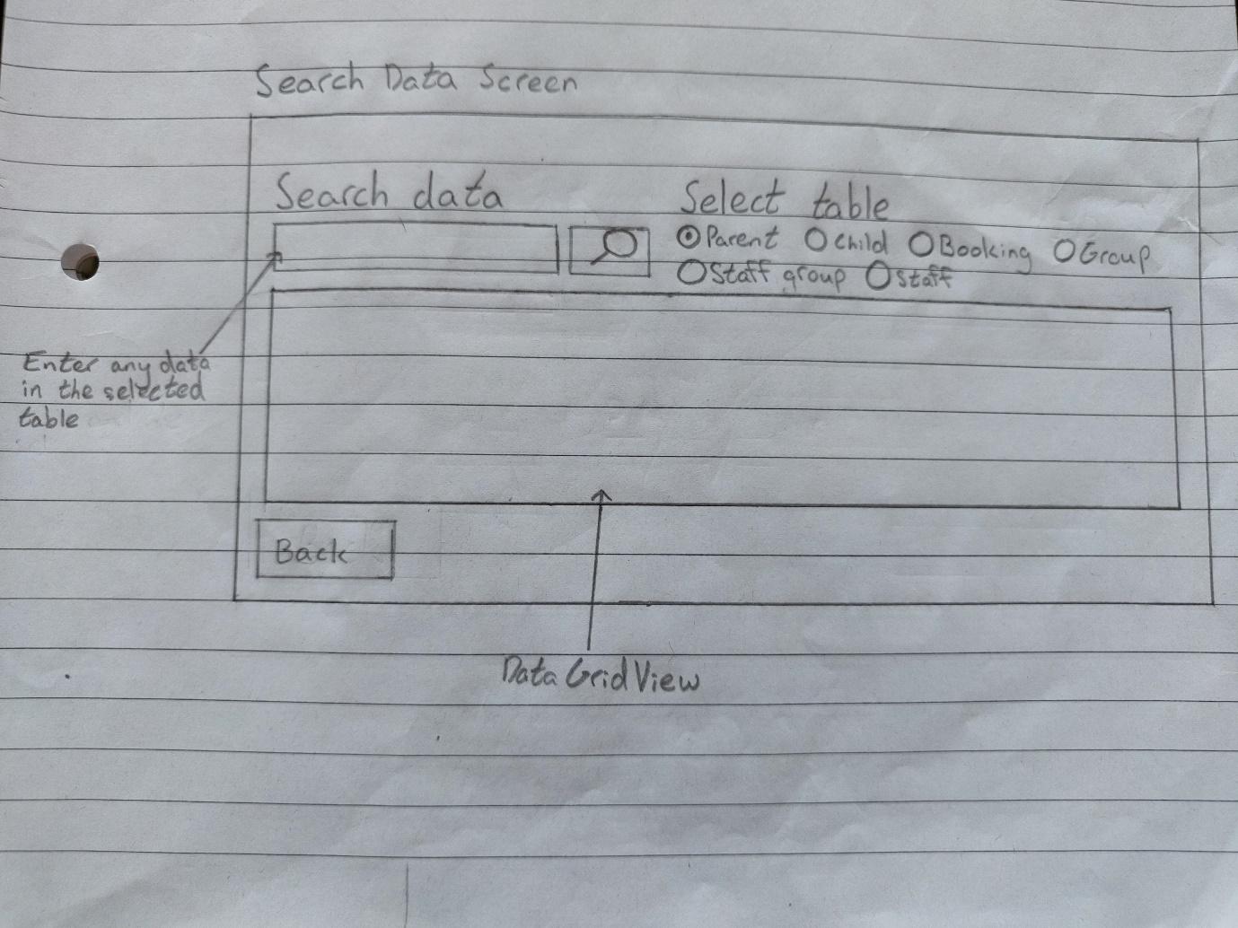

## **Enhanced Storyboards**

### Global Form Template

#### Diagram

(a)

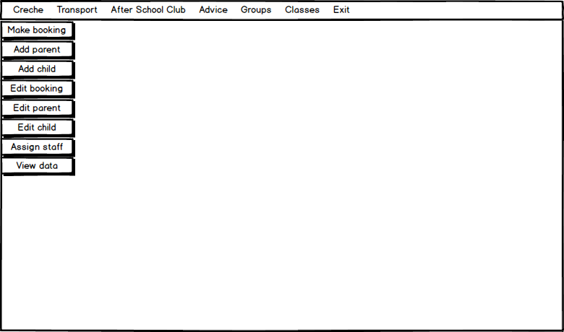

(h)

(p)

(j)

(i)

(b)

(k)

(g)

(f)

(e)

(d)

(c)

(l)

(m)

(n)

(o)

#### Labels

|  |  |  |  |  |  |
| --- | --- | --- | --- | --- | --- |
| Letter | Control type | Name | Properties | Requirement | Algorithm number |
| (a) | Toolstrip  menu  item | menCreche |  |  |  |
| (b) | menTransport |  |  |  |
| (c) | menAfterSchoolClub |  |  |  |
| (d) | menAdvice |  |  |  |
| (e) | menGroups |  |  |  |
| (f) | menClasses |  |  |  |
| (g) | menExit |  | 22 | 9 |
| (h) | menMakeBooking |  |  | 1 |
| (i) | menAddParent |  |  | 2 |
| (j) | menAddChild |  |  | 3 |
| (k) | menEditBooking |  |  | 4 |
| (l) | menEditParent |  |  | 5 |
| (m) | menEditChild |  |  | 6 |
| (n) | menAssignStaff |  |  | 7 |
| (o) | menViewDate |  |  | 8 |
| (p) | Menu strip | mstrpMenu |  | p, 23 |  |

#### Algorithms

*1: menMakeBooking clicked event*

When menMakeBookingis clicked

Close current form and load Booking Select Child Form

*2: menAddParent clicked event*

When menAddParentis clicked

Close current form and load Add Parent Form

*3: menAddChild clicked event*

When menAddChildis clicked

Close current form and load Add Child Form

*4: menEditBooking clicked event*

When menEditBookingis clicked

Close current form and load Edit and Delete Booking Form

*5: menEditParent clicked event*

When menEditParentis clicked

Close current form and load Edit and Delete Parent Form

*6: menEditChild clicked event*

When menEditChildis clicked

Close current form and load Edit and Delete Child Form

*7: menAssignStaff clicked event*

When menAssignStaffis clicked

Close current form and load Assign Staff Form

*8: menViewData clicked event*

When menViewDatais clicked

Close current form and load View Data Form

*9: menExit clicked event*

When menExitis clicked

Close program

### Main Menu Form

#### Diagram

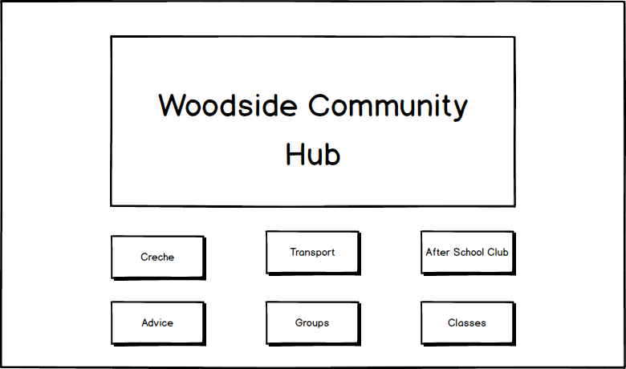

(g)

(f)

(e)

(d)

(c)

(b)

(a)

#### Labels

|  |  |  |  |  |  |
| --- | --- | --- | --- | --- | --- |
| Letter | Control type | Name | Properties | Requirement | Algorithm number |
| (a) | Picture box | picLogo |  |  |  |
| (b) | Button | btnCreche | ForeColour: Turquoise  BackColour:  0, 64, 0 | 1 | 1 |
| (c) | btnTransport | 1 |  |
| (d) | btnAfterSchoolClub | 1 |  |
| (e) | btnAdvice | 1 |  |
| (f) | btnGroups | 1 |  |
| (g) | btnClasses | 1 |  |

#### Algorithms

*1: btnCreche clicked event*

When btnCrecheis clicked

Close current form and load Creche Menu Form

### Crèche Menu Form

#### Diagram

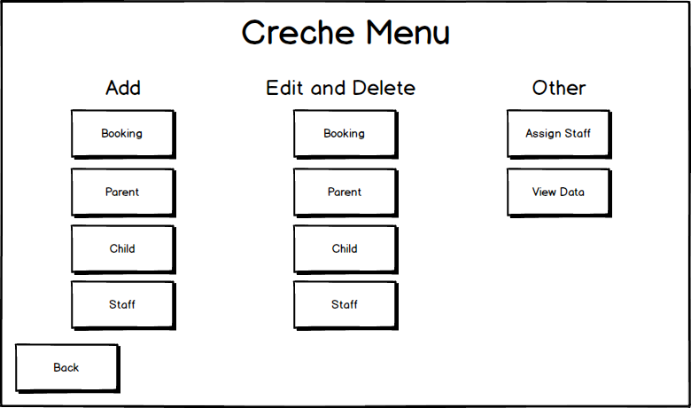

(n)

(d)

(i)

(k)

(l)

(j)

(c)

(o)

(h)

(g)

(f)

(e)

(b)

(a)

(m)

#### Labels

|  |  |  |  |  |  |
| --- | --- | --- | --- | --- | --- |
| Letter | Control type | Name | Properties | Requirement | Algorithm number |
| (a) | Label | lblCrecheMenu |  |  |  |
| (b) | lblAdd |  |  |  |
| (c) | lblEditAndDelete |  |  |  |
| (d) | lblOther |  |  |  |
| (e) | Button | btnAddBooking | ForeColour: Turquoise  BackColour: 0, 64, 0 | n, 2 | 1 |
| (f) | btnAddParent | n, 2 | 2 |
| (g) | btnAddChild | n, 2 | 3 |
| (h) | btnAddStaff | n, 2 |  |
| (i) | btnEditBooking | n, 2 | 4 |
| (j) | btnEditParent | n, 2 | 5 |
| (k) | btnEditChild | n, 2 | 6 |
| (l) | btnEditStaff | n, 2 |  |
| (m) | btnAssignStaff | n, 2 | 7 |
| (n) | btnViewData | n, 2 | 8 |
| (o) | btnBack | n, 2 | 9 |

#### Algorithms

*1: btnAddBooking clicked event*

When btnAddBookingis clicked

Close current form and load Booking Select Child Form

*2: btnAddParent clicked event*

When btnAddParent is clicked

Close current form and load Add Parent Form

*3: btnAddChild clicked event*

When btnAddChild is clicked

Close current form and load Add Child Form

*4: btnEditBooking clicked event*

When btnEditBooking is clicked

Close current form and load Edit and Delete Booking Form

*5: btnEditParent clicked event*

When btnEditParent is clicked

Close current form and load Edit and Delete Parent Form

*6: btnEditChild clicked event*

When btnEditChild is clicked

Close current form and load Edit and Delete Child Form

*7: btnAssignStaff clicked event*

When btnAssignStaff is clicked

Close current form and load Assign Staff Form

*8: btnViewData clicked event*

When btnViewData is clicked

Close current form and load View Data Form

*9: btnBack clicked event*

When btnBack is clicked

Close current form and load Main Menu Form

### Booking Select Child Form

#### Diagram

(a)

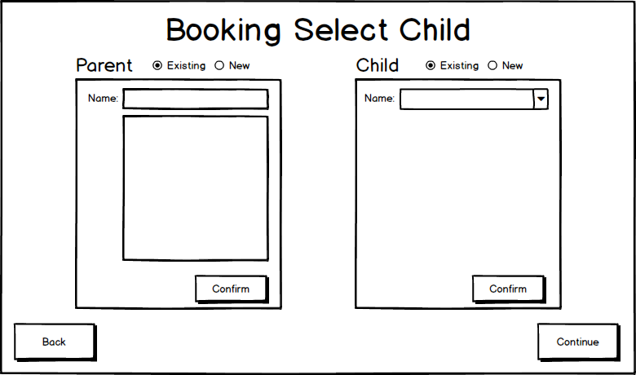

(r)

|  |  |  |  |  |  |
| --- | --- | --- | --- | --- | --- |
|  |  |  |  |  |  |
|  |  |  |  |  |  |
|  |  |  |  |  |  |
|  |  |  |  |  |  |
|  |  |  |  |  |  |
|  |  |  |  |  |  |
|  |  |  |  |  |  |
|  |  |  |  |  |  |
|  |  |  |  |  |  |
|  |  |  |  |  |  |
|  |  |  |  |  |  |
|  |  |  |  |  |  |
|  |  |  |  |  |  |
|  |  |  |  |  |  |
|  |  |  |  |  |  |
|  |  |  |  |  |  |
|  |  |  |  |  |  |
|  |  |  |  |  |  |

)

(m)

(o)

(i)

(c)

(h)

(l)

(e)

(p)

(n)

(q)

(k)

(j)

(d)

(g)

(f)

(b)

#### Labels

|  |  |  |  |  |  |
| --- | --- | --- | --- | --- | --- |
| Letter | Control type | Name | Properties | Requirement | Algorithm number |
| (a) | Label | lblBookingSelectChild | ForeColour: DarkOrange |  |  |
| (b) | lblParent |  |  |
| (c) | lblChild |  |  |
| (d) | lblParentName | ForeColour: Turquoise |  |  |
| (e) | lblChildName |  |  |
| (f) | Radio button | radExistingParent | Checked: True |  |  |
| (g) | radNewParent |  | 7 |  |
| (h) | radExistingChild | Enabled: False  Checked: True |  |  |
| (i) | radNewChild | Enabled: False | 7 |  |
| (j) | Text box | txtParentName |  |  |  |
| (k) | List box | lstParentName |  |  |  |
| (l) | Combo box | cmbChildName | Drop down style: DropDownList | 9 |  |
| (m) | Panel | panParentInfo | BackColour: 0, 50, 0 | 8 |  |
| (n) | panChildInfo | BackColour: 0, 50, 0  Enabled: False | 8, 10 |  |
| (o) | Button | btnConfirmParent | ForeColour: Turquoise  BackColour: 0, 64, 0 |  | 2 |
| (p) | btnConfirmChild |  | 3 |
| (q) | btnBack |  | 1 |
| (r) | btnContinue |  | 4 |

#### Algorithms

*1: btnBack clicked event*

When btnBackis clicked

Close current form and load Creche Menu Form

*2: btnConfirmParent clicked event*

If radExistingParent is checked

If parent has been selected from lstParentName

Set selected parent object to parent selected from lstParentName

Enable panChildInfo and disable panParentInfo

Populate cmbChildName with selected the parent’s children

Else

Show error message indicating that no parent is selected

If radNewParent is checked

If all validations are met

Add new parent to database with the details entered

Set selected parent object to newly created parent

Enable panChildInfo, disable panParentInfo and disable radExistingChild

Else

Show error message indicating which validation isn’t met

*3: btnConfirmChild clicked event*

If radExistingChild is checked

If child is selected from cmbChildName

Set selected child object to child selected from cmbChildName

Enable btnContinue and disable panChildInfo

Else

Show error message indicating that no parent is selected

Else if radNewChild is checked

If all validations are met

Add new child to database with the details entered

Set selected child object to newly created child

Enable btnContinue and disable panChildInfo

Else

Show error message indicating which validation isn’t met

*4: btnContinue clicked event*

When btnContinueis clicked

Close current form and load Booking Select Child Form, passing in selected parent and child objects

### Booking Select Dates Form

#### Diagram

(a)

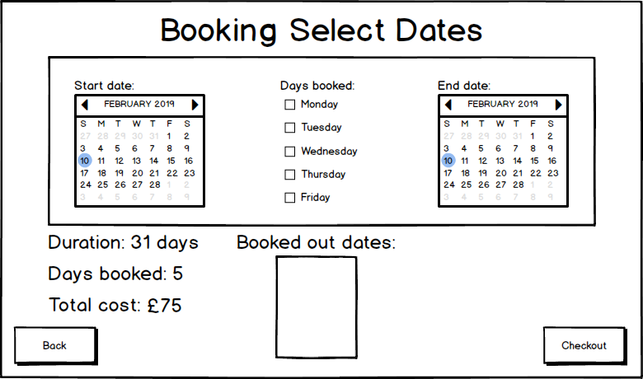

(m)

(c)

(b)

(l)

(e)

(f)

(g)

(t)

(r)

(j)

(i)

(h)

(q)

(s)

(k)

(p)

(u)

(o)

(n)

(d)

(v)

#### Labels

|  |  |  |  |  |  |
| --- | --- | --- | --- | --- | --- |
| Letter | Control type | Name | Properties | Requirement | Algorithm number |
| (a) | Label | lblBookingSelectDates | ForeColour: DarkOrange |  |  |
| (b) | lblStartDate | ForeColour: Turquoise |  |  |
| (c) | lblDaysBooked |  |  |
| (d) | lblEndDate |  |  |
| (e) | lblDurationLabel |  |  |
| (f) | lblDaysBookedLabel |  |  |
| (g) | lblTotalCostLabel |  |  |
| (h) | lblBookingDuration |  |  |
| (i) | lblDaysBooked | 13 |  |
| (j) | lblTotalCost | 13 |  |
| (k) | lblBookedOutDates | 13 |  |
| (l) | Month calendar | calStartDate | MaxSelectionCount: 1 | f, 11, 14 | 3 |
| (m) | calEndDate | f, 11, 14 | 4 |
| (n) | Check box | chkMonday | ForeColour: Yellow | 11, 12 | 5 |
| (o) | chkTuesday | 11, 12 | 5 |
| (p) | chkWednesday | 11, 12 | 5 |
| (q) | chkThursday | 11, 12 | 5 |
| (r) | chkFriday | 11, 12 | 5 |
| (s) | List box | lstSelectedBookedOutDates |  | 15 |  |
| (t) | Button | btnBack | ForeColour: Turquoise  BackColour: 0, 64, 0 |  | 1 |
| (u) | btnCheckout |  | 6 |
| (v) | Panel | panSelectBookingDates | BackColour: 0, 50, 0 |  |  |

#### Algorithms

*1: btnBack clicked event*

When btnBack is clicked

Close current form and load Booking Select Child Form

*2: Form load event*

When form is loaded

Embolden all dates of calStartDate and calEndDate that are booked out for the selected child’s group

*3: calStartDate date changed event*

When selected date is changed on calStartDate

If date has been selected on calEndDate and at least one combo box is checked

Set lblBookingDuration to number of days between selected date on calStartDate and calEndDate

Populate lstSelectedBookedOutDates with all dates of current booking that overlap with booked out dates

Set lblDaysBooked to number of days selected on booking, not counting already booked out dates

Set lblTotalCost to cost of booking

Else if date has been selected on calEndDate

Set lblBookingDuration to number of days between selected date on calStartDate and calEndDate

*4: calEndDate date changed event*

When selected date is changed on calStartDate

If date has been selected on calStartDate and at least one combo box is checked

Set lblBookingDuration to number of days between selected date on calStartDate and calEndDate

Populate lstSelectedBookedOutDates with all dates of current booking that overlap with booked out dates

Set lblDaysBooked to number of days selected on booking, not counting already booked out dates

Set lblTotalCost to cost of booking

Else if date has been selected on calStartDate

Set lblBookingDuration to number of days between selected date on calStartDate and calEndDate

*5: chkMonday, chkTuesday, chkWednesday, chkThursday, chkFriday check changed event*

When check is changed on any of the check boxes

If no check box is checked

Set lblDaysBooked to ‘0’

Set lblTotalCost to ‘£0’

Clear lstSelectedBookedOutDates

If date has been selected on calStartDate and calEndDate and at least one check box is checked

*6: btnCheckout clicked event*

When btnCheckout is clicked

If all validations are met

Save booking to database and load Crèche Menu Form

Else

Show error message indicating which validation isn’t met

### Add Parent Form

#### Diagram

(a)

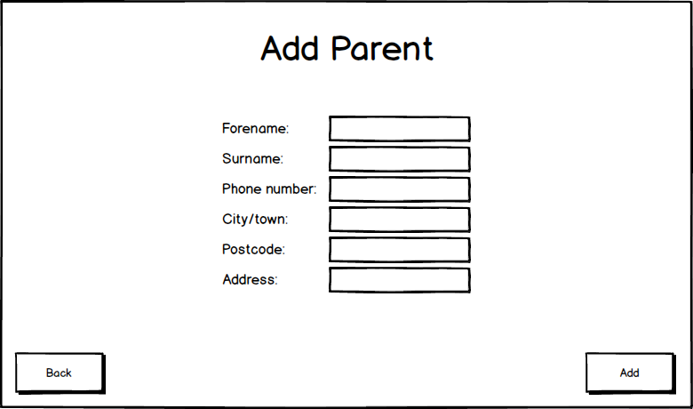

(n)

(m)

(b)

(c)

(d)

(e)

(f)

(g)

(o)

(l)

(k)

(j)

(i)

(h)

#### Labels

|  |  |  |  |  |  |
| --- | --- | --- | --- | --- | --- |
| Letter | Control type | Name | Properties | Requirement | Algorithm number |
| (a) | Label | lblAddParent | ForeColour: DarkOrange |  |  |
| (b) | lblForename | ForeColour: Turquoise |  |  |
| (c) | lblSurname |  |  |
| (d) | lblPhoneNumber |  |  |
| (e) | lblCity |  |  |
| (f) | lblPostcode |  |  |
| (g) | lblAddress |  |  |
| (h) | Text box | txtParentForename |  |  |  |
| (i) | txtParentSurname |  |  |  |
| (j) | txtParentTelNo |  |  |  |
| (k) | txtParentCity |  |  |  |
| (l) | txtParentPostcode |  |  |  |
| (m) | txtParentAddress |  |  |  |
| (n) | Button | btnBack | ForeColour: Turquoise  BackColour: 0, 64, 0 |  | 1 |
| (o) | btnSaveParent | 4 | 2 |

#### Algorithms

*1: btnBack clicked event*

When btnBack is clicked

Close current form and load Creche Menu Form

*2: btnSaveParent clicked event*

When btnSaveParent is clicked

If all validations are met

Add parent to database

Clear all text boxes

### Add Child Form

#### Diagram

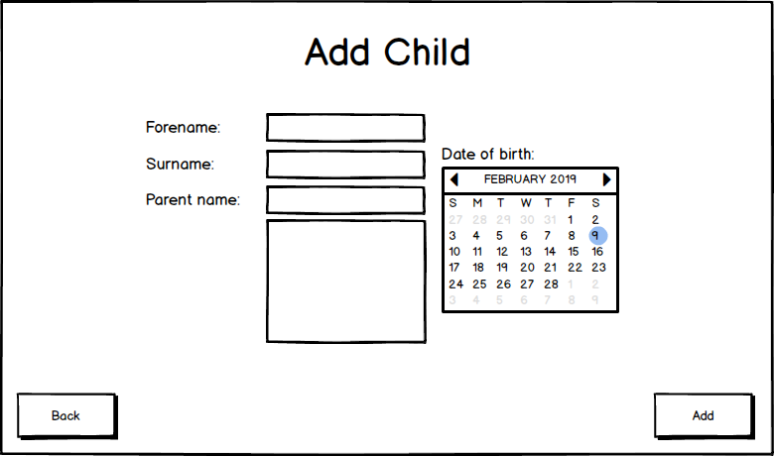

(b)

(c)

(d)

(g)

(h)

(k)

(i)

(l)

(j)

(e)

(f)

(a)

#### Labels

|  |  |  |  |  |  |
| --- | --- | --- | --- | --- | --- |
| Letter | Control type | Name | Properties | Requirement | Algorithm number |
| (a) | Label | lblAddChild | ForeColour: DarkOrange |  |  |
| (b) | lblForename | ForeColour: Turquoise |  |  |
| (c) | lblSurname |  |  |
| (d) | lblParentName |  |  |
| (e) | lblDateOfBirth |  |  |
| (f) | Text box | txtChildForename |  |  |  |
| (g) | txtChildSurname |  |  |  |
| (h) | txtChildParentName |  | d, 6 | 2 |
| (i) | List box | lstChildParentName |  | d, 6 | 3 |
| (j) | Month Calendar | calChildDateOfBirth | MaxSelectionCount: 1 |  |  |
| (k) | Button | btnBack | ForeColour: Turquoise  BackColour: 0, 64, 0 |  | 1 |
| (l) | btnSaveChild |  | 4 |

#### Algorithms

*1: btnBack clicked event*

When btnBack is clicked

Close current form and load Creche Menu Form

*2: txtChildParentName text changed event*

When txtChildParentName text is changed

If text input is a letter

For each parent in Parent table

If current parent forename or surname contains text in txtChildParentName

Add parent forename and surname to lstChildParentName

If text in txtChildParentName equals “”

Clear lstChildParentName

*3: lstChildParentName selected index changed event*

When lstChildParentName selected index is changed

Get ID of selected parent

*4: btnSaveChild clicked event*

When btnSaveChild is clicked

If all validations are met

Add child to database

Clear all text boxes and set calendar selection start to today’s date minus 6 months

### Edit and Delete Booking Form

#### Diagram

(a)

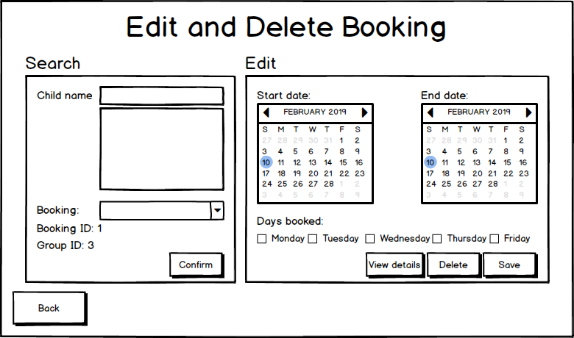

(c)

(ac)

(ab)

(z)

(w)

(m)

(b)

(d)

(n)

(e)

(f)

(g)

(i)

(h)

(o)

(x)

(p)

(r)

(s)

(y)

(t)

(v)

(l)

(u)

(q)

(k)

(j)

(aa)

#### Labels

|  |  |  |  |  |  |
| --- | --- | --- | --- | --- | --- |
| Letter | Control type | Name | Properties | Requirement | Algorithm number |
| (a) | Label | lblEditAndDeleteBooking | ForeColour: DarkOrange |  |  |
| (b) | lblSearchBookings |  |  |
| (c) | lblEditBooking |  |  |
| (d) | lblChildName | ForeColour: Turquoise |  |  |
| (e) | lblBookingDates |  |  |
| (f) | lblBookingIDLabel |  |  |
| (g) | lblGroupIDLabel |  |  |
| (h) | lblBookingID |  |  |
| (i) | lblGroupID |  |  |
| (j) | lblStartDate |  |  |
| (k) | lblEndDate |  |  |
| (l) | lblDaysBooked |  |  |
| (m) | Text box | txtChildName |  |  |  |
| (n) | List box | lstChildName |  |  | 2 |
| (o) | Combo box | cmbBookingDates | Drop down style: DropDownList |  | 3 |
| (p) | Month calendar | calStartDate | MaxSelectionCount: 1 |  |  |
| (q) | calEndDate |  |  |
| (r) | Check box | chkMonday | ForeColour: Yellow |  |  |
| (s) | chkTuesday |  |  |
| (t) | chkWednesday |  |  |
| (u) | chkThursday |  |  |
| (v) | chkFriday |  |  |
| (w) | Button | btnBack | ForeColour: Turquoise  BackColour: 0, 64, 0 |  | 1 |
| (x) | btnConfirm |  | 4 |
| (y) | btnViewDetails |  | 5 |
| (z) | btnSaveChanges |  | 7 |
| (aa) | btnDeleteBooking | ForeColour: Black  BackColour: Red | 16 | 6 |
| (ab) | Panel | panSearchBookings | BackColour: 0, 50, 0 |  |  |
| (ac) | panEditBooking | BackColour: 0, 50, 0  Enabled: False |  |  |

#### Algorithms

*1: btnBack clicked event*

When btnBack is clicked

Close current form and load Creche Menu Form

*2: lstChildName selected index changed event*

When lstChildName selected index is changed

Populate cmbBookingDates with all bookings of the child selected

*3: cmbBookingDates selected index changed event*

When cmbBookingDates selected index is changed

Set selected booking object to the booking selected

*4: btnConfirm clicked event*

When btnConfirm is clicked

Enable panEditBooking

Fill the selected booking details into the calendars and text boxes

If start date of selected booking is not at least one day in the future

Disable calStartDate, calEndDate, all check boxes and btnSaveChanges

*5: btnViewDetails clicked event*

When btnViewDetails is clicked

Load Edit Booking View Details Form, passing in the selected booking object

*6: btnDeleteBooking clicked event*

When btnDeleteBooking is clicked

Set deleted field of selected booking to true and update in the database

Disable panEditBooking

*7: btnSaveChanges clicked event*

When btnSaveChanges is clicked

If all validations are met

Set the details of the selected booking to the selected details and update in the database

### Edit Booking View Details Form

#### Diagram

(a)

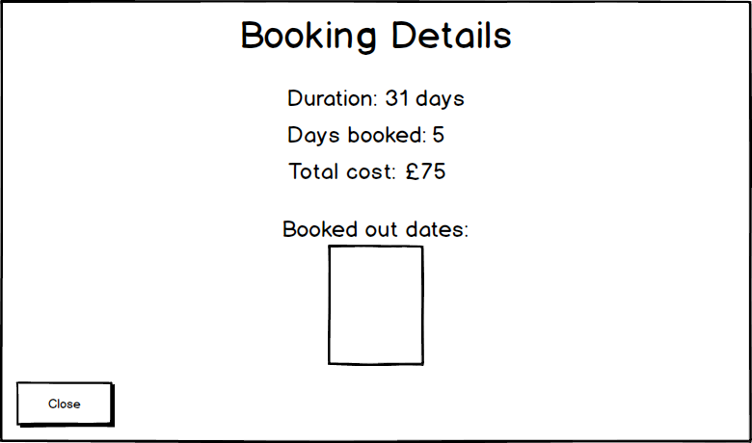

(b)

(c)

(d)

(h)

(g)

(f)

(e)

(i)

(j)

#### Labels

|  |  |  |  |  |  |
| --- | --- | --- | --- | --- | --- |
| Letter | Control type | Name | Properties | Requirement | Algorithm number |
| (a) | Label | lblBookingDetails | ForeColour: DarkOrange  BackColour: 0, 64, 0 |  |  |
| (b) | lblDurationLabel | ForeColour: Turquoise  BackColour: 0, 64, 0 |  |  |
| (c) | lblDaysBookedLabel |  |  |
| (d) | lblTotalCostLabel |  |  |
| (e) | lblBookingDuration |  |  |
| (f) | lblDaysBooked |  |  |
| (g) | lblTotalCost |  |  |
| (h) | lblBookedOutDates |  |  |
| (i) | List box | lstSelectedBookedOutDates |  |  |  |
| (j) | Button | btnClose | ForeColour: Turquoise  BackColour: 0, 64, 0 |  | 1 |

#### Algorithms

*1: btnClose clicked event*

When btnClose is clicked

Close current form

*2: Form load event*

When form loads

Assign details to their respective labels and list box

### Edit and Delete Parent Form

#### Diagram

(a)

(g)

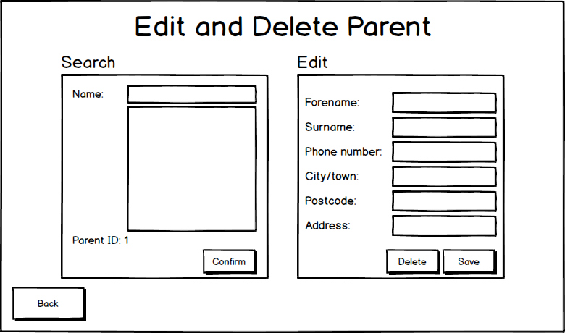

(w)

(u)

(v)

(z) 

(r)

(q) 

(p)

(o)

(n)

(m)

(h)

(d)

(b)

(x)

(j)

(k)

(l)

(i)

(y)

(f)

(e)

(t)

(s)

(c)

#### Labels

|  |  |  |  |  |  |
| --- | --- | --- | --- | --- | --- |
| Letter | Control type | Name | Properties | Requirement | Algorithm number |
| (a) | Label | lblEditAndDelete | ForeColour: DarkOrange  BackColour: 0, 64, 0 |  |  |
| (b) | lalSearchParents |  |  |
| (c) | lblEditParent |  |  |
| (d) | lblParentName | ForeColour: Turquoise  BackColour: 0, 50, 0 |  |  |
| (e) | lblParentIDLabel |  |  |
| (f) | lblParentID |  |  |
| (g) | lblParentForename |  |  |
| (h) | lblParentSurname |  |  |
| (i) | lblParentTelNo |  |  |
| (j) | lblParentCity |  |  |
| (k) | lblParentPostcode |  |  |
| (l) | lblParentAddress |  |  |
| (m) | Text box | txtParentForename |  |  |  |
| (n) | txtParentSurname |  |  |  |
| (o) | txtParentTelNo |  |  |  |
| (p) | txtParentCity |  |  |  |
| (q) | txtParentPostcode |  |  |  |
| (r) | txtParentAddress |  |  |  |
| (s) | txtParentName |  |  |  |
| (t) | List box | lstParentName |  |  | 2 |
| (u) | Button | btnBack | ForeColour: Turquoise  BackColour: 0, 64, 0 |  | 1 |
| (v) | btnConfirm |  | 3 |
| (w) | btnSaveChanges |  | 5 |
| (x) | btnDeleteParent | ForeColour: Black  BackColour: Red | 16 | 4 |
| (y) | Panel | panSearchParents | BackColour: 0, 50, 0 |  |  |
| (z) | panEditParent | BackColour: 0, 50, 0  Enabled: False |  |  |

#### Algorithms

*1: btnBack clicked event*

When btnBack is clicked

Close current form and load Crèche Menu Form

*2: lstParentName selected index changed event*

When lstParentName selected index is changed

Set selected parent object to the parent selected

*3: btnConfirm clicked event*

When btnConfirm is clicked

Enable panEditParent

Fill details of the selected parent into the text boxes in panEditParent

*4: btnDeleteParent clicked event*

When btnDeleteParent is clicked

Set deleted field of selected parent to true and update in the database

Foreach child

If parent ID is equal to ID of selected parent

Foreach booking

If child ID of booking is equal to ID of child and booking start date is after current date

Set deleted field of booking to true and update in the database

Set deleted field of child to true and update in the database

Disable panEditParent

*5: btnSaveChanges clicked event*

When btnSaveChanges is clicked

If all validations are met

Set the selected parent details to the selected details and update in the database

### Edit and Delete Child Form

#### Diagram

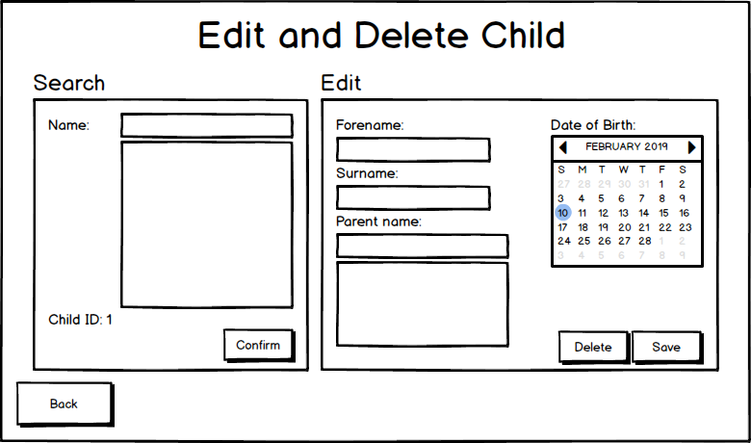

(c)

(a)

(m)

(j)

(g)

(l)

(q)

(n)

(t)

(u)

(w)

(p)

(i)

(h)

(s)

(r)

(f)

(e)

(o)

(v)

(k)

(d)

(b)

#### Labels

|  |  |  |  |  |  |
| --- | --- | --- | --- | --- | --- |
| Letter | Control type | Name | Properties | Requirement | Algorithm number |
| (a) | Label | lblEditDeleteChild | ForeColour: DarkOrange  BackColour: 0, 64, 0 |  |  |
| (b) | lblSearchChildren |  |  |
| (c) | lblEditChild |  |  |
| (d) | lblChildName | ForeColour: Turquoise  BackColour: 0, 50, 0 |  |  |
| (e) | lblChildIDLabel |  |  |
| (f) | lblChildID |  |  |
| (g) | lblChildForename |  |  |
| (h) | lblChildSurname |  |  |
| (i) | lblChildParentName |  |  |
| (j) | lblChildDateOfBirth |  |  |
| (k) | Text box | txtChildName |  |  |  |
| (l) | txtChildForename |  |  |  |
| (m) | txtChildSurname |  |  |  |
| (n) | txtChildParentName |  |  |  |
| (o) | List box | lstChildName |  |  | 2 |
| (p) | lstChildParentName |  |  |  |
| (q) | Month calendar | calChildDateOfBirth | MaxSelectionCount: 1 |  |  |
| (r) | Button | btnBack | ForeColour: Turquoise  BackColour: 0, 64, 0 |  | 1 |
| (s) | btnConfirm |  | 3 |
| (t) | btnSaveChanges |  | 5 |
| (u) | btnDeleteChild | ForeColour: Black  BackColour: Red | 16 | 4 |
| (v) | Panel | panSearchChildren | BackColour: 0, 50, 0 |  |  |
| (w) | panEditChild | BackColour: 0, 50, 0  Enabled: False |  |  |

#### Algorithms

*1: btnBack clicked event*

When btnBack is clicked

Close current form and load Crèche Menu Form

*2: lstChildName selected index changed event*

When lstChildName selected index is changed

Set selected parent object to the parent selected

*3: btnConfirm clicked event*

When btnConfirm is clicked

Enable panEditChild

Fill details of the selected child into the corresponding controls in panEditChild

*4: btnDeleteChild clicked event*

When btnDeleteChild is clicked

Set deleted field of selected child to true and update in the database

Foreach booking

If child ID of booking is equal to ID of child and booking start date is after current date

Set deleted field of booking to true and update in the database

Disable panEditChild

*5: btnSaveChanges clicked event*

When btnSaveChanges is clicked

If all validations are met

Set the selected child details to the selected details and update in the database

### Assign Staff Form

#### Diagram

(a)

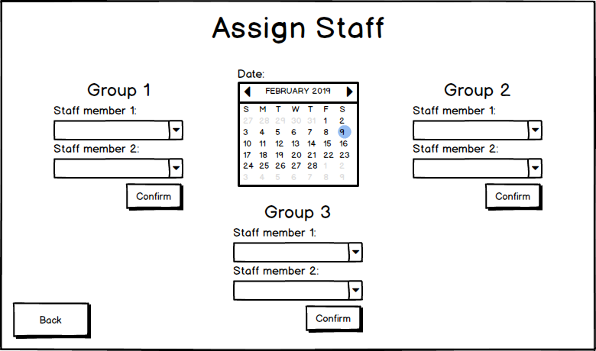

(m)

(b)

(e)

(k)

(f)

(l)

(r)

(s)

(i)

(j)

(p)

(u)

(o)

(d)

(n)

(t)

(h)

(g)

(c)

(q)

#### Labels

|  |  |  |  |  |  |
| --- | --- | --- | --- | --- | --- |
| Letter | Control type | Name | Properties | Requirement | Algorithm number |
| (a) | Label | lblAssignStaff | ForeColour: DarkOrange  BackColour: 0, 64, 0 |  |  |
| (b) | lblGroup1 |  |  |
| (c) | lblGroup2 |  |  |
| (d) | lblGroup3 |  |  |
| (e) | lblGroup1Staff1 | ForeColour: Turquoise  BackColour: 0, 64, 0 |  |  |
| (f) | lblGroup1Staff2 |  |  |
| (g) | lblGroup2Staff1 |  |  |
| (h) | lblGroup2Staff2 |  |  |
| (i) | lblGroup3Staff1 |  |  |
| (j) | lblGroup3Staff2 |  |  |
| (k) | Combo box | cmbGroup1Staff1 | Drop down style: DropDownList | 3 |  |
| (l) | cmbGroup1Staff2 | 3 |  |
| (m) | cmbGroup2Staff1 | 3 |  |
| (n) | cmbGroup2Staff2 | 3 |  |
| (o) | cmbGroup3Staff1 | 3 |  |
| (p) | cmbGroup3Staff2 |  | 3 |
| (q) | Month calendar | calDate | MaxSelectionCount: 1 | 17 | 2 |
| (r) | Button | btnBack | ForeColour: Turquoise  BackColour: 0, 64, 0 |  | 1 |
| (s) | btnGroup1Assign | 17 | 4 |
| (t) | btnGroup2Assign | 17 | 4 |
| (u) | btnGroup3Assign | 17 | 4 |

#### Algorithms

*1: btnBack clicked event*

When btnBack is clicked

Close current form and load Crèche Menu Form

*2: calDate date changed event*

When calDate selected date is changed

Clear all combo boxes

Populate combo boxes with staff members who have been assigned to each group on the selected date

Disable the populated combo boxes

*3: cmbGroup1Staff1, cmbGroup1Staff2, cmbGroup2Staff1, cmbGroup2Staff2, cmbGroup3Staff1, cmbGroup3Staff2 selected index changed event*

When selected index is changed on any combo box

Remove the selected staff member from all combo boxes except for the one in which it is selected

*4: btnGroup1Assign, btnGroup2Assign, btnGroup3Assign clicked event*

When any assign button is clicked

If two different staff members are selected in the combo boxes of that group

Save new staff group for each of the two staff members in that group’s combo boxes

### View Data Form

#### Diagram

(a)

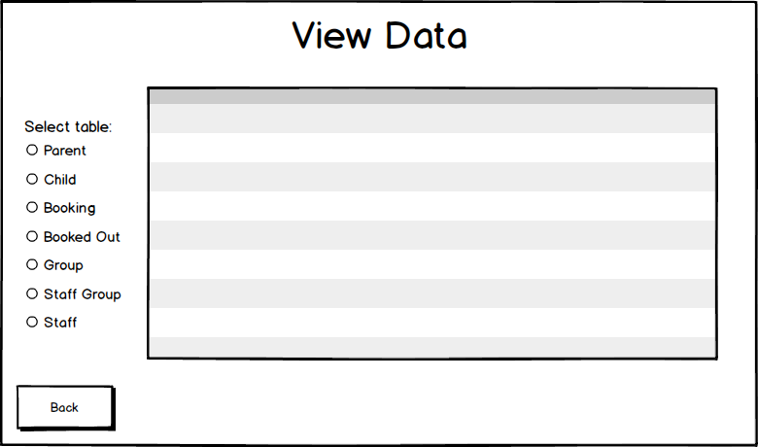

(f)

(e)

(d)

(c)

(b)

(h)

(g)

(i)

(k)

(j)

#### Labels

|  |  |  |  |  |  |
| --- | --- | --- | --- | --- | --- |
| Letter | Control type | Name | Properties | Requirement | Algorithm number |
| (a) | Label | lblViewData | ForeColour: DarkOrange  BackColour: 0, 64, 0 |  |  |
| (b) | lblSelectTable | ForeColour: Turquoise  BackColour: 0, 64, 0 |  |  |
| (c) | Radio buttons | radParent | ForeColour: Yellow  BackColour: 0, 64, 0 | 21 | 2 |
| (d) | radChild | 21 | 3 |
| (e) | radBooking | 21 | 4 |
| (f) | radBookedOut | 21 | 5 |
| (g) | radGroup | 21 | 6 |
| (h) | radStaffGroup | 21 | 7 |
| (i) | radStaff | 21 | 8 |
| (j) | Data grid view | dgvTables | BackGroundColour: AppWorkSpace | o, 21, 14 |  |
| (k) | Button | btnBack | ForeColour: Turquoise  BackColour: 0, 64, 0 |  | 1 |

#### Algorithms

*1: btnBack clicked event*

When btnBackis clicked

Close current form and load Creche Menu Form

*2: radParent check changed event*

WhenradParent check ischanged

Add in columns of Parent table to data grid view

For each parent in Parent table

Add row of that parent’s details

*3: radChild check changed event*

WhenradChild check ischanged

Add in columns of Child table to data grid view

For each child in Child table

Add row of that child’s details

*4: radBooking check changed event*

WhenradBooking check ischanged

Add in columns of Booking table to data grid view

For each booking in Booking table

Add row of that booking’s details

*5: radBookedOut check changed event*

WhenradBookedOut check ischanged

Add in columns of BookedOuttable to data grid view

For each booked out in BookedOuttable

Add row of that booked out’s details

*6: radGroup check changed event*

WhenradGroup check ischanged

Add in columns of Group table to data grid view

For each group in Group table

Add row of that group’s details

*7: radStaffGroup check changed event*

WhenradStaffGroup check ischanged

Add in columns of StaffGroup table to data grid view

For each staff group in StaffGroup table

Add row of that staff group’s details

*8: radStaff check changed event*

WhenradStaff check ischanged

Add in columns of Staff table to data grid view

For each staff in Staff table

Add row of that staff group’s details

### Report Form

#### Diagram

(c)

(b)

(a)

#### Labels

|  |  |  |  |  |  |
| --- | --- | --- | --- | --- | --- |
| Letter | Control type | Name | Properties | Requirement | Algorithm number |
| (a) | Label | lblReport | ForeColour: DarkOrange  BackColour: 0, 64, 0 |  |  |
| (b) | Report viewer | rep1 |  | 25 |  |
| (c) | Button | btnBack | ForeColour: Turquoise  BackColour: 0, 64, 0 |  | 1 |

#### Algorithms

*1: btnBack clicked event*

When btnBack is clicked

Close current form and load Creche Menu Form

*2: Form load event*

When form is loaded

Fill data table adapter

Refresh report

# **Testing**

## **Introduction**

In this section, I have outlined instructions on how to reproduce every test, with my aim being that anyone can carry out the test plan, no matter their programming experience. I have included screenshot(s) of all my tests, providing as much evidence as possible that the result of each test is as stated in the test plan.

## **Testing Strategy**

I began my testing with the menu bar, testing if the user can close the program and if every form can be opened from each form. I also had to test if a message box informs the user of which aspects of the system I did not cover, such as the add staff functionality. I then proceeded to test every button on Main Menu Form, and subsequently every button on Crèche Menu Form, ensuring that they either take the user to the corresponding form or they display a message box explaining that the current system does not facilitate such functionality due to time constraints. Next, I advanced to adding a booking, testing first Booking Select Child Form and then Booking Select Dates form. In Booking Select Child Form, I covered many validations that are also found in other forms, for example, ensuring that the user cannot input numbers into name text boxes or letters into phone number text boxes. For this reason, I merged many tests into one, with instructions on how to carry out the text for each specific form that you wish to test. This cut down the number of tests, and hopefully made the test plan easier to follow. I also tested all aspects of the parent search functionality (of which I merged into one text if other forms did the same thing) and the adding and selecting new and existing parents and children functionality. The next form was perhaps the most complicated; Booking Select Dates Form contained some of the most complex features of the entire program, mostly relating to booked out dates or the calculation of booking details such as number of days booked, all of which I thoroughly tested, as well as other aspects such as validations and making a booking. The next two forms, Add Parent Form and Add Child Form were very simple as much of their functionality had already been tested when I was merging repeated tests on the Booking Select Child Form. I proceeded by testing the edit and delete forms, beginning with Edit and Delete Booking Form, before testing Edit and Delete Parent Form and Edit and Delete Child Form. I covered the search child functionality in Edit and Delete Booking Form, which I merged with the same tests I carried out on Edit and Delete Child Form, as well as testing every aspect of selecting bookings from the combo box and which bookings can and cannot be deleted. I also tested the view details functionality, edit booking validations, editing bookings and deleting bookings. On Edit and Delete Parent Form I tested all validations, edit parent functionality and delete parent functionality, including the complexities of the parents’ children being deleted too and when the bookings of those children are deleted and when they are not. The same sort of tests were carried out on Edit and Delete Child form, due to the similar nature of the two forms. Next, I moved on to Assign Staff Form, another form ripe with complex functionality. Here I mainly tested every possible way of selecting and deselecting staff members in the combo boxes of each group, ensuring that the same staff member cannot be selected for more than one shift on a given day. On View Data Form, I tested if all data displayed was correct, and whether each table’s columns stayed in the same position after viewing different tables. The final form I tested was Report Form, where I ensured that all booking date in the table was correct and that the statistics were calculated correctly.

Please find below a table that directs you to the core aspects of my testing based on the number of the test in the test plan.

|  |  |
| --- | --- |
|  | Test No |
| * Menu strip | 1 - 18 |
| * Main Menu Form | 19 - 20 |
| * Crèche Menu Form | 21 - 22 |
| * Booking Select Child Form | 23 - 43 |
| * + Validations | 23 - 30 |
| * + List box/search parents functionality | 31 - 34 |
| * + Adding and selecting parents and children | 35 - 43 |
| * Booking Select Dates Form | 44 - 62 |
| * Validations | 46 - 49 |
| * + No overlapping bookings of same child | 49 |
| * Booked out dates | 50 - 53 |
| * + Booked out dates emboldened on calendars | 50 |
| * + Booked out dates of current booking added to list box | 51 |
| * + Booked out dates not factored into price or days booked | 52 - 53 |
| * Booking details | 54 - 58 |
| * + Discounts are calculated and applied accordingly | 56 - 58 |
| * Add Parent Form | 23 - 30, 35, 63, |
| * + Validations | 23 - 30 |
| * + Create parent | 35 |
| * Add Child Form | 23, 31 - 34, 38 - 39, 64 - 65 |
| * + Validations | 23, 38 - 39 |
| * + Create child | 65 |
| * Edit and Delete Booking Form | 66 - 74, 79 - 79 |
| * + Validation | 77 |
| * + Bookings in past cannot be edited | 73 |
| * + Bookings in future can be edited | 76 |
| * + All bookings can be deleted | 78 |
| * Edit and Delete Parent Form | 23 - 24, 26, 28, 31 - 34, 80 - 90 |
| * + Validation | 81 - 84 |
| * + Edit parent | 86 |
| * + Delete parent | 87 |
| * Edit and Delete Child Form | 23, 67 - 69, 91 - 98 |
| * + Validation | 92 - 93 |
| * + Edit child | 94 |
| * + Delete child | 95 |
| * Assign Staff Form | 99 - 108 |
| * View Data Form | 109 - 116 |
| * Report Form | 117 - 120 |

## **Legacy Tests**

|  |  |  |  |  |  |  |  |
| --- | --- | --- | --- | --- | --- | --- | --- |
| **No** | **Form** | **Reason for Test** | **Requirement** | **User Action/**  **Test Data** | **Expected Outcome** | **Pass?**  **T/F** | **Corrective Action** |
| 1 | Edit and Delete Booking Form | Ensure correct booking details are displayed |  | (On Edit and Delete Booking Form) Select ‘Chris Shepard’ from combo box, select ‘From 26-03-19 to 27-04-19’ then click ‘View details’ button | ‘32 days’ should be displayed beside ‘Booking duration:’, ‘7’ should be displayed beside ‘Days booked:’, ‘£105’ should be displayed beside ‘Unavailable dates:’ and ‘28/03/2019’, ‘03/04/2019’ and ‘04/04/2019’ should populate the list box | F | I ensured that the booked dates of the selected booking are not added to the selected dates list when in the method that identifies all booked out dates |
| 2 | View Data Form | Ensure that correct data for group table is displayed | l | Click ‘Group’ radio button | All correct data from group table will be shown | F | I changed the SQL by adding square brackets around ‘Group’ |
| 3 | Booking Select Child Form | Ensure that the user can search for a parent then select them from the list box |  | Input ‘m’ into the parent name text box then select ‘Manus McColgan’ from the list box below | ‘Manus McColgan’ will appear under parent selected label and child info panel will become enabled | F | I added a try catch, catching all NullReferenceExceptions |

### Legacy Test Screenshots

Test 1 - Failed

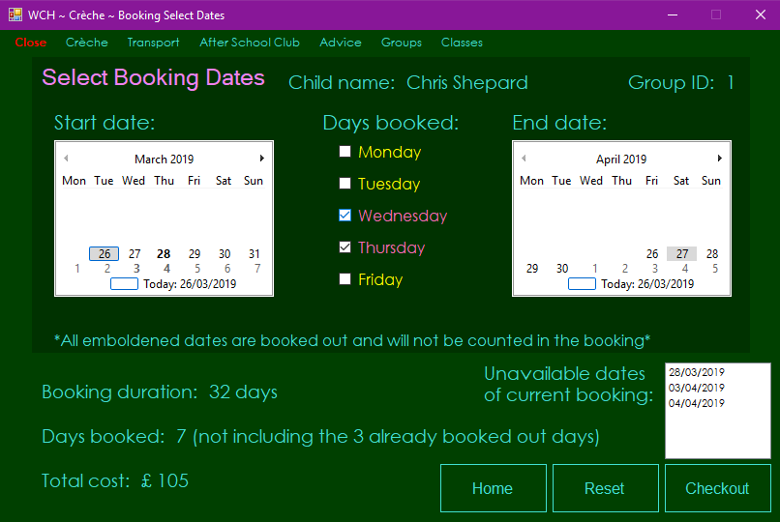

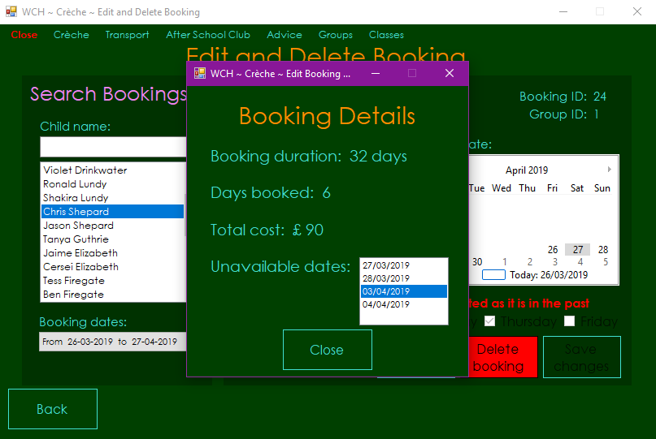

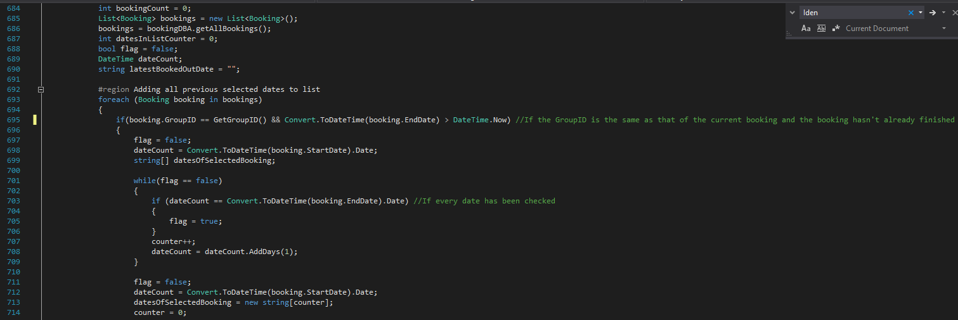

Test 1 - Fixed

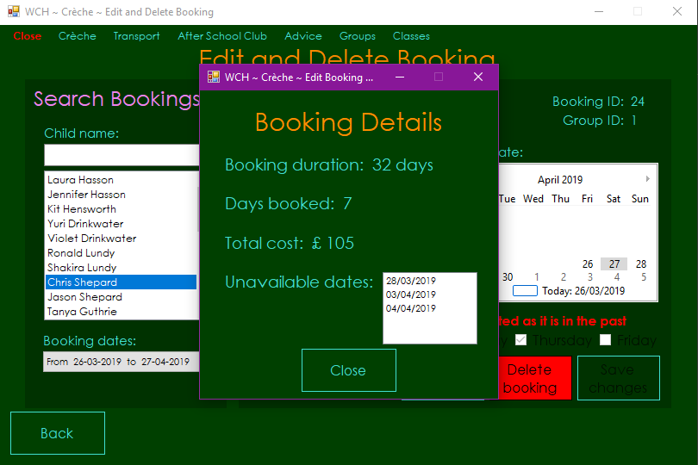

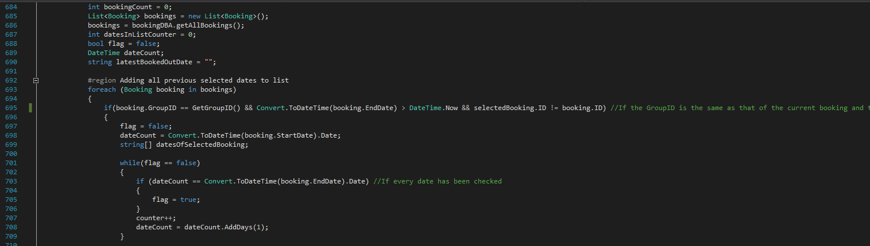

Test 2 - Failed

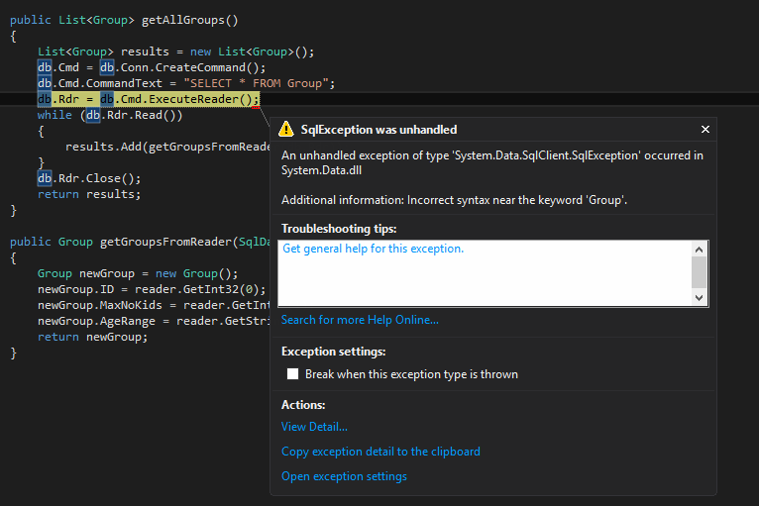

Test 2 - Fixed

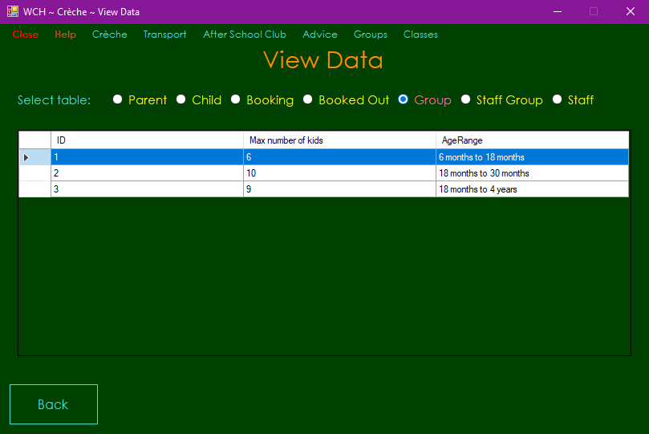

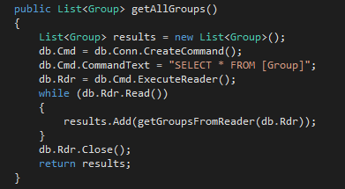

Test 3 - Failed

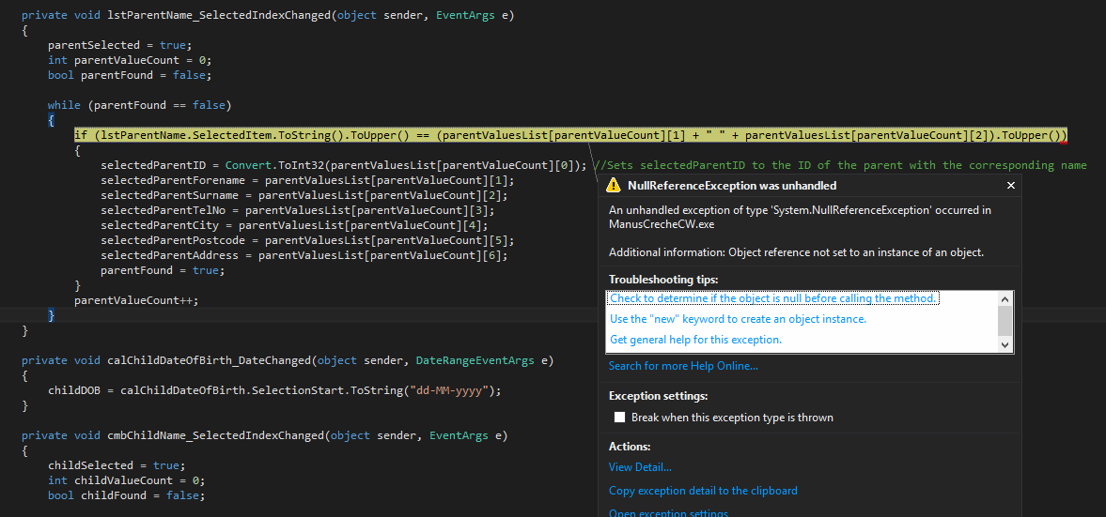

Test 3 - Fixed

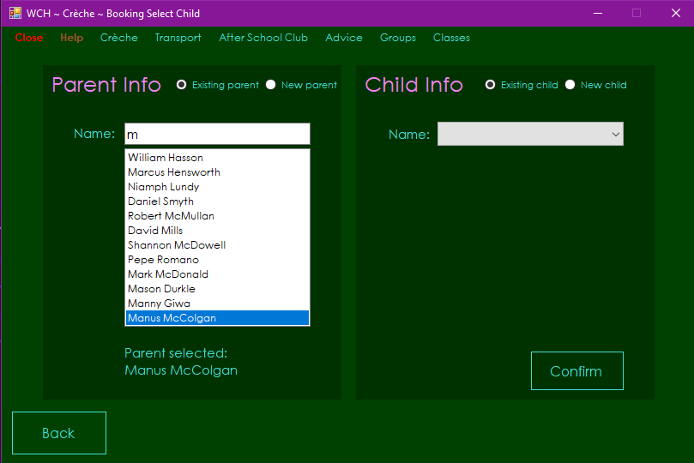

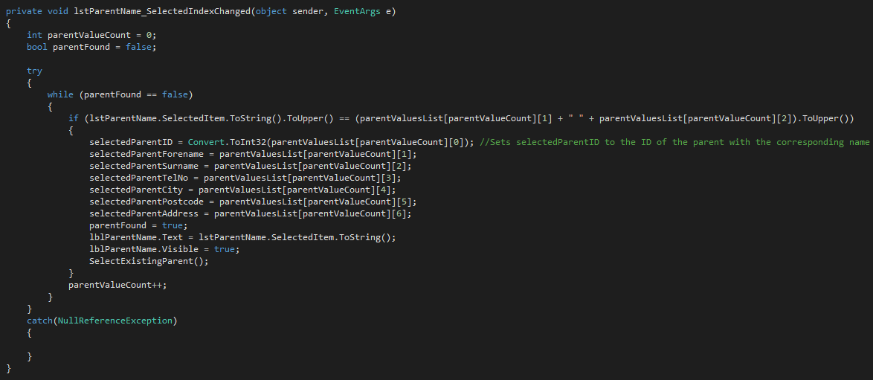

## **Test Plan**

|  |  |  |  |  |  |  |  |
| --- | --- | --- | --- | --- | --- | --- | --- |
| **No** | **Form** | **Reason for Test** | **Requirement** | **User Action/**  **Test Data** | **Expected Outcome** | **Pass?**  **T/F** | **Corrective Action** |
| 1 | All forms except Edit Booking View Details Form | Ensure that the program can be closed the via close button on menu strip | p | Click ‘Close’ button on menu strip then click ‘Yes’ on message box that appears | The program will close | T |  |
| 2 | All forms except Edit Booking View Details Form | Ensure that selecting the ‘No’ option keeps the program open and returns the user to the form they were on | p | Click ‘Close’ button on menu strip then click ‘No’ on message box that appears | The message box will close | T |  |
| 3 | All forms except Edit Booking View Details Form | Ensure that a add booking button on menu strip works | p | Click ‘Crèche’ on menu strip then enter ‘Add’ button with cursor and click ‘Booking’ | Booking Select Child Form will load, and current form will close | T |  |
| 4 | All forms except Edit Booking View Details Form | Ensure that a add parent button on menu strip works | p | Click ‘Crèche’ on menu strip then enter ‘Add’ button with cursor and click ‘Parent’ | Add Parent Form will load, and current form will close | T |  |
| 5 | All forms except Edit Booking View Details Form | Ensure that a add child button on menu strip works | p | Click ‘Crèche’ on menu strip then enter ‘Add’ button with cursor and click ‘Child’ | Add Child Form will load, and current form will close | T |  |
| 6 | All forms except Edit Booking View Details Form | Ensure that a add staff button on menu strip works | p | Click ‘Crèche’ on menu strip then enter ‘Add’ button with cursor and click ‘Staff’ | A message box will appear with the text, “This functionality has not been added due to the fact that the same skills were shown elsewhere” | T |  |
| 7 | All forms except Edit Booking View Details Form | Ensure that edit booking button on menu strip works | p | Click ‘Crèche’ on menu strip then enter ‘Edit and Delete’ button with cursor and click ‘Booking’ | Edit and Delete Booking Form will load, and current form will close | T |  |
| 8 | All forms except Edit Booking View Details Form | Ensure that edit parent button on menu strip works | p | Click ‘Crèche’ on menu strip then enter ‘Edit and Delete’ button with cursor and click ‘Parent’ | Edit and Delete Parent Form will load, and current form will close | T |  |
| 9 | All forms except Edit Booking View Details Form | Ensure that edit child button on menu strip works | p | Click ‘Crèche’ on menu strip then enter ‘Edit and Delete’ button with cursor and click ‘Child’ | Edit and Delete Child Form will load, and current form will close | T |  |
| 10 | All forms except Edit Booking View Details Form | Ensure that edit staff button on menu strip works | p | Click ‘Crèche’ on menu strip then enter ‘Edit and Delete’ button with cursor and click ‘Staff’ | A message box will appear with the text, “This functionality has not been added due to the fact that the same skills were shown elsewhere” | T |  |
| 11 | All forms except Edit Booking View Details Form | Ensure that assign staff button on menu strip works | p | Click ‘Crèche’ on menu strip then click ‘Assign Staff’ button | Assign Staff Form will load, and current form will close | T |  |
| 12 | All forms except Edit Booking View Details Form | Ensure that view data button on menu strip works | p | Click ‘Crèche’ on menu strip then click ‘View Data’ button | View Data Form will load, and current form will close | T |  |
| 13 | All forms except Edit Booking View Details Form | Ensure that report button on menu strip works | p | Click ‘Crèche’ on menu strip then click ‘Report’ button | Report Form will load, and current form will close | T |  |
| 14 | All forms except Edit Booking View Details Form | Ensure that transport button on menu strip works | p | Click ‘Transport’ on menu strip | A message box will appear with the text, “I have not covered this aspect of the case study as I only had time to implement the crèche subsystem” | T |  |
| 15 | All forms except Edit Booking View Details Form | Ensure that after school club button on menu strip works | p | Click ‘After School Club’ on menu strip | A message box will appear with the text, “I have not covered this aspect of the case study as I only had time to implement the crèche subsystem” | T |  |
| 16 | All forms except Edit Booking View Details Form | Ensure that advice button on menu strip works | p | Click ‘Advice’ on menu strip | A message box will appear with the text, “I have not covered this aspect of the case study as I only had time to implement the crèche subsystem” | T |  |
| 17 | All forms except Edit Booking View Details Form | Ensure that groups button on menu strip works | p | Click ‘Groups’ on menu strip | A message box will appear with the text, “I have not covered this aspect of the case study as I only had time to implement the crèche subsystem” | T |  |
| 18 | All forms except Edit Booking View Details Form | Ensure that classes button on menu strip works | p | Click ‘Classes’ on menu strip | A message box will appear with the text, “I have not covered this aspect of the case study as I only had time to implement the crèche subsystem” | T |  |
| 19 | Main Menu Form | Ensure that user can navigate to Crèche Menu Form via crèche button |  | Click ‘Crèche’ button | Crèche Menu Form will load, and current form will close | T |  |
| 20 | Main Menu Form | Ensure that message boxes appear explaining why the respective button does not have any functionality when any button other than crèche button is clicked |  | Click every button that isn’t ‘Crèche’ button | A message box will appear with the text, “I have not covered this aspect of the case study as I only had time to implement the crèche subsystem” | T |  |
| 21 | Crèche Menu Form | Ensure that user can navigate to each form by clicking the respective buttons, excluding staff buttons in add panel and edit and delete panel | n | Click every button that isn’t ‘Staff’ button in ‘Add’ panel or ‘Staff’ button in edit and delete panel | The respective form will be loaded | T |  |
| 22 | Crèche Menu Form | Ensure that message box appears, explaining to the user why the respective functionality has not been implemented when add staff or edit and delete staff buttons are clicked | n | Click ‘Staff’ button in add panel and ‘Staff’ button in edit and delete panel | A message box will appear with the text, ‘This functionality has not been added due to the fact that the same skills were shown elsewhere’ on each click | T |  |
| 23 | Booking Select Child Form, Add Parent Form, Add Child Form, Edit and Delete Parent Form, Edit and Delete Child Form | Ensure that user cannot input numbers into text boxes for fields which cannot contain numbers |  | Booking Select Child Form: Input ‘1’ into name text box with existing parent checked, click new parent radio button and input ‘1’ into forename, surname and city/town text boxes. Then input ‘Manus’ into forename textbox, ‘McColgan’ into the surname text box, ‘07907023822’ into the phone number text box, ‘14 Rosetta Park’ into the address text box, ‘BT7 3HL’ into the postcode text box and ‘Belfast’ into the city/town text box then click ‘Confirm’ button. Input ‘1’ into the forename and surname text boxes in the child info panel  Add Parent Form: Input ‘1’ into forename, surname and city/town text boxes  Add Child Form: Input ‘1’ into parent name, forename and surname text boxes  Edit and Delete Parent Form: Click ‘William Hasson’ in list box in search parents panel and input ‘1’ into forename, surname and city/town text boxes on the edit patent panel  Edit and Delete Child Form: Select ‘Ross Power’ from list box in search children panel and input ‘1’ into parent name, forename and surname text boxes on the edit child panel | Booking Select Child Form, Edit and Delete Parent Form and Edit and Delete Child Form: No text will be entered into the text box when ‘1’ is input  Add Parent Form and Add Child Form: No text will be entered into the text box when ‘1’ is input, and a red label will become visible under the text box with the text, ‘Only letters may be input’ | T |  |
| 24 | Booking Select Child Form, Add Parent Form, Edit and Delete Parent Form | Ensure that user cannot input non-numerical characters into text boxes that take a phone number |  | Booking Select Child Form: Select new parent radio button then input ‘p’ into phone number text box  Add Parent Form: Insert ‘p’ into phone number text box  Edit and Delete Parent Form: Click ‘William Hasson’ in the list box on search parents panel then insert ‘p’ into phone number text box | Booking Select Child Form and Edit and Delete Parent Form: No text will be entered into the text box  Add Parent Form: No text will be entered into the text box and a red label will become visible below with the text, ‘Only numbers may be input’ | T |  |
| 25 | Booking Select Child Form, Add Parent Form | Ensure that user cannot create parent without first filling in every text box |  | Booking Select Child Form: Select new parent radio button then input ‘David’ into forename textbox, ‘McColgan’ into the surname text box, ‘07907023822’ into the phone number text box, ‘14 Rosetta Park’ into the address text box and ‘BT7 3HL’ into the postcode text box, leaving the city/town text box blank then click ‘Confirm’ button  Add Parent Form: Input ‘Manus’ into forename textbox, ‘McColgan’ into the surname text box, ‘07907023822’ into the phone number text box, ‘14 Rosetta Park’ into the address text box and ‘BT7 3HL’ into the postcode text box, leaving the city/town text box blank then click ‘Save Parent’ button  Add Parent Form (different button): Input ‘Manus’ into forename textbox, ‘McColgan’ into the surname text box, ‘07907023822’ into the phone number text box, ‘14 Rosetta Park’ into the address text box and ‘BT7 3HL’ into the postcode text box, leaving the city/town text box blank then click ‘Save and add child’ button | An error label with the text, ‘Please fill in every box’ will become visible | T |  |
| 26 | Booking Select Child Form, Add Parent Form, Edit and Delete Parent Form | Ensure that user cannot enter a phone number that is too long |  | Booking Select Child Form: Select new parent radio button then input ‘1234567890123456’ into phone number text box  Add Parent Form: Input ‘1234567890123456’ into phone number text box  Edit and Delete Parent Form: Select ‘William Hasson’ from list box on search parents panel, remove all text then input ‘1234567890123456’ into phone number text box | The text box will only allow ‘123456789012345’ to be input | T |  |
| 27 | Booking Select Child Form, Add Parent Form | Ensure that the user cannot create a parent with a phone number that is too short |  | Booking Select Child Form: Select new parent radio button then input ‘Kelly’ into forename text box, ‘Anderson’ into surname text box, ‘1234567’ into phone number text box, ‘300 Memory Lane’ into address text box, ‘BT8 3JL’ into postcode text box and ‘Lurgan’ into city/town text box then click ‘Confirm’ button  Add Parent Form: input ‘Kelly’ into forename text box, ‘Anderson’ into surname text box, ‘1234567’ into phone number text box, ‘300 Memory Lane’ into address text box, ‘BT8 3JL’ into postcode text box and ‘Lurgan’ into city/town text box then click ‘Save parent’ button  Add Parent Form (different button): input ‘Kelly’ into forename text box, ‘Anderson’ into surname text box, ‘1234567’ into phone number text box, ‘300 Memory Lane’ into address text box, ‘BT8 3JL’ into postcode text box and ‘Lurgan’ into city/town text box then click ‘Save and add child’ button | A label with the text, ‘Phone number is too short’ will become visible | T |  |
| 28 | Booking Select Child Form, Add Parent Form, Edit and Delete Parent Form | Ensure that the user cannot enter a postcode that is too long |  | Booking Select Child Form: Select new parent radio button then input ‘123456789’ into postcode text box  Add Parent Form: Input ‘123456789’ into postcode text box  Edit and Delete Parent Form: Select ‘William Hasson’ from list box on search parents panel, remove all text then input ‘123456789’ into postcode text box | The text box will only allow ‘12345678’ to be input | T |  |
| 29 | Booking Select Child Form, Add Parent Form | Ensure that the user cannot create a parent with a postcode that is too short |  | Booking Select Child Form: Select new parent radio button then input ‘Chris’ into forename text box, ‘Brown’ into surname text box, ‘1263454674’ into phone number text box, ’66 Howard Road’ into address text box, ‘1234’ into postcode text box and ‘Belfast’ into city/town text box then click ‘Confirm’ button  Add Parent Form: Input ‘Chris’ into forename text box, ‘Brown’ into surname text box, ‘1263454674’ into phone number text box, ’66 Howard Road’ into address text box, ‘1234’ into postcode text box and ‘Belfast’ into city/town text box then click ‘Save parent’ button  Add Parent Form (different button): Input ‘Chris’ into forename text box, ‘Brown’ into surname text box, ‘1263454674’ into phone number text box, ’66 Howard Road’ into address text box, ‘1234’ into postcode text box and ‘Belfast’ into city/town text box then click ‘Save and add child’ button | A label with the text ‘Postcode does not exist’ will become visible | T |  |
| 30 | Booking Select Child Form, Add Parent Form | Ensure that user cannot create a parent with the exact same details as an already existing parent |  | Booking Select Child Form: Select existing parent radio button then input ‘William’ into forename textbox, ‘Hasson’ into the surname text box, ‘07353746624’ into the phone number text box, ’99 West Street’ into the address text box, ‘BT6 3RF’ into the postcode text box and ‘Hollywood’ into the city/town text box then click ‘Confirm’ button  Add Parent Form: Input ‘William’ into forename textbox, ‘Hasson’ into the surname text box, ‘07353746624’ into the phone number text box, ’99 West Street’ into the address text box, ‘BT6 3RF’ into the postcode text box and ‘Hollywood’ into the city/town text box then click ‘Save parent’ button  Add Parent Form (different button): Input ‘William’ into forename textbox, ‘Hasson’ into the surname text box, ‘07353746624’ into the phone number text box, ’99 West Street’ into the address text box, ‘BT6 3RF’ into the postcode text box and ‘Hollywood’ into the city/town text box then click ‘Save and add child’ button | A label with the text, ‘Parent already exists’ will become visible | T |  |
| 31 | Booking Select Child Form, Add Child Form, Edit and Delete Parent Form | Ensure that every parent with a deleted field of ‘False’ displayed on the search/select parent list box when form is loaded | d | Load form | List box will display all parents from ‘Parent’ table which have a ‘Deleted’ field equal to ‘False’ in database (I cannot say the exact parents, as this will depend on which parents the examiner has added or deleted) | T |  |
| 32 | Booking Select Child Form, Add Child Form, Edit and Delete Parent Form | Ensure that search functionality displays the correct parents when the text has been changed in the search parents text box | d | Input ‘sh’ into search parents text box | List box will display ‘Natalia Shepard’ and ‘Shannon McDowell’ | T |  |
| 33 | Booking Select Child Form, Add Child Form, Edit and Delete Parent Form | Ensure that the selected parent from the list box is correctly identified (e.g. selected parent name is displayed beside parent selected label or correct parent details are filled into text boxes etc.) | d | Select ‘William Hasson’ from parents list box | Booking Select Child Form: ‘William Hasson’ will appear under parent selected label and child info panel will become enabled. ‘Laura Hasson’ and ‘Jennifer Hasson’ will populate the child name combo box  Add Child Form: ‘William Hasson’ will appear under parent selected label  Edit and Delete Parent Form: Edit parent panel will become enabled and William’s details (1, William, Hasson, 07353746624, 99 West Street, BT6 3RF, Hollywood) will populate their corresponding labels/text boxes | T |  |
| 34 | Booking Select Child Form, Add Child Form, Edit and Delete Parent Form | Ensure that all parents are redisplayed after text is input and then cleared from search parent text box | d | Input ‘z’ into search parents text box then press backspace | The only parent displayed in the list box will be ‘Karen Elizabeth’ when ‘z’ populates the search parents text box, but when it is removed all parents with a ‘Deleted’ attribute of ‘False’ will populate the list box | T |  |
| 35 | Booking Select Child Form, Add Parent Form | Ensure that a new parent can be created with valid data | a | Booking Select Child Form: Click new parent radio button then enter ‘Jack’ into forename text box, ‘Durkle’ into surname text box, ‘07526784399’ into phone number text box, ‘33 Garland Crescent’ into address textbox, ‘BT66 7UB’ into postcode text box and ‘Dollingstown’ into city text box, click ‘Confirm’ button then click ‘Ok’ on message box  Add Parent Form: Insert ‘Jason’ into forename text box, ‘McCartney’ into surname text box, ‘07583594047’ into phone number text box, ‘99 Preston Avenue’ into address text box, ‘BT5 3RH’ into postcode text box and ‘Cornwall’ into city town text box, click ‘Save parent’ button then click ‘Yes’ on message box  Add Parent Form (different button): Insert ‘Nikita’ into forename text box, ‘Vance’ into surname text box, ‘07583554047’ into phone number text box, ‘95 Preston Avenue’ into address text box, ‘BT5 4RH’ into postcode text box and ‘Cornwall’ into city town text box, click ‘Save and add child’ button then click ‘Yes’ on message box | Booking Select Child Form: The child info panel will become enabled and the new parent radio button will be disabled. The newly created parent will also now be available in View Data Form  Add Parent Form (after clicking ‘Save Parent’ button): All text boxes will be cleared and the newly created parent will now be visible in the parent table in View Data Form  Add Parent Form (after clicking ‘Save and add child’ button): Add Child Form will be loaded and the text under ‘Parent selected’ will be ‘Nikita Vance’. The newly created parent will also be visible in the parent table in the View Data Form | F | (Fixed 15/01/2019) I added a line of code to enable child info panel when a new parent is created in Booking Select Child Form |
| 36 | Booking Select Child Form | Ensure that user can create a new parent then create a new child for that parent on the Booking Select Child Form | a, b | Click new parent radio button then enter ‘Mason’ into forename text box, ‘Durkle’ into surname text box, ‘07526784384’ into phone number text box, ‘33 Garland Crescent’ into address textbox, ‘BT66 7UB’ into postcode text box and ‘Dollingstown’ into city text box, click ‘Confirm’ button then click ‘Ok’ on message box. Input ‘Harry’ into child forename text box, ‘Durkle’ into child surname text box, select the 28th of September 2017 in the month calendar then click ‘Confirm’ button below then click ‘Ok’ on message box | The newly created parent and child will now be visible in the parent and child tables in the View Data Form | T |  |
| 37 | Booking Select Child Form | Ensure that the user can select an existing parent then create a child for that parent on the Booking Select Child Form | b | Insert ‘eoghan’ into search parent text box then click on ‘Eoghan Guthrie’ in the parents list box. Click on the ‘New Child’ radio button on the child info panel, insert ‘Ben’ into the forename text box, ‘Guthrie’ into the Surname text box, select September 3rd 2017 from the date of birth calendar, click the ‘Confirm’ button under the calendar then click ‘Ok’ on message box | The child will be able to be viewed in the View Data Form | T |  |
| 38 | Booking Select Child Form, Add Child Form | Ensure that user cannot create a child without all details being filled in |  | Booking Select Child Form: Input ‘eoghan’ into search parent text box then click on ‘Eoghan Guthrie’ in the parents list box. Click on the ‘New Child’ radio button on the child info panel, input ‘Dave’ into the forename text box, ‘Guthrie’ into the Surname text box then click ‘Confirm’ button under the calendar  Add Child Form: Input ‘Dave’ into the forename text box, ‘Guthrie’ into the Surname text box then click ‘Save child’ button | A label with the text, ‘Please fill in all details’ will appear | T |  |
| 39 | Booking Select Child Form, Add Child Form | Ensure that user cannot create a child with the exact same details as an already existing child |  | Booking Select Child Form: Input ‘lundy’ into search parent text box then click on ‘Niamph Lundy’ in the parents list box. Click on the ‘New Child’ radio button on the child info panel, input ‘Ronald’ into the forename text box, ‘Lundy’ into the Surname text box, select May 21st 2017 on the date of birth calendar then click the ‘Confirm’ button under the calendar  Add Child Form: Input ‘lundy’ into search parent text box then click on ‘Niamph Lundy’ in the parents list box. Input ‘Ronald’ into the forename text box, ‘Lundy’ into the Surname text box, select May 21st 2017 on the date of birth calendar then click the ‘Save child’ button | An error label with the text ‘Child already exists’ will become visible | T |  |
| 40 | Booking Select Child Form | Ensure that the select existing child combo box is populated with all children of the selected parent that are of a valid age |  | Select ‘Natalia Shepard’ from parents list box then click on the child name combo box in the child info panel | The combo box will be populated with the children ‘Chris Shepard’ and ‘Jason Shepard’ | T |  |
| 41 | Booking Select Child Form | Ensure that an existing child that is over four years old will be displayed in the existing child combo box |  | Select ‘Niamph Lundy’ from the parents list box | ‘Shakira Lundy’ will populate the child combo box | T |  |
| 42 | Booking Select Child Form | Ensure that children with a deleted field of ‘True’ do not appear for selection in the select child combo box |  | Select ‘David Mills’ from parents list box then click on child name combo box on child info panel | The combo box will be populated with ‘Tasha Mills’ and ‘Alana Mills’ (the deleted child, Borrar Mills, will not be there) | T |  |
| 43 | Booking Select Child Form | Ensure that the user can select an existing parent then select an existing child of that parent on the Booking Select Child Form |  | Select ‘David Mills’ from parents list box, select ‘Tasha Mills’ from child combo box on child info panel then click ‘Confirm’ button below | Current form will close and Booking Select Dates Form will open | T |  |
| 44 | Booking Select Dates Form | Ensure that the correct child name is displayed |  | Navigate to the form using the test data from test 43 | The label beside ‘Child name’ will say ‘Tasha Mills’ | T |  |
| 45 | Booking Select Dates Form | Ensure that the correct group is displayed based on the child selected | h | Navigate to the form using the test data from test 43 | The label beside ‘Group ID’ will say ‘3’ | T |  |
| 46 | Booking Select Dates Form | Ensure that the end date calendar does not allow the user to select a date less than one month after the start date | f | Select August 16th 2019 on the start date calendar | The earliest selectable date on the end date calendar will be September 16th 2019 | T |  |
| 47 | Booking Select Dates Form | Ensure that user cannot create booking without selecting a start date and end date |  | Click ‘Monday’ check box then click ‘Checkout’ button | A label with the text ‘Please select a start and end date’ will become visible under the start date calendar | T |  |
| 48 | Booking Select Dates Form | Ensure that user cannot create booking without selecting at least one day of week | e | Select August 16th 2019 on start date calendar and September 27th 2019 on end date calendar then click ‘Checkout’ button | A label with the text ‘Please select which days you want to book’ will become visible under the start date calendar | T |  |
| 49 | Booking Select Dates Form | Ensure that user cannot create booking which overlaps with another booking of the same child |  | (On Booking Select Child Form) Click ‘Robert McMullan’ on parents list box, select ‘Sarah McMullan’ from child combo box then click ‘Confirm’ button below. (On Booking Select Dates Form) Select June 1st 2019 on start date calendar, July 1st 2019 on end date calendar, click ‘Monday’ check box then click ‘Checkout’ button | A label with the text ‘Two bookings of the same child must not overlap’ will become visible under the start date calendar | T |  |
| 50 | Booking Select Dates Form | Ensure that every booked-out date for that group is emboldened in both start date and end date calendars |  | Load form with ‘Aoife Wells’ as the selected parent and ‘Fiona Wells’ as the selected child | On both calendars, every Wednesday between April 10th 2019 and June 12th 2019, April 11th, 25th and every Friday between April 26th and June 7th will be emboldened on both the start date calendar and the end date calendar | T |  |
| 51 | Booking Select Dates Form | Ensure that all booked-out dates which would otherwise be included in the current booking are identified in the unavailable dates of current booking list box |  | Do test 50, select June 20th 2019 on the end date calendar, select May 20th on the start date calendar then select Tuesday and Wednesday check boxes | The unavailable dates of current booking list box will be populated by ‘22/05/2019’, ‘29/05/2019’, ‘05/06/2019’ and ‘12/06/2019’ | T |  |
| 52 | Booking Select Dates Form | Ensure that all booked-out dates which would otherwise be included in the current booking are not factored into the number of days booked |  | Do test 51 | ‘6 (not including the 4 already booked out dates)’ will be displayed beside ‘Days booked:’ | T |  |
| 53 | Booking Select Dates Form | Ensure that all booked-out dates which would otherwise be included in the current booking are not factored into the price |  | Do test 51 | ‘£90’ will be displayed beside ‘Total cost:’ | T |  |
| 54 | Booking Select Dates Form | Ensure that the booking duration is correctly calculated |  | Select May 1st 2019 on start date calendar and June 14th 2019 on end date calendar | It will say ‘44 days’ beside ‘Booking duration’ label | T |  |
| 55 | Booking Select Dates Form | Ensure that the number of days booked is correctly calculated |  | Select May 1st 2019 on start date calendar, June 14th 2019 on end date calendar then click ‘Monday’ and ‘Tuesday’ check boxes | It will say ‘12’ beside ‘Days booked’ label | T |  |
| 56 | Booking Select Dates Form | Ensure that the cost is correctly calculated when no discount is applied |  | Select May 1st 2019 on start date calendar, June 14th 2019 on end date calendar then click ‘Monday’ and ‘Tuesday’ check boxes | It will say ‘£180’ beside ‘Total cost’ label | T |  |
| 57 | Booking Select Dates Form | Ensure that the cost is correctly calculated when a 3% discount is applied | g | Select July 1st 2019 on start date calendar, August 14th 2019 on end date calendar then click ‘Monday’ check box | It will say ‘£101.85 *3% discount applied*’ beside ‘Total cost’ label | T |  |
| 58 | Booking Select Dates Form | Ensure that the cost is correctly calculated when a 5% discount is applied | g | Select December 1st 2019 on start date calendar, January 14th 2020 on end date calendar then click ‘Monday’ check box | It will say ‘£99.75 *5% discount applied*’ beside ‘Total cost’ label | T |  |
| 59 | Booking Select Dates Form | Ensure that ‘Home’ button works |  | Click ‘Home’ button then click ‘Yes’ on message box | Current form will close and Crèche Menu Form will be loaded | T |  |
| 60 | Booking Select Dates Form | Ensure that ‘Reset’ button works |  | Select July 1st 2019 on start date calendar, August 14th 2019 on end date calendar, click ‘Monday’ check box, click ‘Reset’ button then click ‘Yes’ on message box | The selected start date will be reset to the current date and the selected end date will be reset to one month after the current date and ‘Monday’ check box will become unchecked | T |  |
| 61 | Booking Select Dates Form | Ensure that a child that was created on the previous form can create a booking | c, e | (On Booking Select Child Form) Insert ‘lundy’ into search parent text box then click on ‘Niamph Lundy’ in the parents list box. Click on the ‘New Child’ radio button on the child info panel, insert ‘Will’ into the forename text box, ‘Lundy’ into the Surname text box, select May 26th 2016 on the date of birth calendar, click the ‘Confirm’ button under the calendar then click ‘Ok’. (On Booking Select Dates Form) Select December 1st 2019 on start date calendar, January 14th 2020 on end date calendar, click ‘Monday’ and ‘Friday’ check boxes, click ‘Yes’ on the message box | The current form will close, Crèche Menu Form will be loaded and the booking will be visible in the booking table on the View Data Form | T |  |
| 62 | Booking Select Dates Form | Ensure that a child that was not created on the previous form can create a booking | c, e | (On Booking Select Child Form) Click ‘Robert McMullan’ on parents list box, select ‘Sarah McMullan’ from child combo box then click ‘Confirm’ button below. (On Booking Select Dates Form) Select June 1st 2020 on start date calendar, July 1st 2020 on end date calendar, click ‘Monday’ check box, click ‘Checkout’ button then click ‘Yes’ on message box | The current form will close, Crèche Menu Form will be loaded and the booking will be visible in the booking table on the View Data Form | T |  |
| 63 | Add Parent Form | Ensure that back button works |  | Click ‘Back’ button | The current form will close and Crèche Menu Form will be loaded | T |  |
| 64 | Add Child Form | Ensure that back button works |  | Click ‘Back’ button | The current form will close and Crèche Menu Form will be loaded | T |  |
| 65 | Add Child Form | Ensure that new child can be created with valid data | b | Insert ‘Bran’ into the forename text box, ‘McMullan’ into the surname text box, select September 4th 2018 as the date of birth, click ‘Robert McMullan’ in parents list box, click ‘Save child’ button then click ‘Ok’ | A message box will appear with the text, “Child added” and the child will be visible on the View Data Form | T |  |
| 66 | Edit and Delete Booking Form | Ensure that back button works |  | Click ‘Back’ button | The current form will close, and Crèche Menu Form will be loaded | T |  |
| 67 | Edit and Delete Booking Form, Edit and Delete Child Form | Ensure that every child with a deleted field of ‘False’ displayed on the search/select child list box when form is loaded |  | Load form | List box will display all children from ‘Child’ table which have a ‘Deleted’ field of ‘False’ | T |  |
| 68 | Edit and Delete Booking Form, Edit and Delete Child Form | Ensure that search functionality displays the correct children when the text has been changed in the search child text box |  | Input ‘v’ into search parents text box | List box will display ‘Violet Drinkwater’ and ‘Kevin McDowell’ | T |  |
| 69 | Edit and Delete Booking Form, Edit and Delete Child Form | Ensure that all children are redisplayed after text is input and then cleared from search child text box |  | Input ‘z’ into search parents text box then press backspace | The only parent displayed in the list box will be ‘Jaime Elizabeth’ and ‘Cersei Elizabeth’ when ‘z’ populates the search parents text box, but when it is removed all parents with a ‘Deleted’ attribute of ‘False’ will populate the list box | T |  |
| 70 | Edit and Delete Booking Form | Ensure that bookings combo box is populated with all non-deleted bookings of the child selected in the list box |  | Input ‘amber’ into search children text box, click ‘Amber McDonald’ in the children list box then click on the booking dates combo box below | The booking dates combo box should be populated with two items, ‘From 01-06-2019 to 29-08-2019’ and ‘From 11-03-2019 to 18-04-2019’ | T |  |
| 71 | Edit and Delete Booking Form | Ensure that correct booking data is filled into edit booking panel when a booking in the future is selected |  | Input ‘amber’ into search children text box, click ‘Amber McDonald’ in the children list box then click on ‘From 01-06-2019 to 29-08-2019’ in the booking dates combo box | ‘Amber McDonald’ should be displayed beside ‘Child name:’, ‘9’ should be displayed beside ‘Booking ID:’, ‘3’ should be displayed beside ‘Group ID:’, the selected date on start date calendar should be June 1st 2019, the selected date on end date calendar should be August 29th 2019 and ‘Monday’, ‘Tuesday’ and ‘Thursday’ check boxes should be checked | T |  |
| 72 | Edit and Delete Booking Form | Ensure that correct booking data is filled into edit booking panel when a booking in the past is selected |  | Input ‘laura’ into search children text box, click ‘Laura Power’ in the children list box then click on ‘From 09-03-2019 to 09-04-2019’ in the booking dates combo box | ‘Laura Power’ should be displayed beside ‘Child name:’, ‘11’ should be displayed beside ‘Booking ID:’, ‘1’ should be displayed beside ‘Group ID:’, the selected date on start date calendar should be June 9th 2019, the selected date on end date calendar should be April 9th 2019 and ‘Wednesday’ and ‘Thursday’ check boxes should be checked (it may be difficult to see whether they are checked or not due to the controls being disabled) | F | (Fixed 15/01/2019) The error was thrown because the minimum date value of the end date calendar was being set to one month after today’s date when the booking selected is in the past, meaning the selected date was being set below the minimum date. I fixed this by setting the earliest selectable date to one month from the start date of the current booking |
| 73 | Edit and Delete Booking Form | Ensure that bookings in the past cannot be edited |  | Input ‘laura’ into search children text box, click ‘Laura Power’ in the children list box then click on ‘From 09-03-2019 to 09-04-2019’ in the booking dates combo box | Start date calendar, end date calendar, all weekday check boxes and ‘Save changes’ button will be disabled and a label with the text, ‘Booking cannot be edited as it is in the past’ will become visible | T |  |
| 74 | Edit and Delete Booking Form | Ensure that the view details button opens a new window with correct booking details |  | (on Edit and Delete Booking Form) Input ‘laura’ into search children text box, click ‘Laura Power’ in the children list box, click on ‘From 09-03-2019 to 09-04-2019’ in the booking dates combo box then click ‘View details’ button | ’31 days’ should be displayed beside ‘Booking duration:’, ‘12’ should be displayed beside ‘Days booked’ and ‘£180’ should be displayed beside ‘Total cost’ | T |  |
| 75 | Booking View Details Form | Ensure that close button works |  | Click ‘Close’ button | Form is closed | T |  |
| 76 | Edit and Delete Booking Form | Ensure that user can edit bookings in the future | c | Input ‘alana’ into search children text box, click ‘Alana Mills’ in the children list box, click on ‘From 24-05-2019 to 28-06-2019’ in the booking dates combo box, select May 27th 2019 on start date calendar, deselect ‘Tuesday’ check box then click ‘Save changes’ button | A message box will appear with the text, ‘Data updated’ and booking details will now be saved as the updated ones, as will be evident in View Data Form | T |  |
| 77 | Edit and Delete Booking Form | Ensure that bookings cannot be edited if no days are selected |  | Input ‘ronald’ into search children text box, click ‘Ronald Lundy’ in the children list box, click on ‘From 15-05-2019 to 07-07-2019’ in the booking dates combo box, deselect ‘Monday’, ‘Tuesday’ and ‘Wednesday’ check boxes then click ‘Save changes’ button | A label with the text, ‘No days are selected’ will become visible | T |  |
| 78 | Edit and Delete Booking Form | Ensure that bookings can be deleted | c | Input ‘laura’ into search children text box, click ‘Laura Hasson’ in the children list box, click on ‘From 11-11-2019 to 13-12-2019’ in the booking dates combo box, click ‘Delete booking’ button then click ‘Yes’ on message box | The edit booking panel will become disabled, the booking will no longer show up in the booking dates combo box and the ‘Deleted’ field of the booking will be set to ‘True’, as will be able to be seen in View Data Form | T |  |
| 79 | Edit and Delete Booking Form | Ensure that bookings that have just been deleted do not populate the bookings combo box |  | (Just after doing test 79) Type ‘laura’ into search children text box, click ‘Laura Hasson’ then click on booking dates combo box | The combo box will not contain ‘From 11-11-2019 to 13-12-2019’ | T |  |
| 80 | Edit and Delete Parent Form | Ensure that back button works |  | Click ‘Back’ button | The current form will be closed and Crèche Menu Form will be loaded | T |  |
| 81 | Edit and Delete Parent Form | Ensure that all text boxes must be filled in before a parent can be edited |  | Click ‘William Hasson’ from search parents list box, remove ‘Hollywood’ from city/town text box so that it is empty then click ‘Save changes’ button | A label will appear with the text, ‘Please fill in every box’ | T |  |
| 82 | Edit and Delete Parent Form | Ensure that a parent cannot be edited to have the exact same details as an already existing parent |  | Click ‘Marcus Hensworth’ from search parents list box then replace all data in text boxes on the edit parent panel with the data: ‘William’, ‘Hasson’, ‘07353746624’, ‘99 West Street’, ‘BT6 3RF’ and ‘Hollywood’. Click ‘Save changes’ button | A label will appear with the text, ‘Parent already exists’ | T |  |
| 83 | Edit and Delete Parent Form | Ensure that a parent cannot be edited to have a phone number that is too short |  | Click ‘William Hasson’ from search parents list box, remove the last four characters from the phone number in the phone number text box then click ‘Save changes’ button | A label will appear with the text, ‘Phone number is too short’ | T |  |
| 84 | Edit and Delete Parent Form | Ensure that a parent cannot be edited to have a postcode that is too short |  | Click ‘William Hasson’ from search parents list box, remove the last four characters from the postcode in the postcode text box then click ‘Save changes’ button | A label will appear with the text, ‘Postcode does not exist’ | T |  |
| 85 | Edit and Delete Parent Form | Ensure that correct parent data is filled into edit parent panel when a parent is selected from parent list box |  | Click ‘William Hasson’ from search parents list box | ‘1’ will be displayed beside ‘ID:’ ‘William Hasson’ will be displayed beside ‘Parent name’, ‘William’ will populate forename text box, ‘Hasson’ will populate surname text box, ‘07353746624’ will populate phone number text box, ’99 West Street’ will populate address text box, ‘BT6 3RF’ will populate postcode text box and ‘Hollywood’ will populate city/town text box | T |  |
| 86 | Edit and Delete Parent Form | Ensure that parents can be edited | a | Click ‘Shannon McDowell’ from parents list box, replace ‘Belfast’ in city/town text box with ‘Dunmurry’ then click ‘Save changes’ button | A message box with the text, ‘Data updated’ will appear and the ‘City’ attribute of the parent ‘Shannon McDowell’ will now be ‘Dunmurry’, as can be seen in the View Data Form | T |  |
| 87 | Edit and Delete Parent Form | Ensure that parents can be deleted | a | Input ‘reeves’ into search parents text box, click ‘Benson Reeves’, click ‘Delete parent’ button then click ‘Yes’ on message box | ‘Benson Reeves’, with an ID of 16 will have a ‘Deleted’ attribute of ‘True’, as can be seen in the View Data Form | T |  |
| 88 | Edit and Delete Parent Form | Ensure that parents that have just been deleted do not populate the parents list box |  | (Just after doing test 87) Input ‘Benson Reeves’ into search parents text box | The parents list box will be empty | T |  |
| 89 | Edit and Delete Parent Form | Ensure that all children of the deleted parent are also deleted, as well as all future bookings of the parents’ children |  | Do test 87 | The child, ‘Conall Reeves’, with an ID of 26, will have its ‘Deleted’ attribute of ‘True’ and the booking with an ID of 16 will have its ‘Deleted’ attribute set to ‘True’ | T |  |
| 90 | Edit and Delete Parent Form | Ensure that all children of the deleted parent are also deleted, but bookings in the past of the children are not deleted |  | Do test 87 | The child, ‘Conall Reeves’, with an ID of 26, will have its ‘Deleted’ attribute of ‘True’ and the booking with an ID of 15 will have its ‘Deleted’ attribute set to ‘False’ | T |  |
| 91 | Edit and Delete Child Form | Ensure that back button works |  | Click ‘Back’ button | Current form will be closed and Crèche Menu Form will be loaded | T |  |
| 92 | Edit and Delete Child Form | Ensure that child forename and surname are filled in and a date of birth and parent is selected before the child can be edited |  | Click ‘Laura Hasson’ in children list box, remove all text in forename text box then click ‘Save changes’ | A label with the text, ‘Please fill in every box’ will become visible | T |  |
| 93 | Edit and Delete Child Form | Ensure that a child cannot be edited to have the exact same details as an already existing child |  | Click ‘Jennifer Hasson’ in children list box, replace ‘Jennifer’ with ‘Laura’ in forename text box, select September 28th 2017 on date of birth calendar then click ‘Save changes’ button | A label with the text, ‘Child already exists’ will become visible | T |  |
| 94 | Edit and Delete Child Form | Ensure that children can be edited | b | Click ‘Ciara Smyth’ in children list box, replace ‘Ciara’ with ‘Bernie’ in forename text box, click ‘Save changes’ button then click ‘Ok’ on the message box | The ‘Forename’ attribute of the child with an ID of 15 will be stored as ‘Bernie’, instead of ‘Ciara’, as will be able to be seen in the View Data Form | T |  |
| 95 | Edit and Delete Child Form | Ensure that children can be deleted | b | Click ‘Ben Firegate’ in children list box, click ‘Delete child’ button then click ‘Yes’ on message box | The ‘Delete’ attribute of ‘Ben Firegate’ will be set as ‘True’, as will be able to be seen in the View Data Form | T |  |
| 96 | Edit and Delete Child Form | Ensure that children that have just been deleted do not populate the children list box |  | (Just after doing test 95) Input ‘Ben Firegate’ into search children text box | The children list box will be empty | T |  |
| 97 | Edit and Delete Child Form | Ensure that all future bookings of the deleted child are deleted |  | Do test 95 | The booking with an ID of 17 will have a ‘Deleted’ attribute of ‘False’ | F | (Fixed 16/01/2019) I added an if statement which deletes the booking only if its start date is after the current date |
| 98 | Edit and Delete Child Form | Ensure that past bookings of the deleted child are not deleted |  | Do test 95 | The booking with an ID of 18 will have a ‘Deleted’ attribute of ‘True’ | T |  |
| 99 | Assign Staff Form | Ensure that back button works |  | Click ‘Back’ button | The current form will be closed and Crèche Menu Form will be loaded | T |  |
| 100 | Assign Staff Form | Ensure that staff cannot be assigned on weekends |  | Select the next date which is a Saturday then select the next date which is a Sunday on the date calendar | Group 1, group 2 and group 3 panels will be disabled on both dates | T |  |
| 101 | Assign Staff Form | Ensure that each combo box is populated with every staff member when form loads |  | Select the earliest selectable week day on the calendar | Each combo box will be populated by: ‘Jok Wilson’, ‘Noah Howie’, ‘Caleb Ruddock’, ‘Dinko Robinson’, ‘Eric Dunwoody’ and ‘David Merron’ | T |  |
| 102 | Assign Staff Form | Ensure that once a staff member has been selected in a combo box, they aren’t available for selection on any other combo box on that date |  | Select the earliest selectable week day on the calendar then select ‘David Merron’ from the first combo box in the group 1 panel | ‘David Merron’ will not populate any of the other combo boxes | T |  |
| 103 | Assign Staff Form | Ensure that staff members can be deselected by clicking on red x |  | Select the earliest selectable week day on the calendar then select ‘David Merron’ from the first combo box in the group 1 panel, then click on the red x beside it | ‘David Merron’ will be deselected from the combo box | T |  |
| 104 | Assign Staff Form | Ensure that a staff member that has been deselected is available for selection in every combo box again |  | Do test 103 | ‘David Merron’ will populate every combo box | T |  |
| 105 | Assign Staff Form | Ensure that staff members can be assigned to groups on a specific date | k | Select the earliest selectable weekday on the calendar, select ‘Dinko Robinson’ in the first combo box in the group 1 panel, select ‘Caleb Ruddock’ in the second combo box in the group 1 panel then click ‘Assign’ button below | The group 1 panel becomes disabled | T |  |
| 106 | Assign Staff Form | Ensure that the user can assign staff to a specific group on a specific date and change the date without any assignments being affected | k | Do test 105, select the day after the selected date then select the earliest selectable date on the calendar again | The group 1 panel will become disabled, ‘Dinko Robinson’ will populate the first combo box in the panel and ‘Caleb Ruddock’ will populate the combo box below it | T |  |
| 107 | Assign Staff Form | Ensure that the user can leave the form without any assignments being affected |  | Do test 105, click ‘Back’ button, click ‘Assign Staff’ button in the other panel then select the earliest selectable date on the calendar | The group 1 panel will become disabled, ‘Dinko Robinson’ will populate the first combo box in the panel and ‘Caleb Ruddock’ will populate the combo box below it | T |  |
| 108 | Assign Staff Form | Ensure that the user can only assign staff members to a group two at a time | k | Select the next selectable week day on the calendar, select ‘David Merron’ in the first combo box in the group 2 panel then click ‘Assign’ button below | A label will become visible below the group 2 panel with the text, ‘Please select two different staff members’ | T |  |
| 109 | View Data Form | Ensure that back button works |  | Click ‘Back’ button | The current form will be closed and Crèche Menu Form will be loaded | T |  |
| 110 | View Data Form | Ensure that correct data for parent table is displayed | l | Click ‘Parent’ radio button | All correct data from parent table will be shown | T |  |
| 111 | View Data Form | Ensure that correct data for child table is displayed | l | Click ‘Child’ radio button | All correct data from child table will be shown | T |  |
| 112 | View Data Form | Ensure that correct data for booking table is displayed | l | Click ‘Booking’ radio button | All correct data from booking table will be shown | T |  |
| 113 | View Data Form | Ensure that correct data for booked out table is displayed | l | Click ‘Booked Out’ radio button | All correct data from booked out table will be shown | T |  |
| 114 | View Data Form | Ensure that correct data for staff group table is displayed | l | Click ‘Staff Group’ radio button | All correct data from staff group table will be shown | T |  |
| 115 | View Data Form | Ensure that correct data for staff table is displayed | l | Click ‘Staff’ radio button | All correct data from staff table will be shown | T |  |
| 116 | Report Form | Ensure that back button works |  | Click ‘Back’ button | The current form will be closed and Crèche Menu Form will be loaded | T |  |
| 117 | Report Form | Ensure that only bookings with a start date between the selected range are displayed |  | Select March 12th 2019 in the start date 1 date picker, select 25th March 2019 in start date 2 date picker then click confirm | The start date of each booking displayed in the table will be between the selected date | T |  |
| 118 | Report Form | Ensure that only non-deleted bookings are displayed |  | Do test 117 | In the table, none of the bookings displayed will have a deleted field equal to ‘False’ (this can be checked in View Data Form) | T |  |
| 119 | Report Form | Ensure that number of bookings statistic is correctly calculated |  | Do test 117 | The number displayed beside ‘Number of bookings:’ will be equal to the number of bookings in the table below | T |  |
| 120 | Report Form | Ensure that average duration stat is correctly calculated |  | Do test 117 | The number displayed beside ‘Average duration’ will be equal to the sum of the number of days between the start date and end date of every booking in the table below divided by the number of booking in the table below | T |  |

### Test Screenshots

Test 1

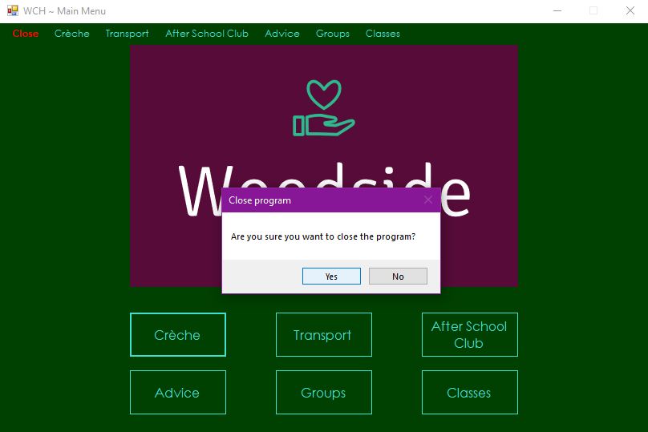

Test 2



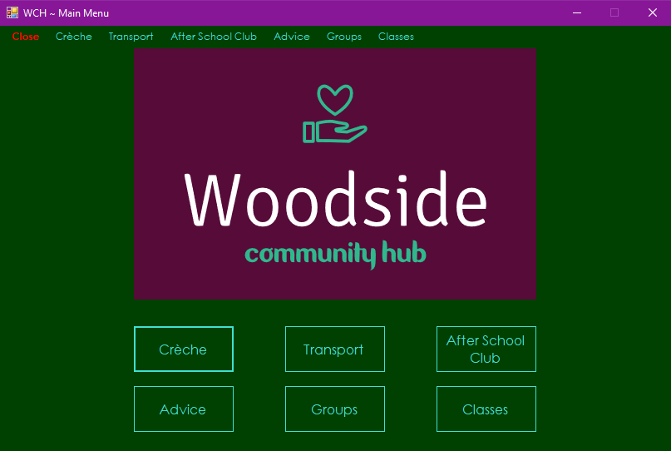

Test 3

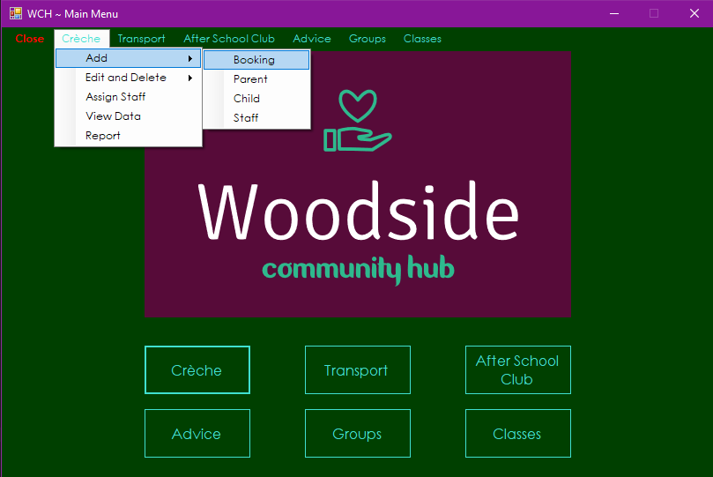

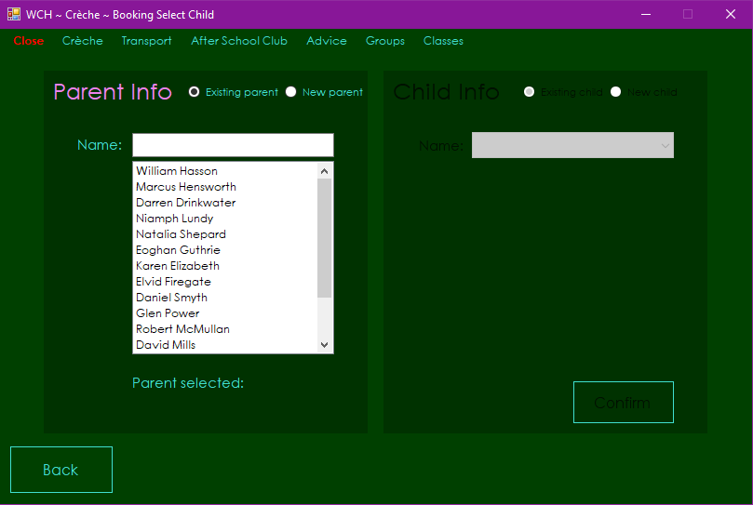

Test 4

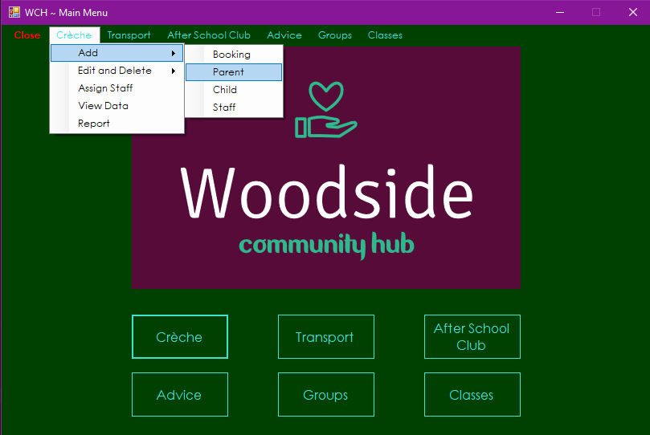

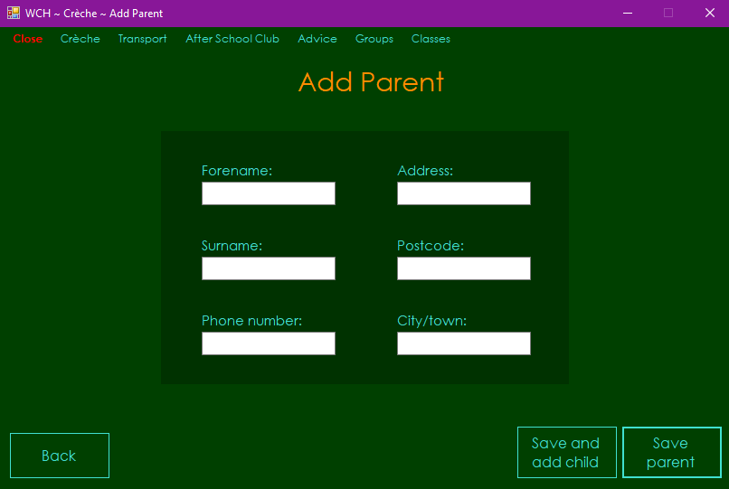

Test 5

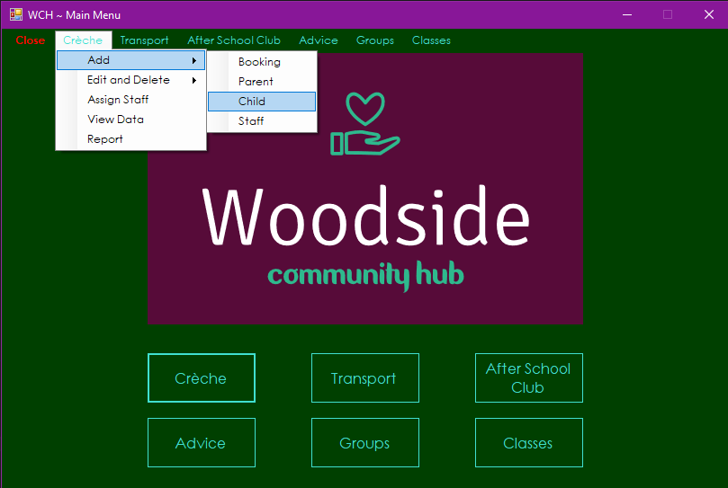

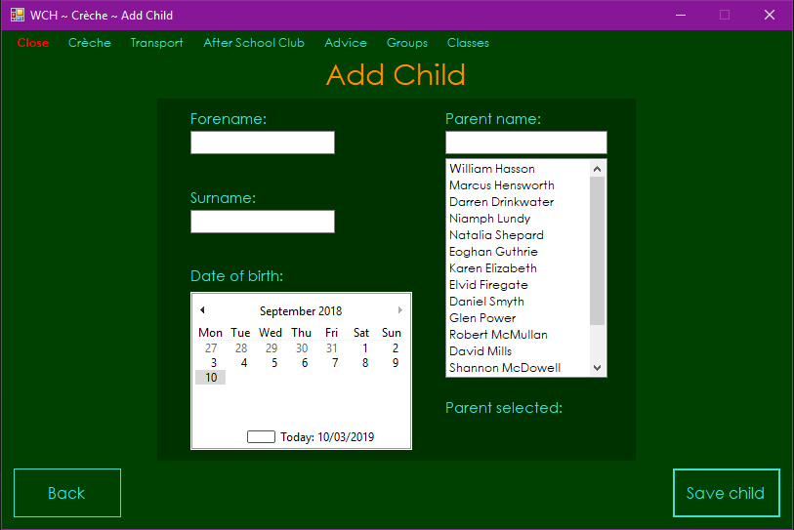

Test 6

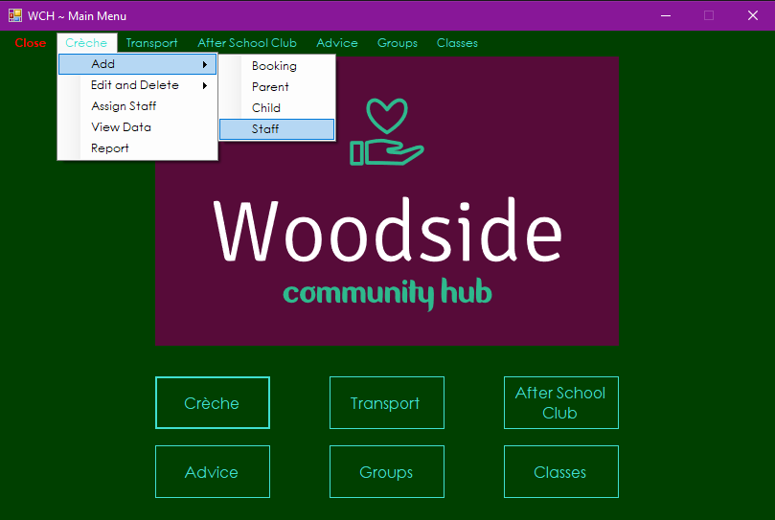

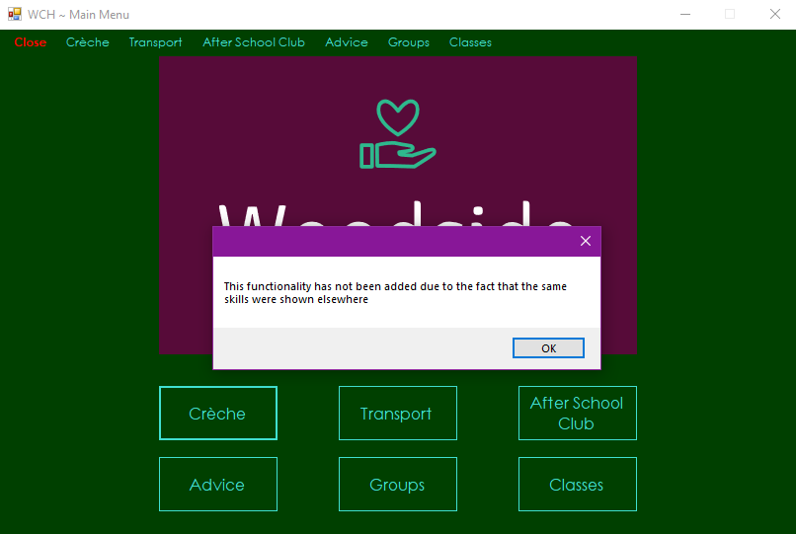

Test 7

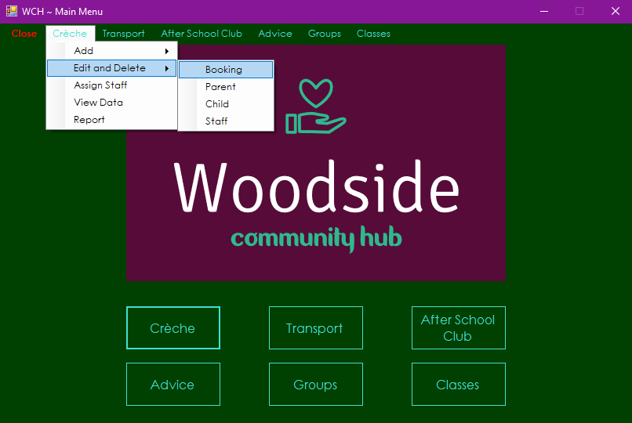

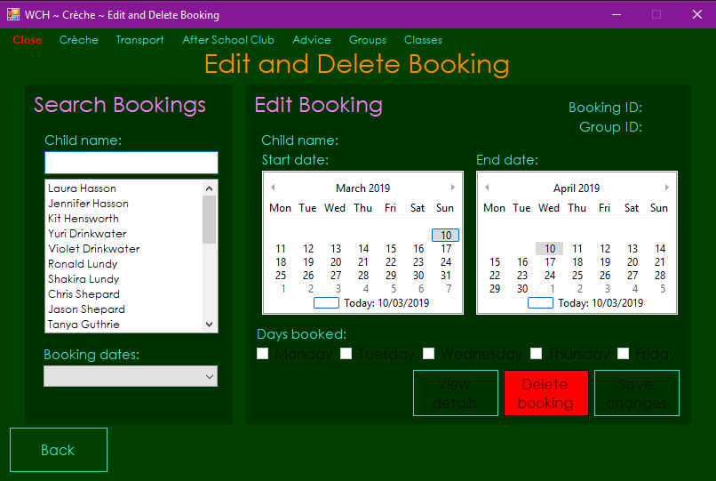

Test 8

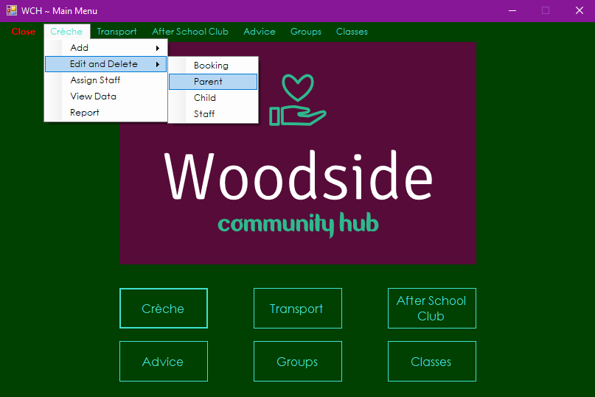

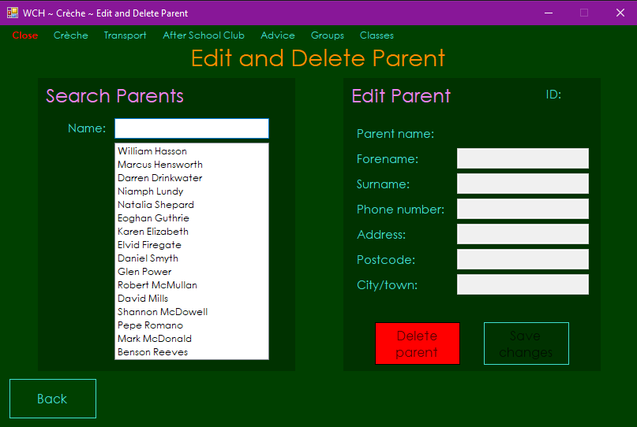

Test 9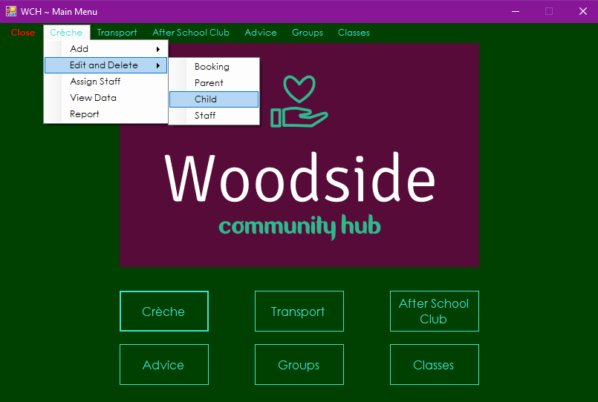

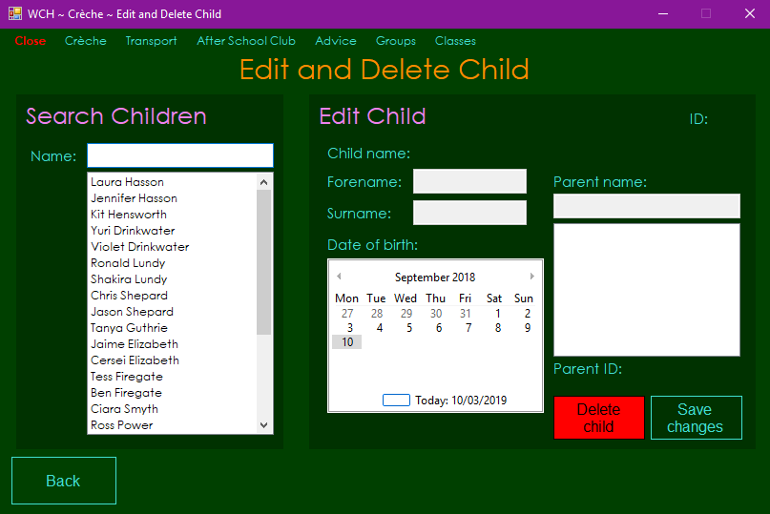

Test 10

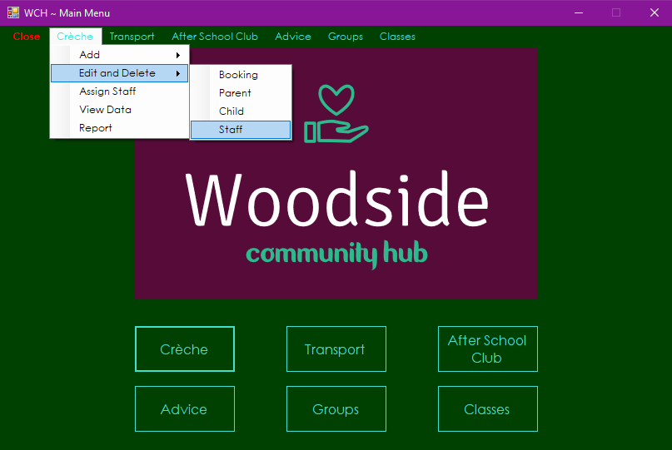



Test 11

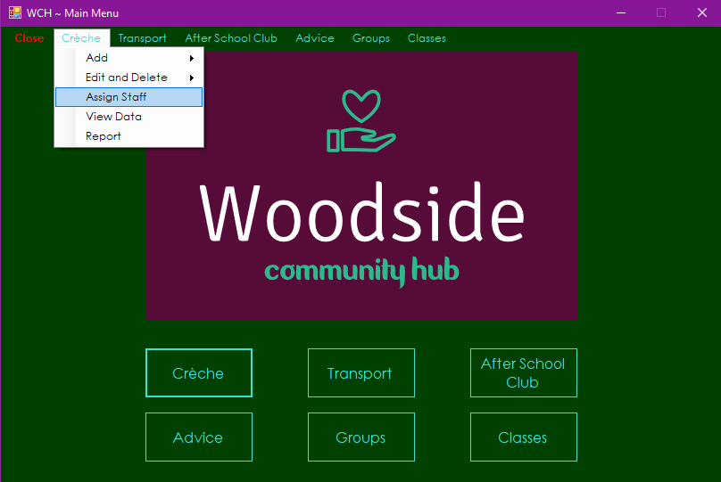

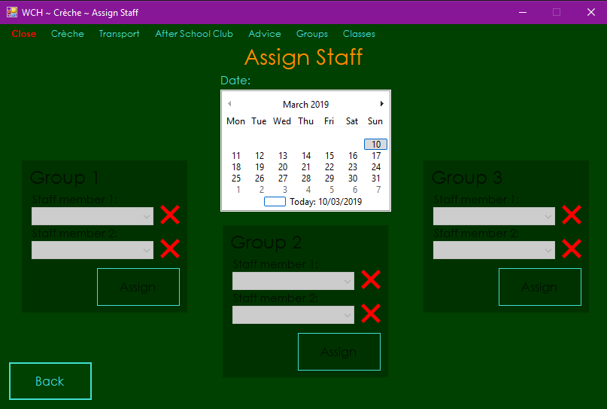

Test 12

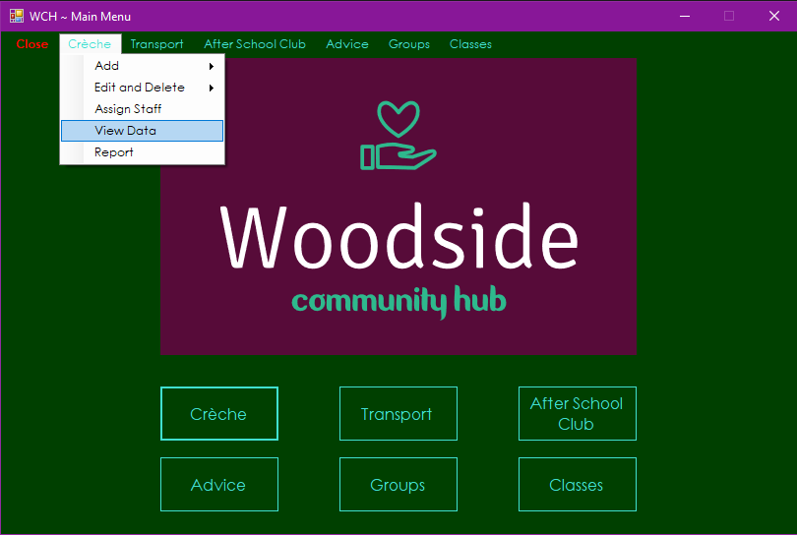

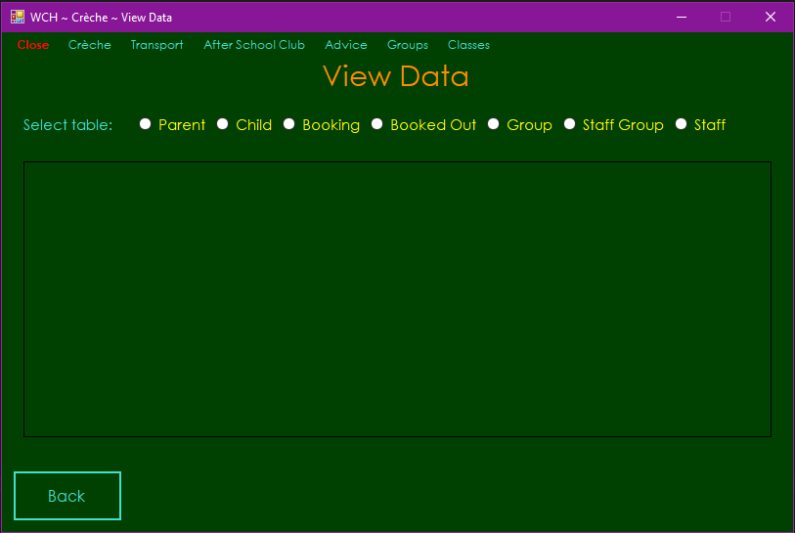

Test 13

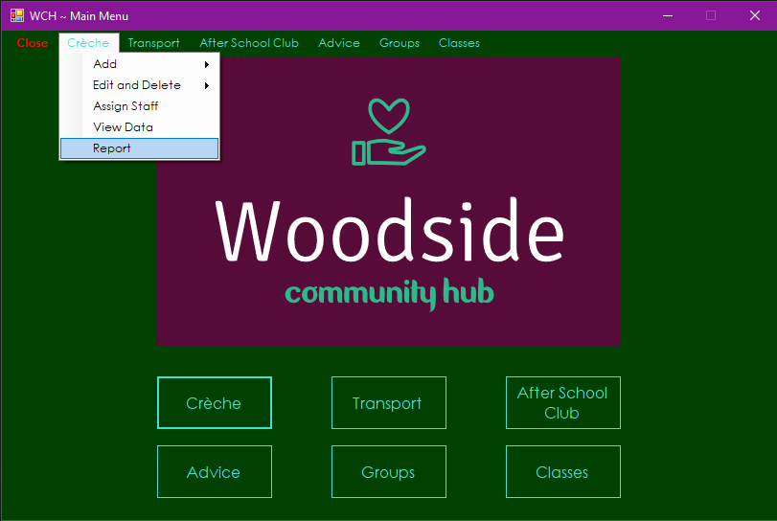

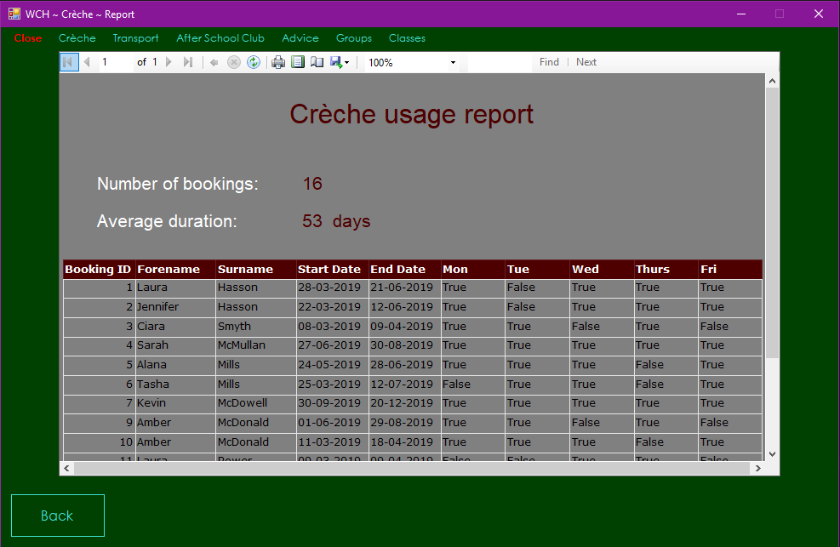

Tests 14 to 18

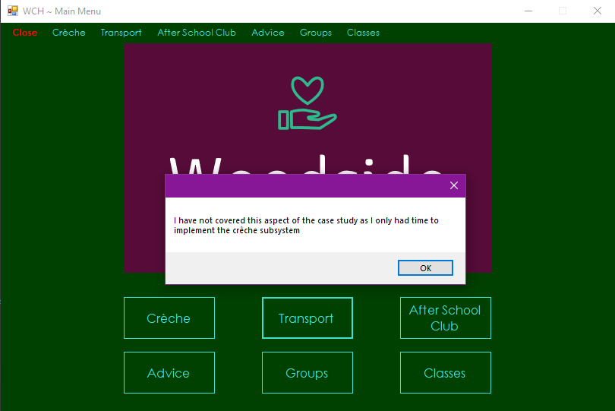

Test 19

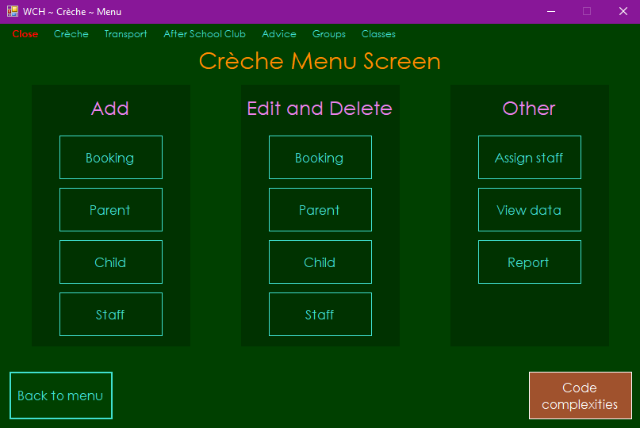

Test 20



Test 22

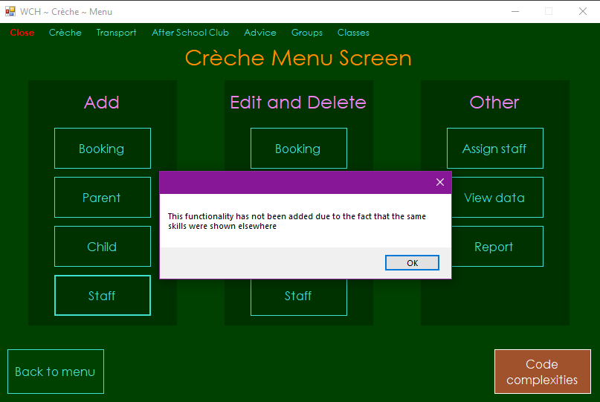

Test 23

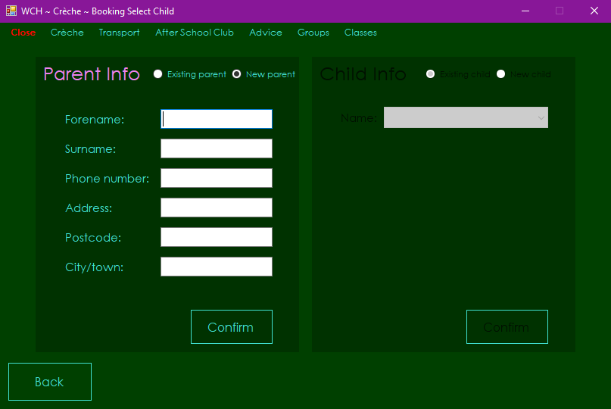

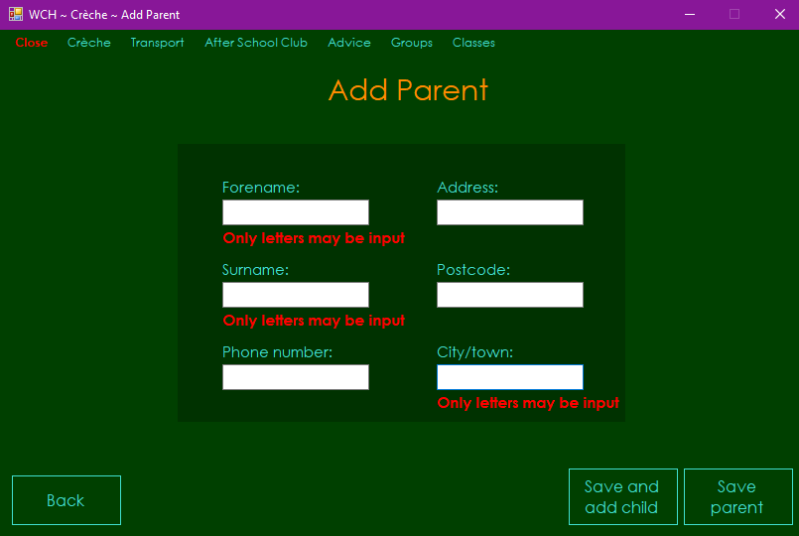

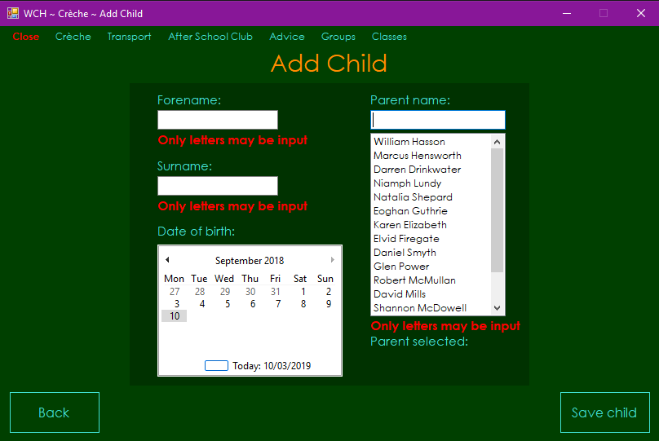

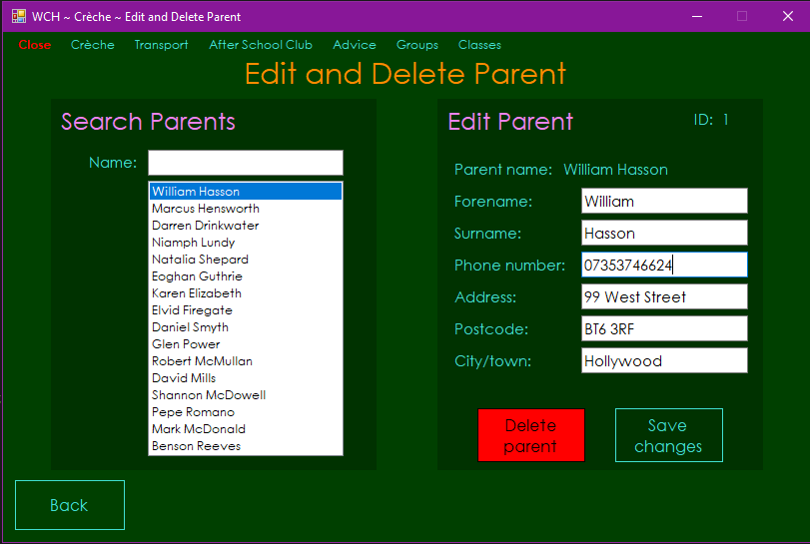

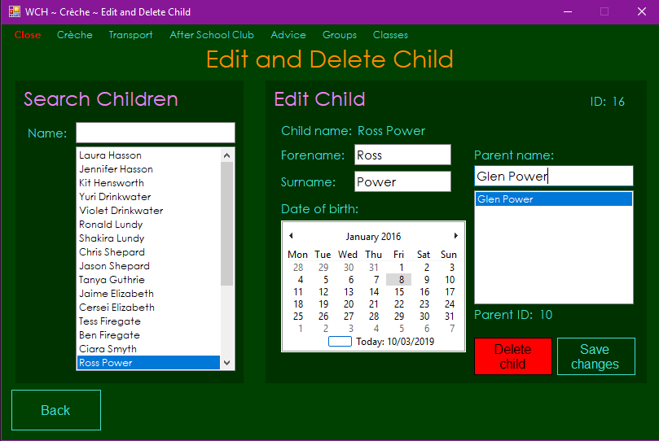

Test 24

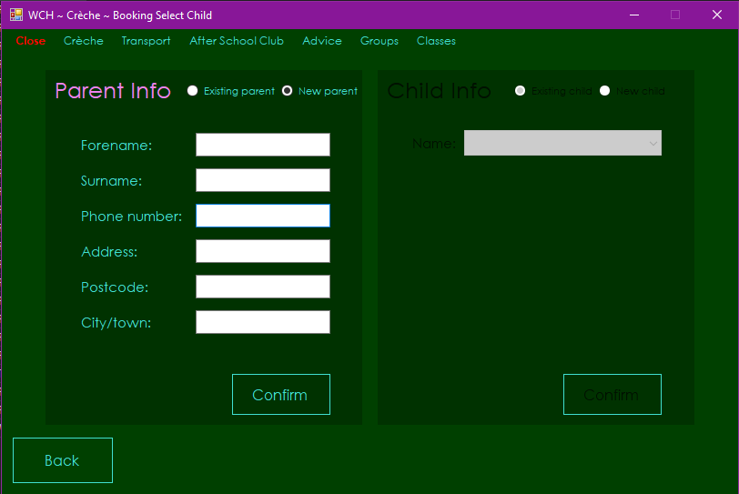

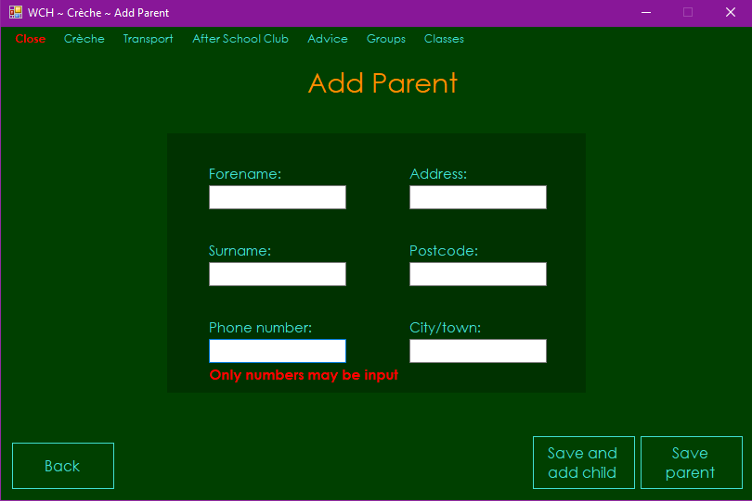

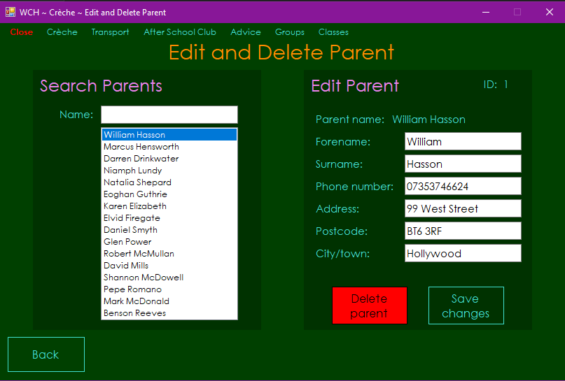

Test 25

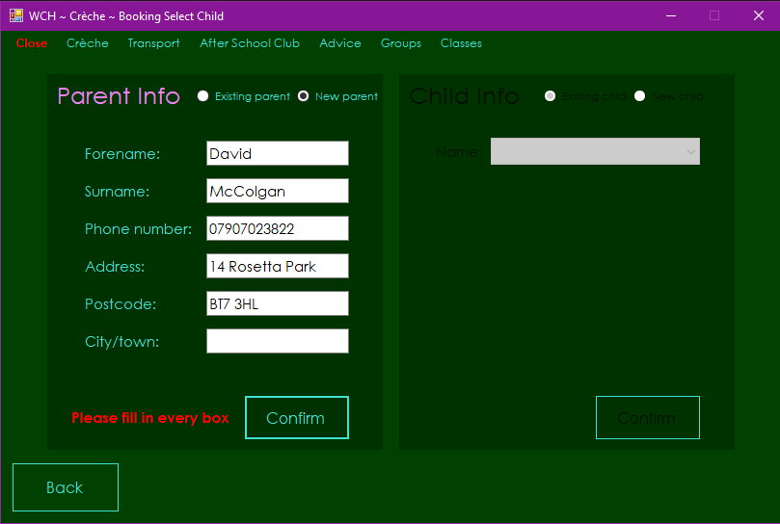

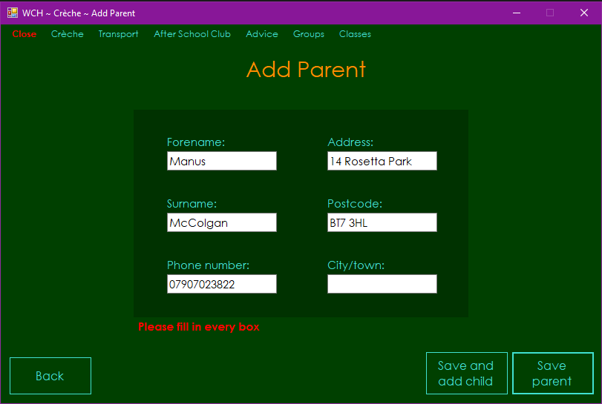

Test 26

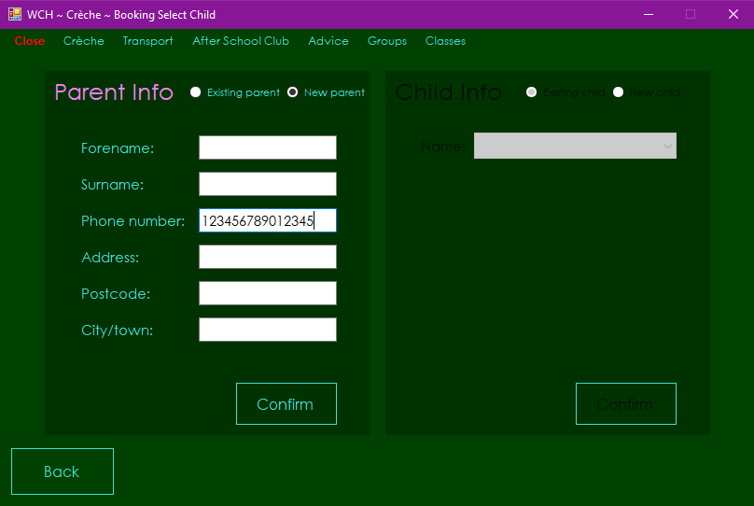

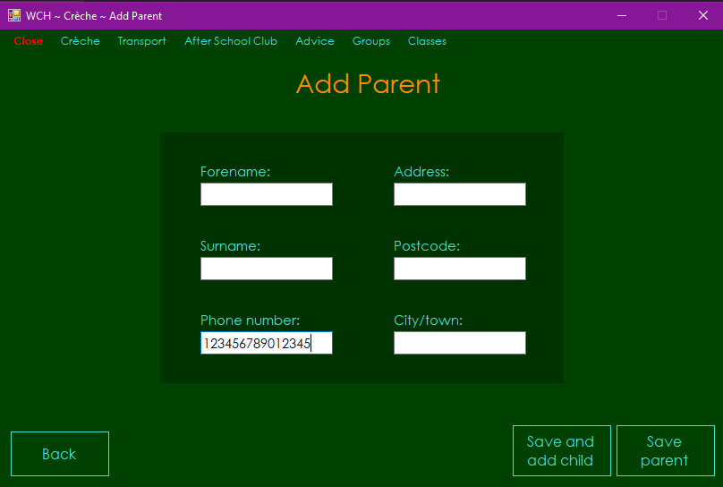

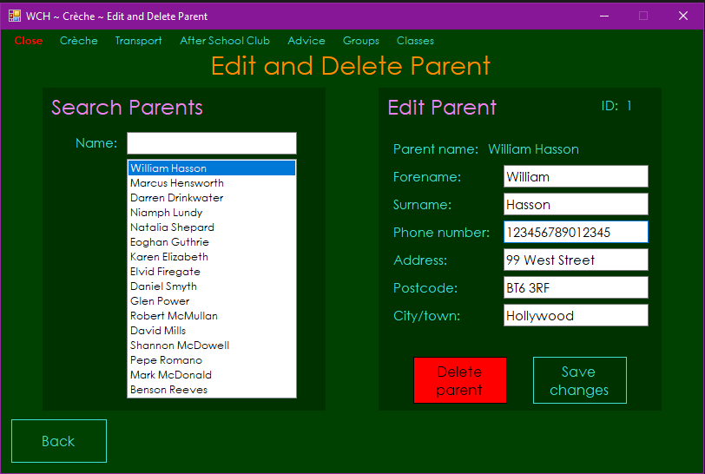

Test 27

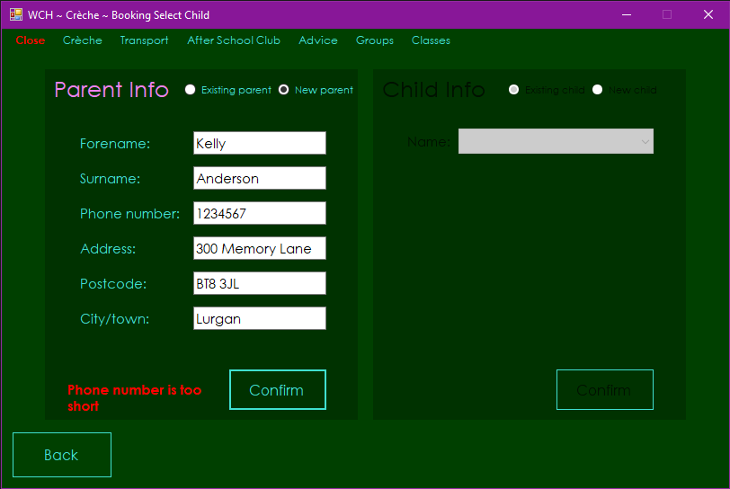

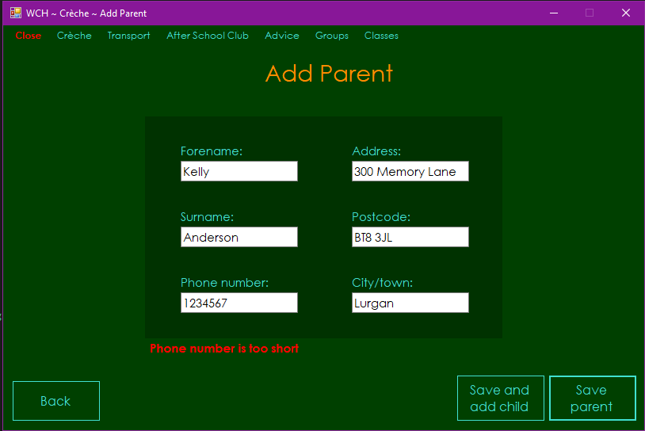

Test 28

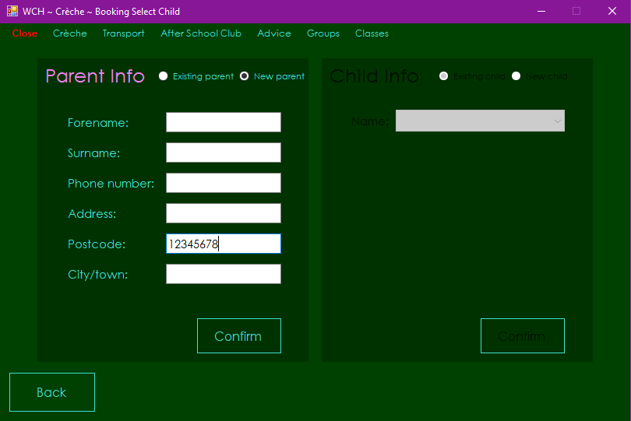

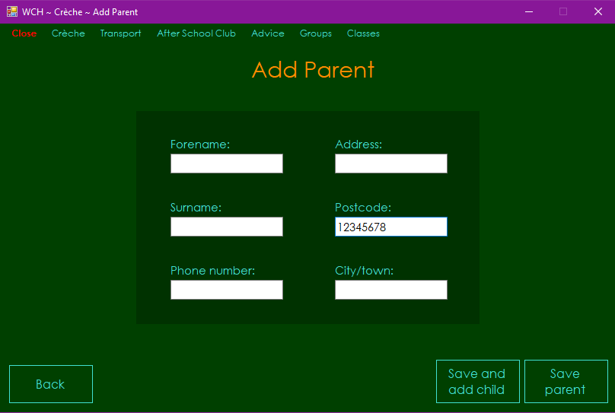

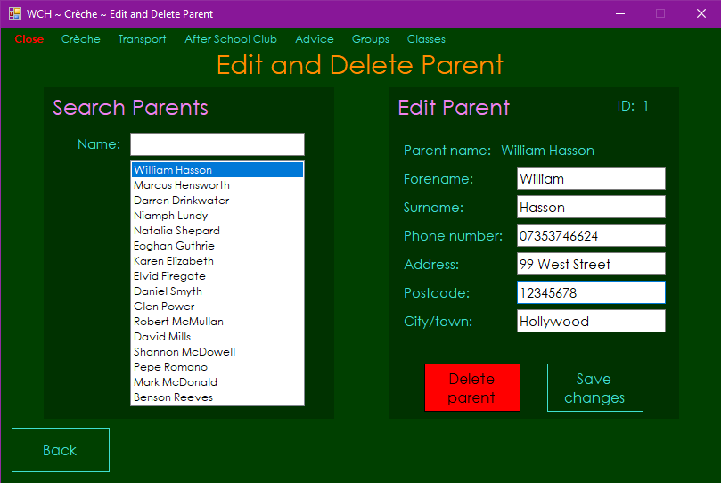

Test 29

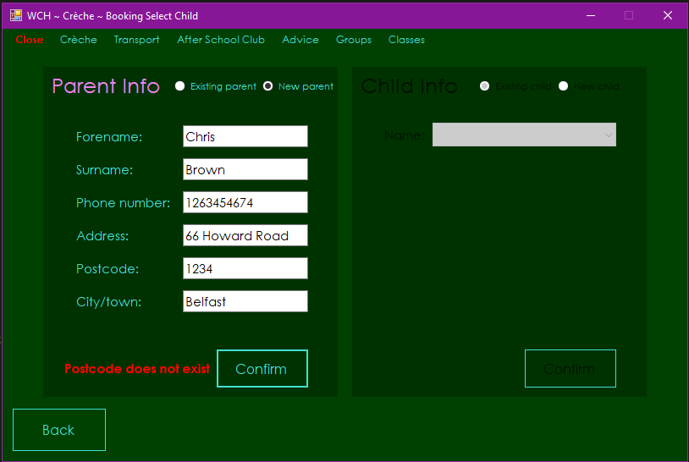

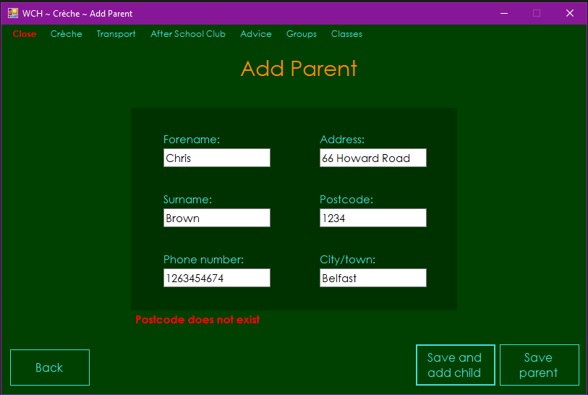

Test 30

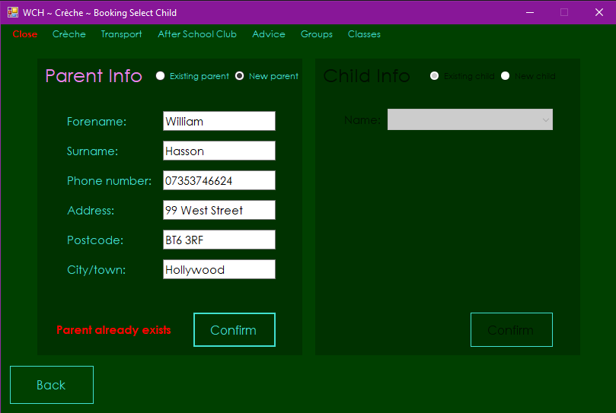

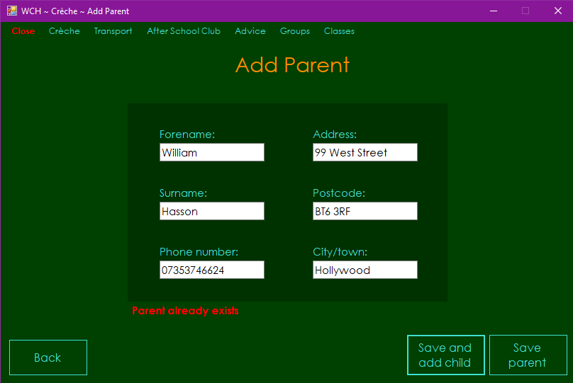

Test 31

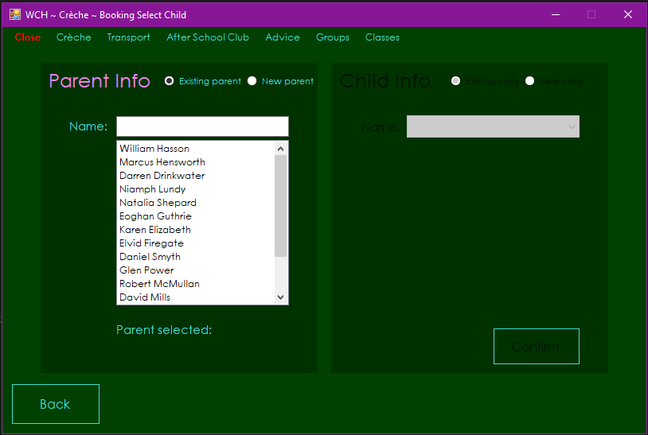

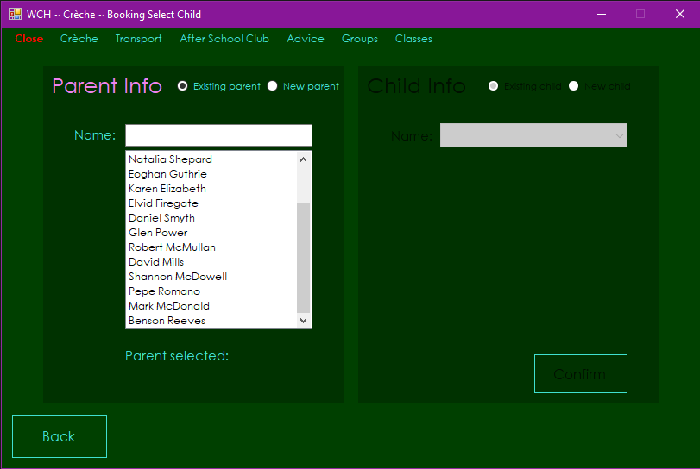

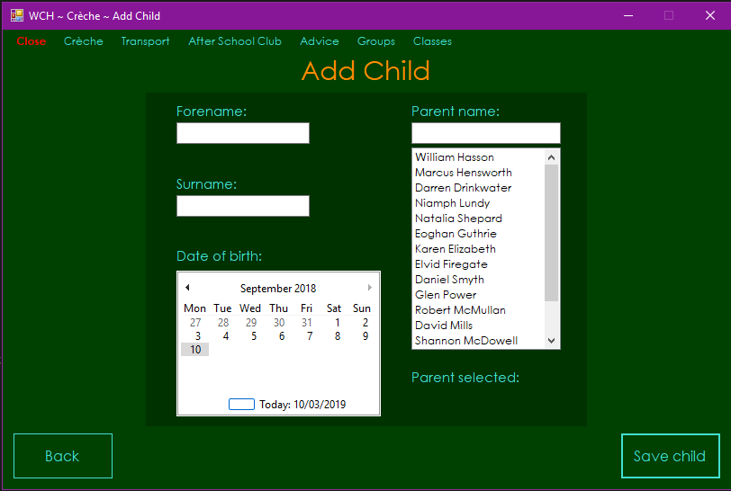

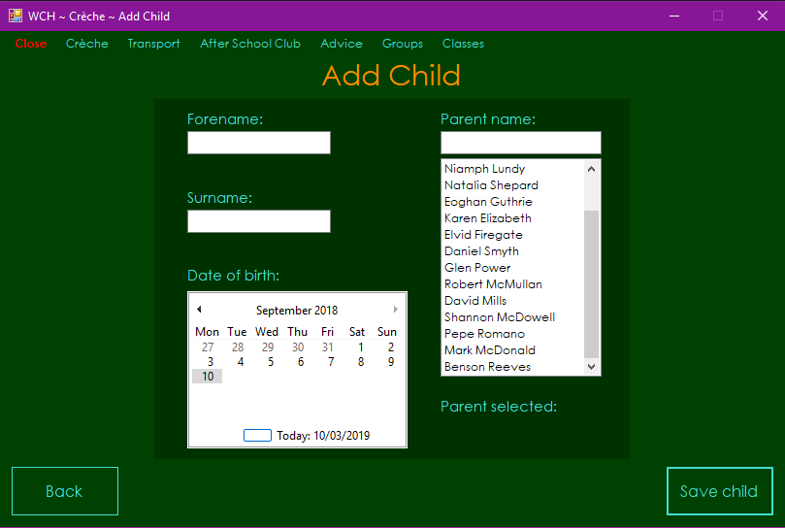

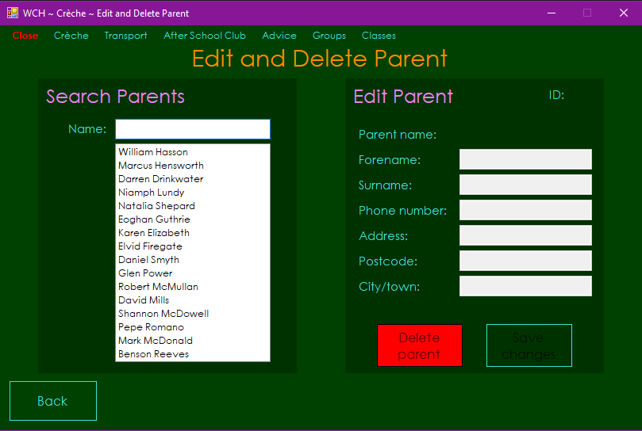

Test 32

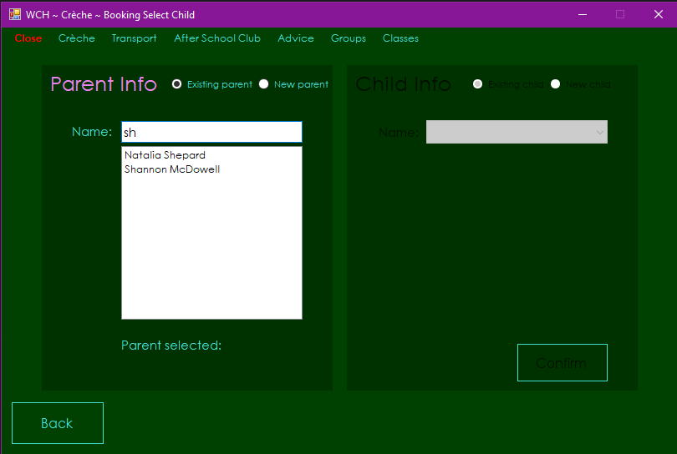

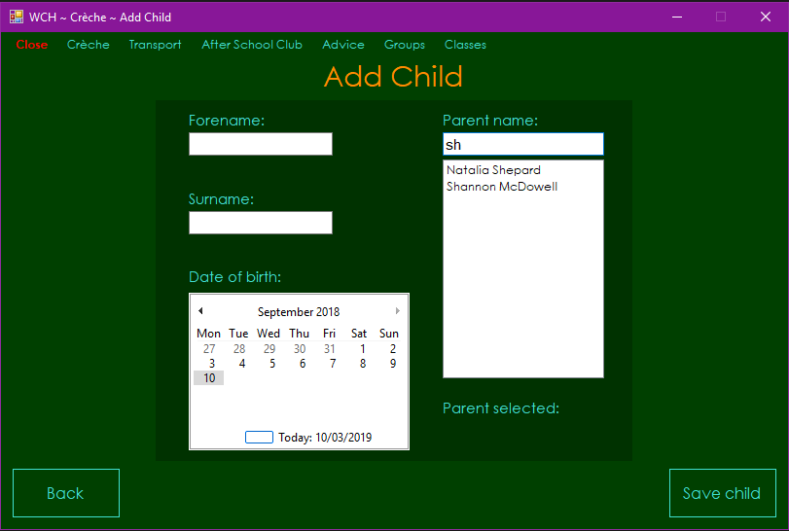

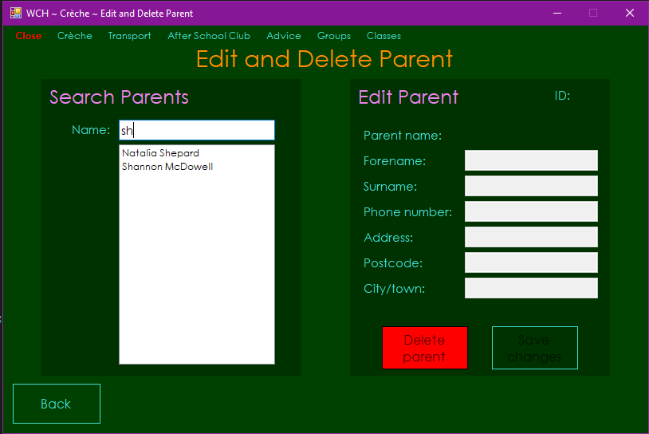

Test 33

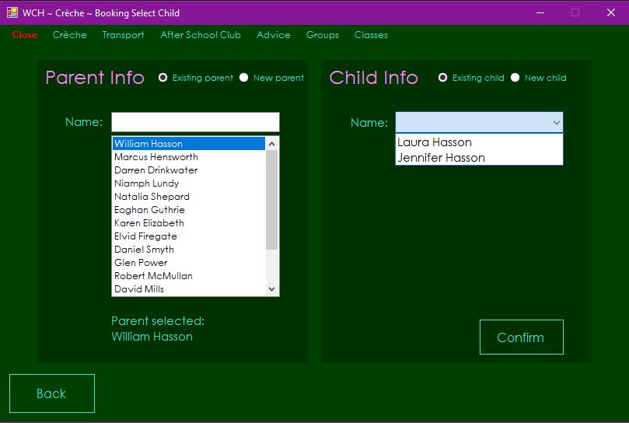

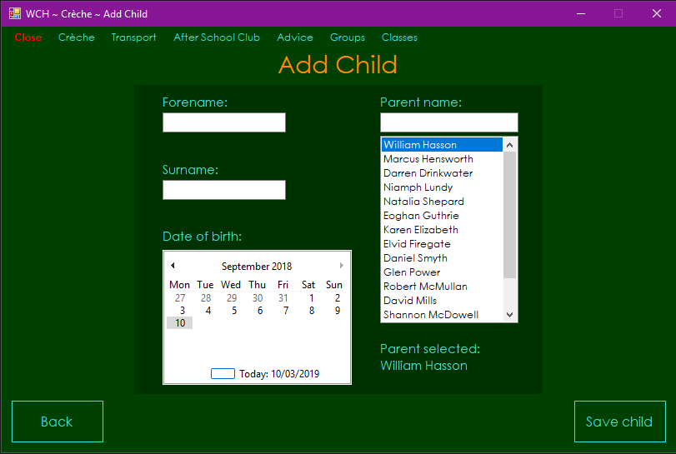

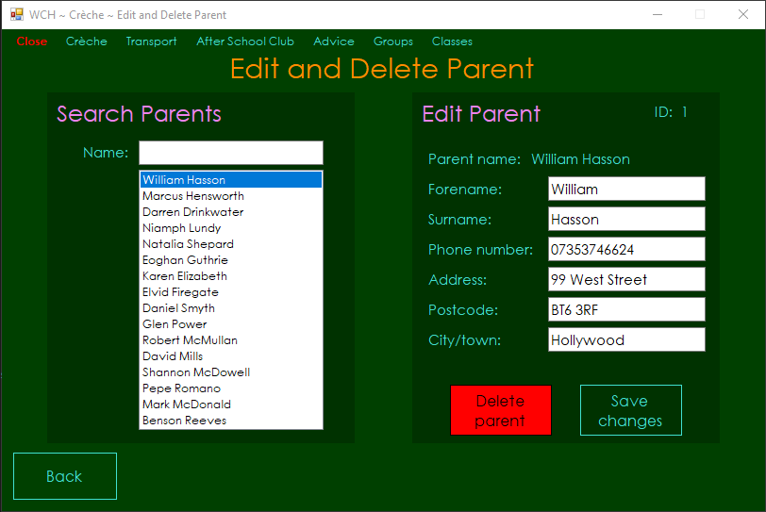

Test 34

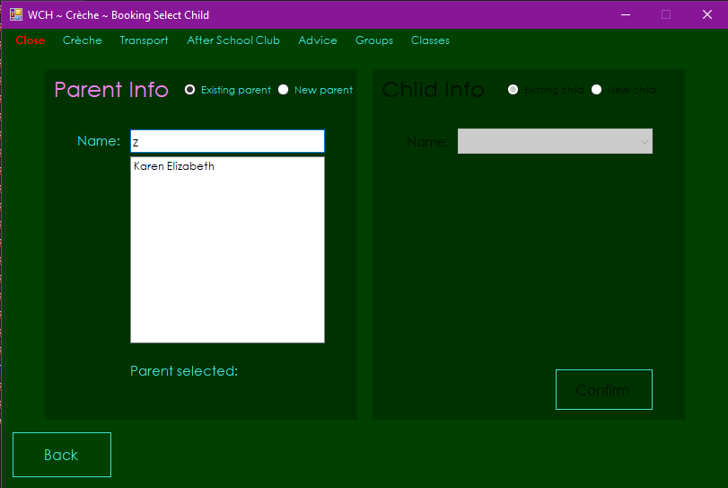

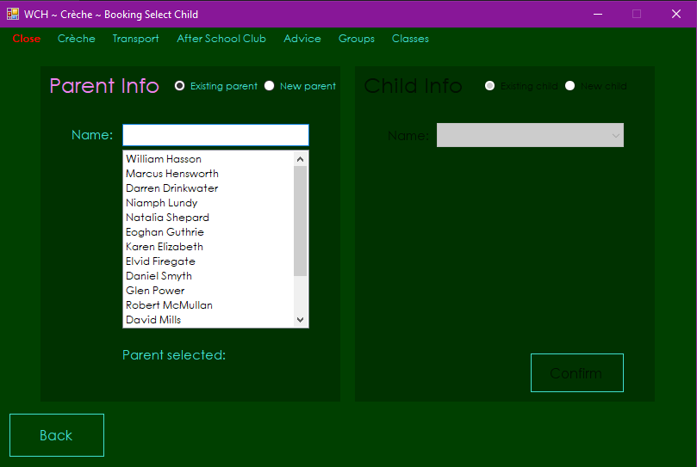

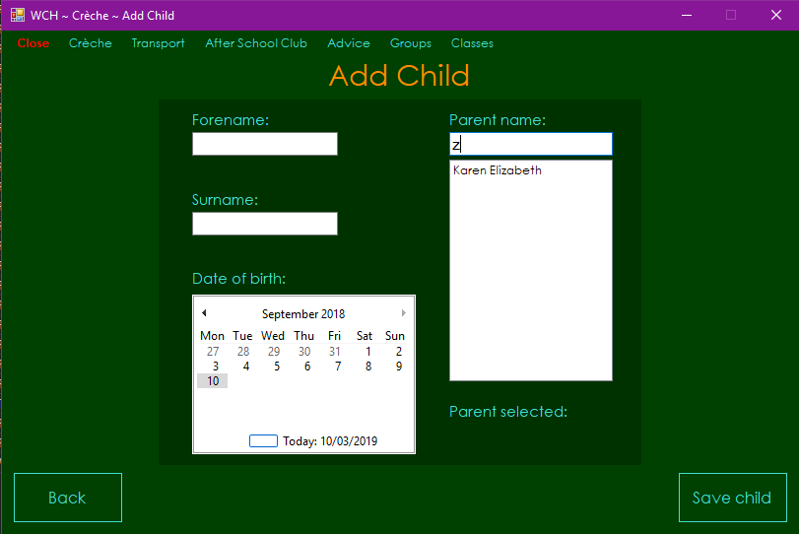

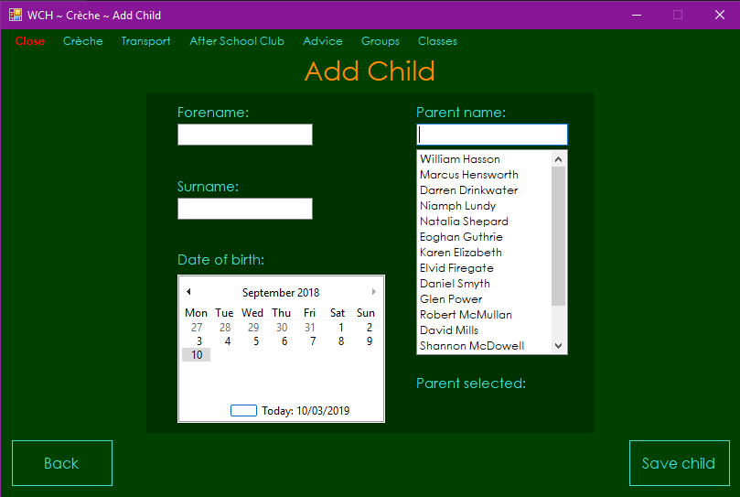

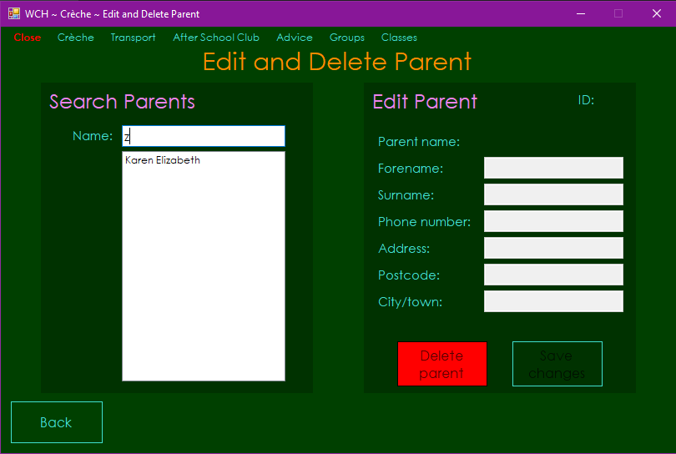

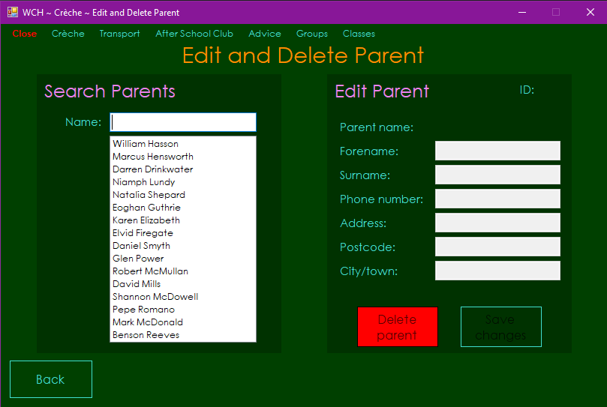

Test 35 - Failed

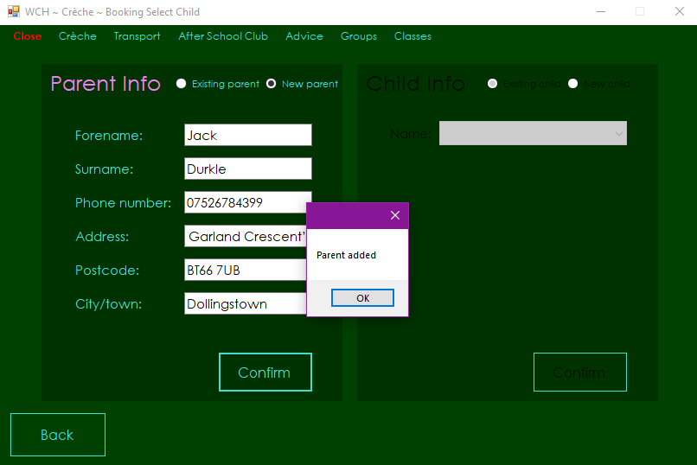

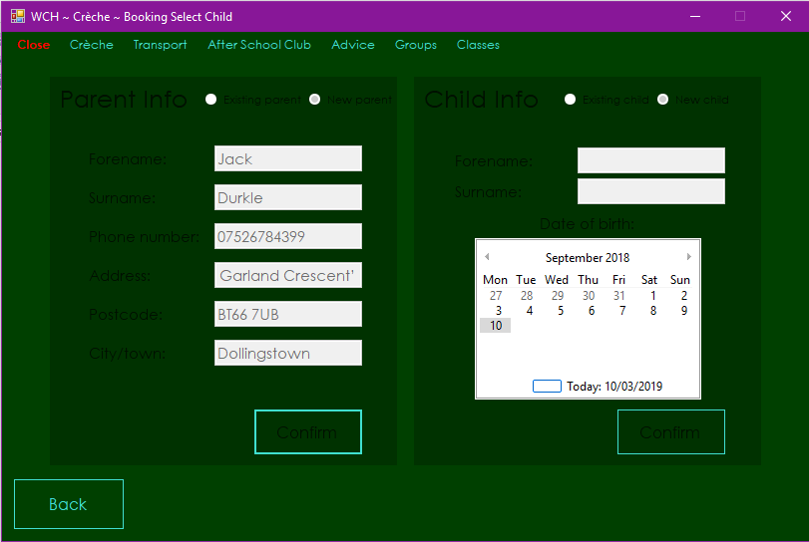

Test 35 - Fixed

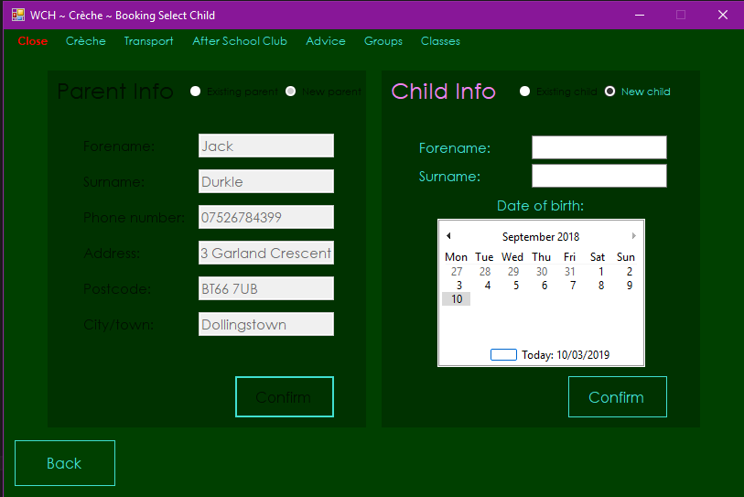

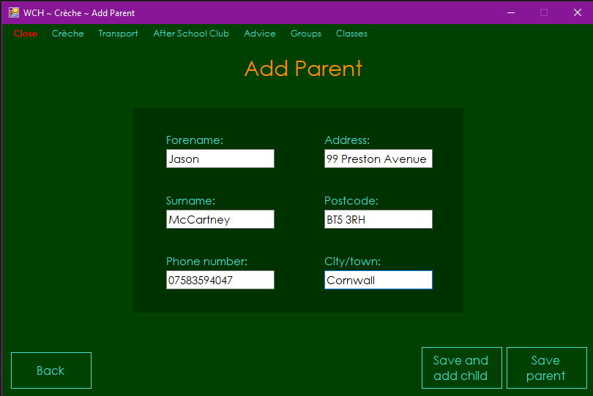

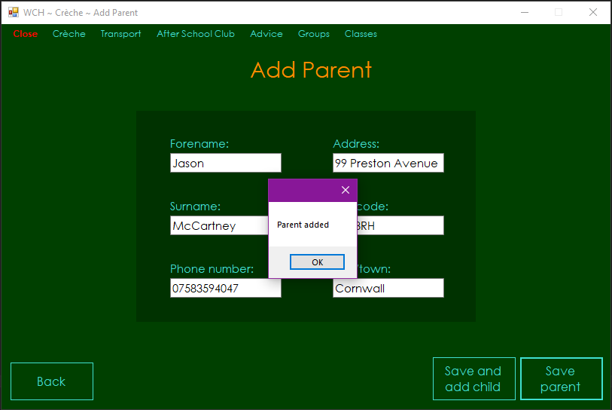

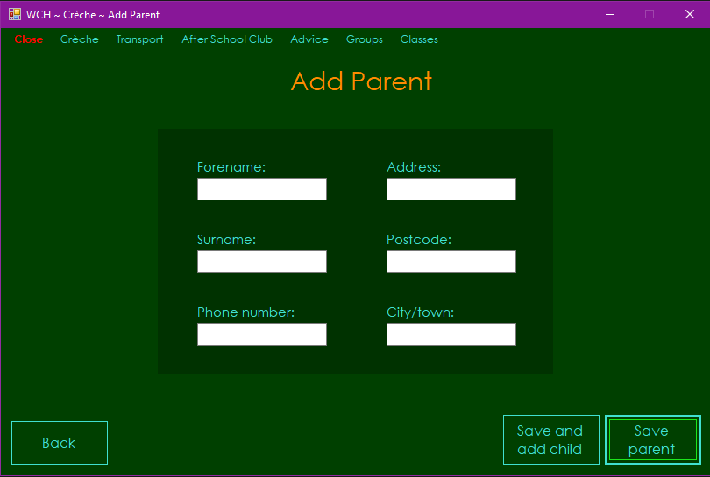

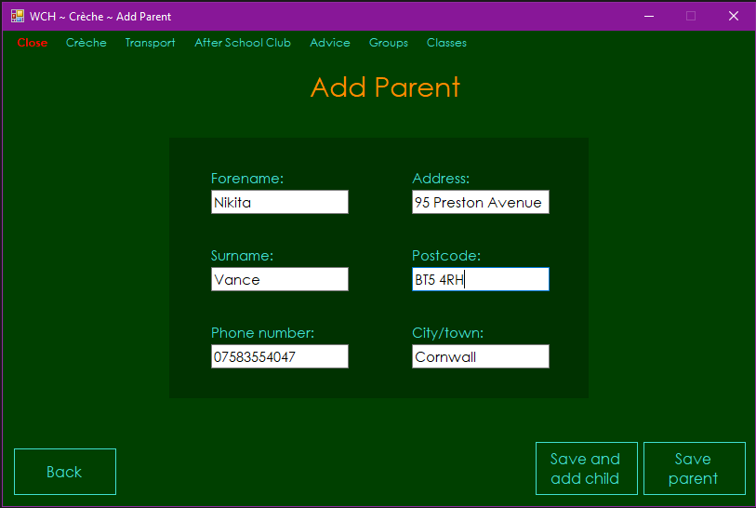

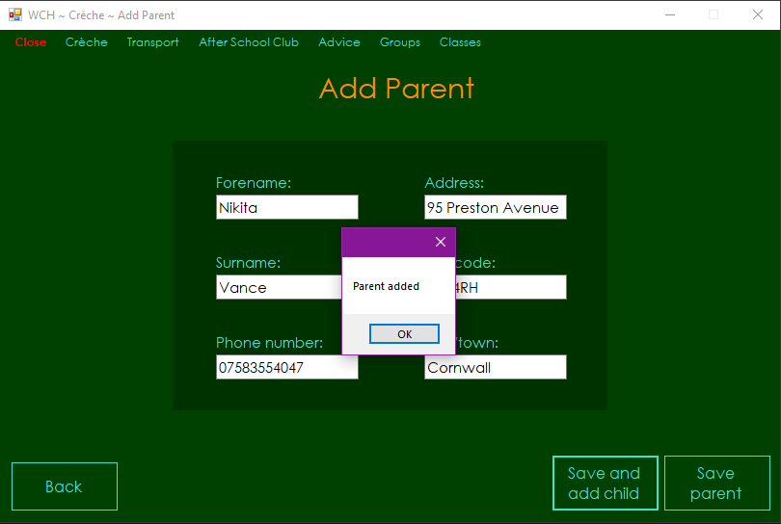

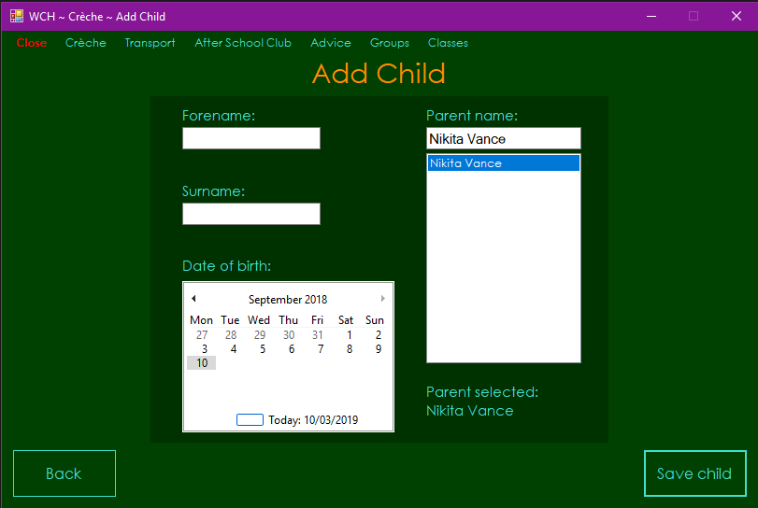

Test 36

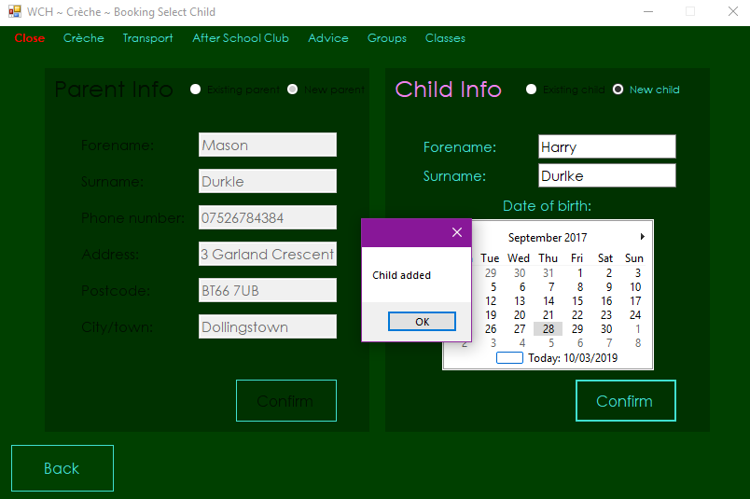

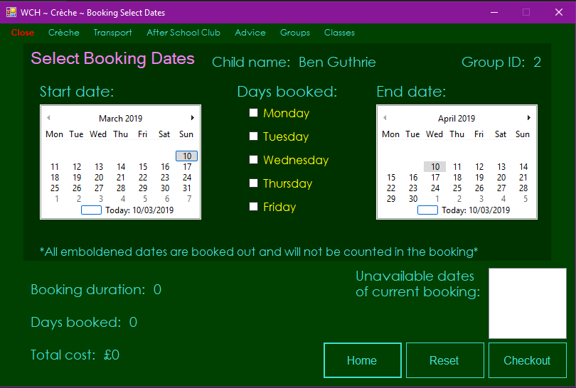

Test 37

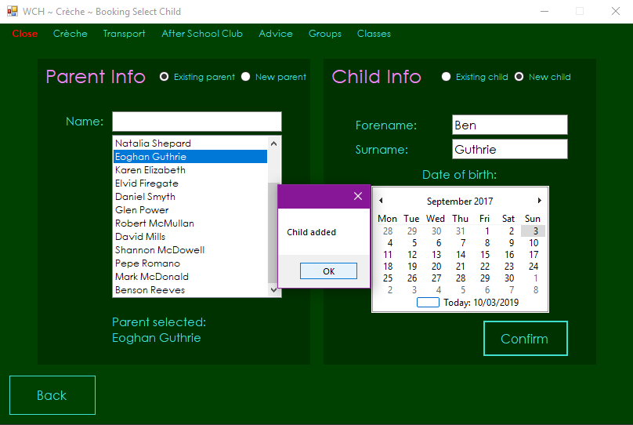



Test 38

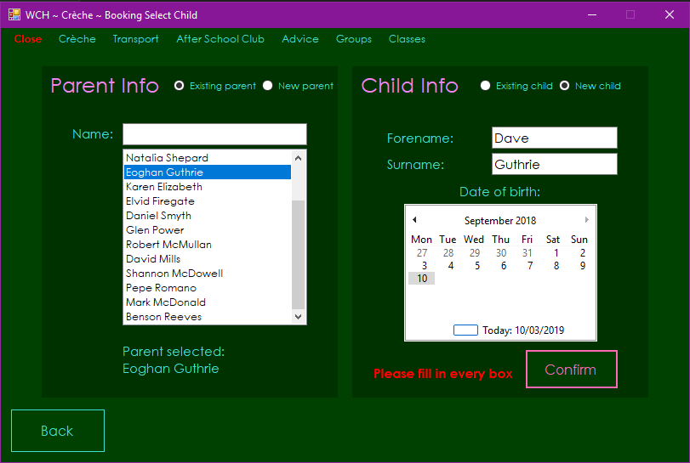

Test 39

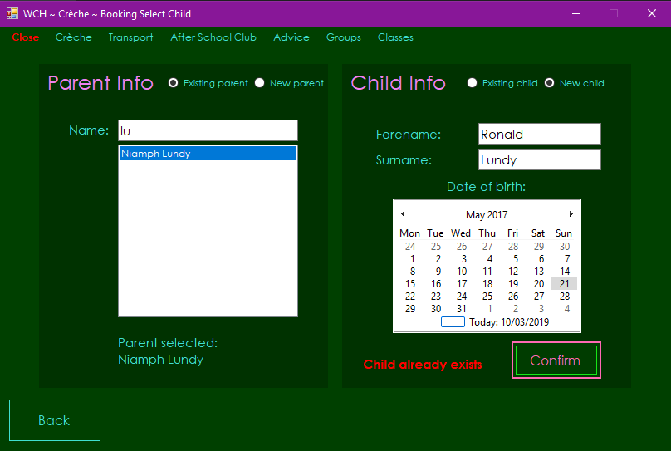

Test 40

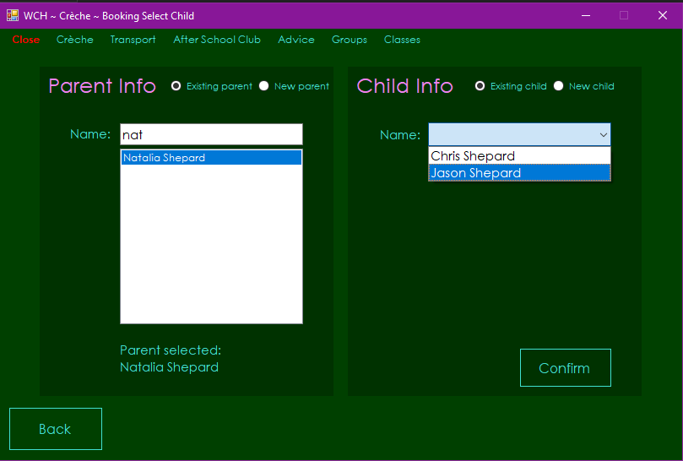

Test 41

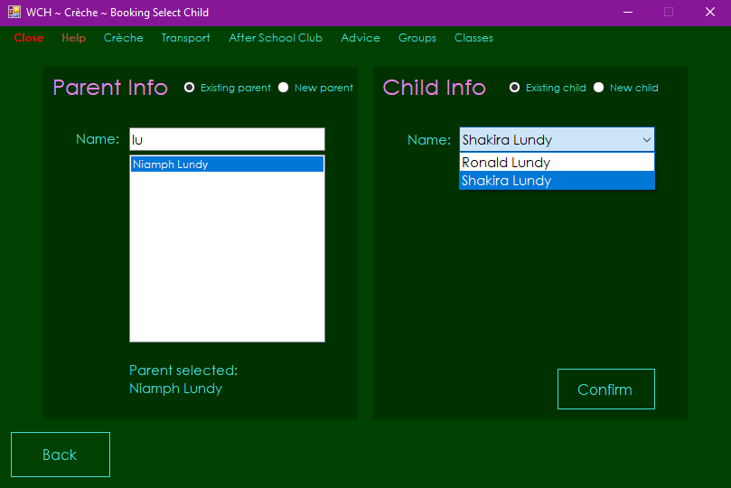

Test 42

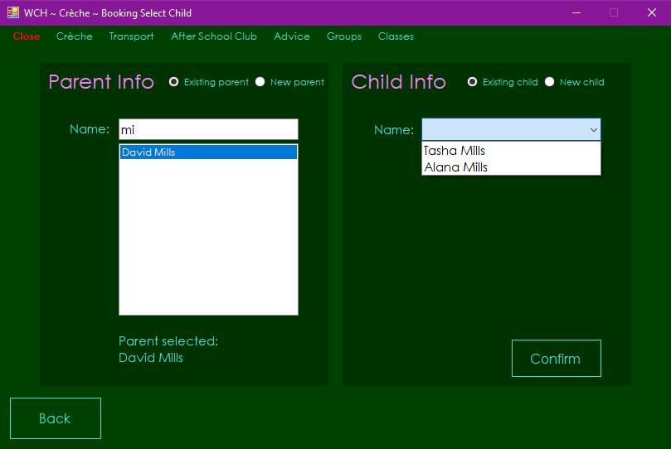

Test 43

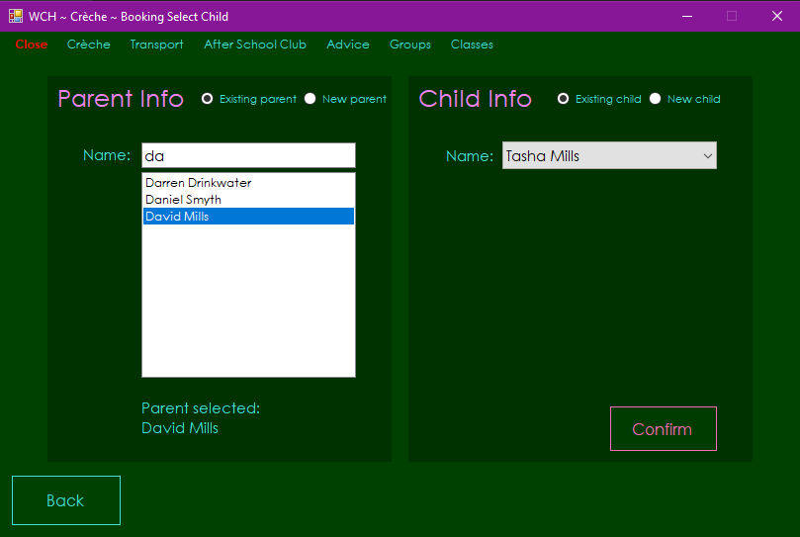

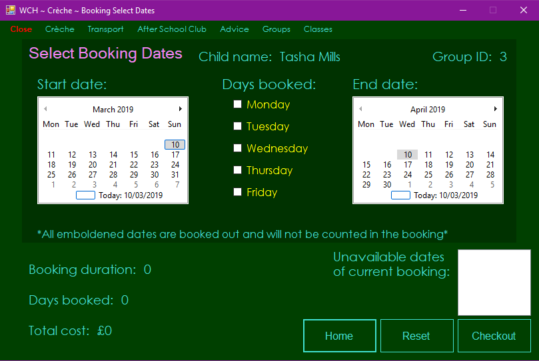

Test 44

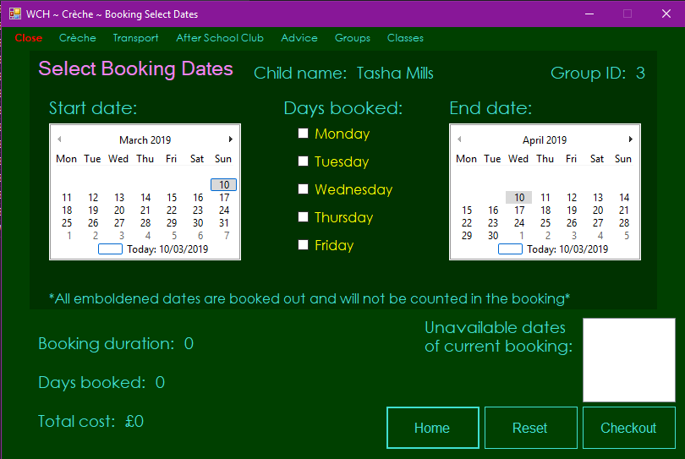

Test 45

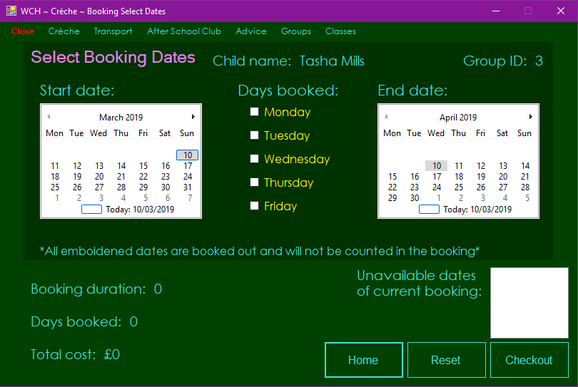

Test 46

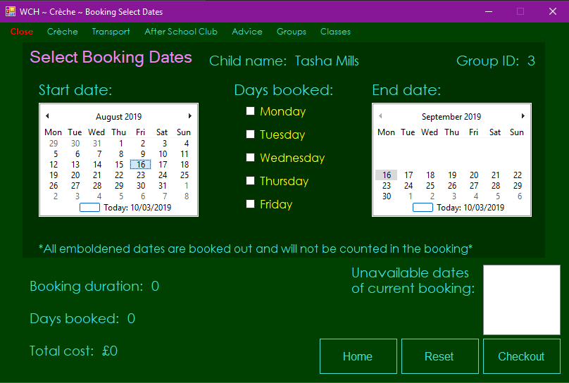

Test 47

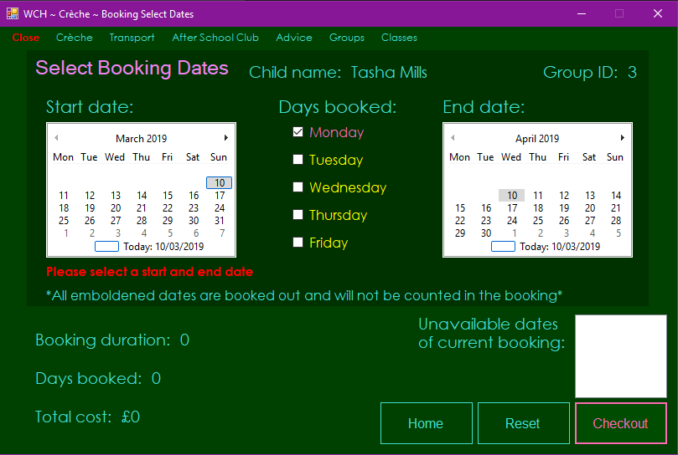

Test 48

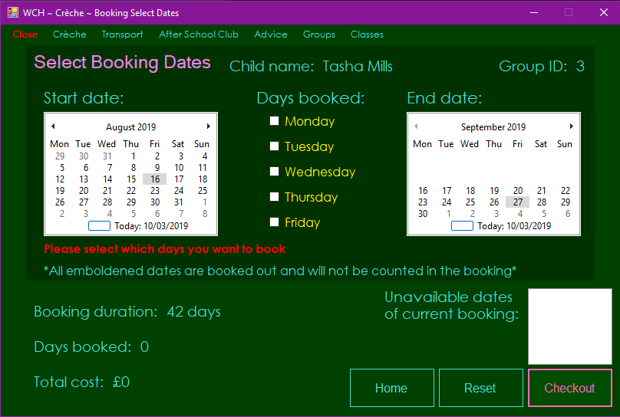

Test 49

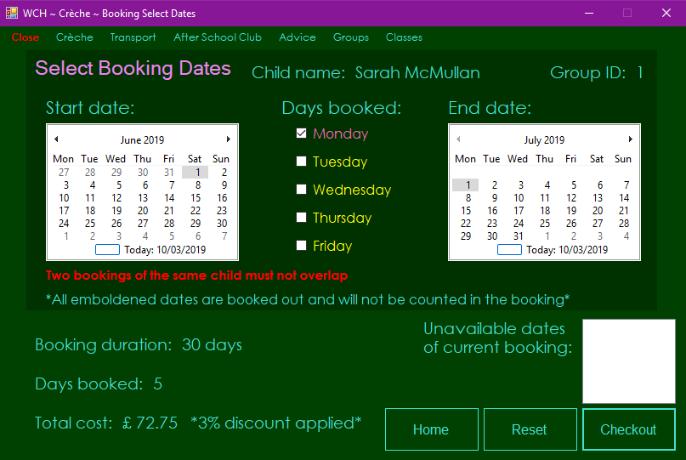

Test 50

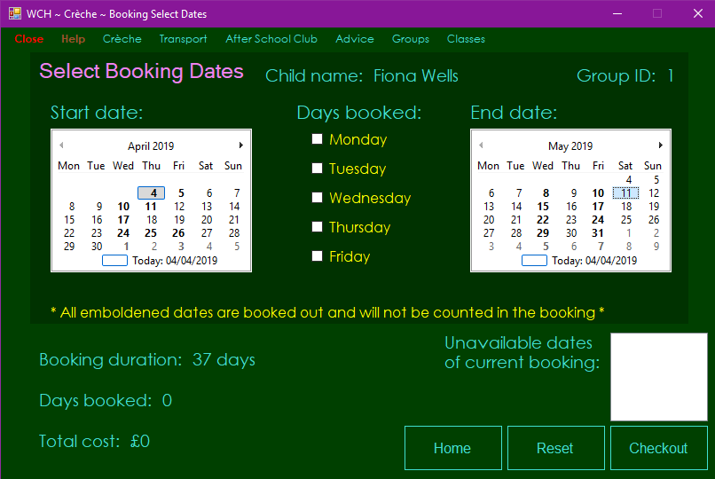

Tests 51 to 53

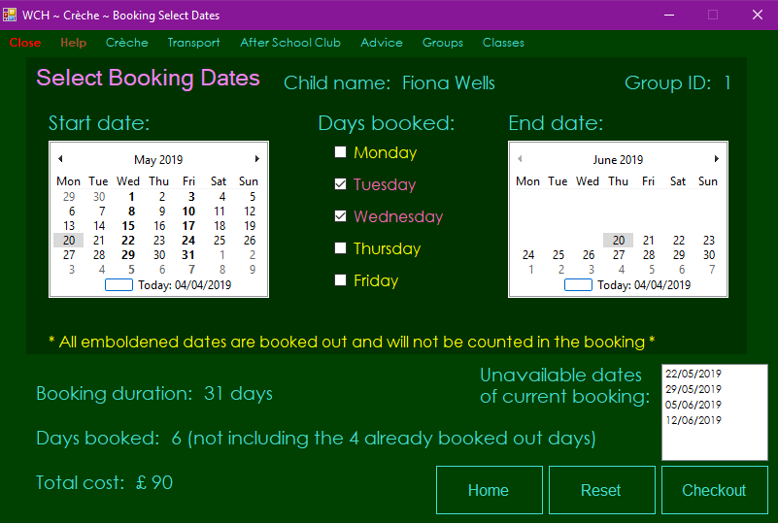

Test 54

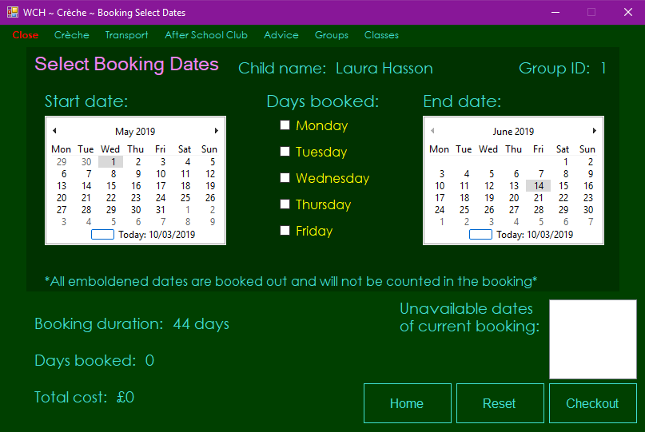

Test 55

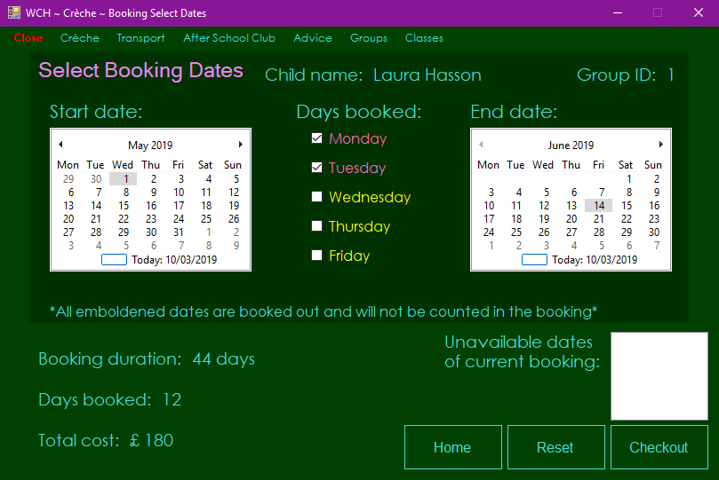

Test 56

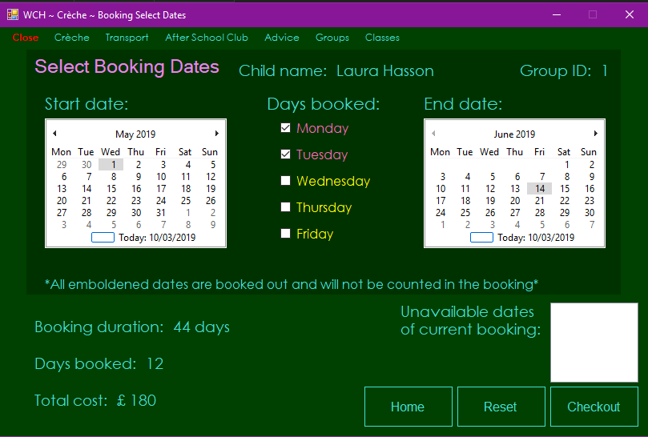

Test 57

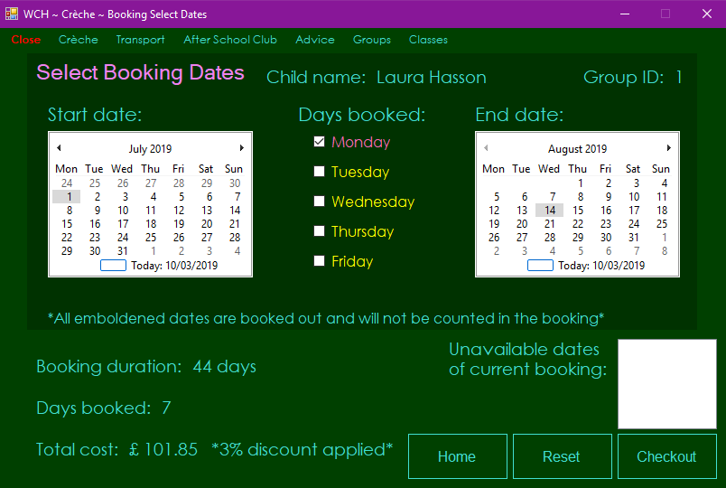

Test 58

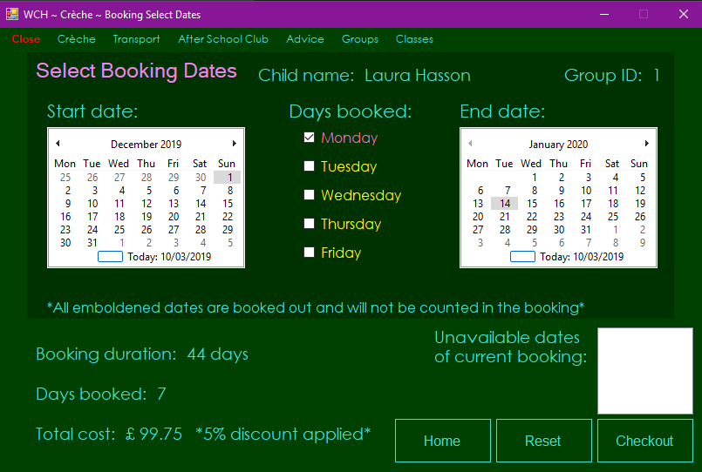

Test 59

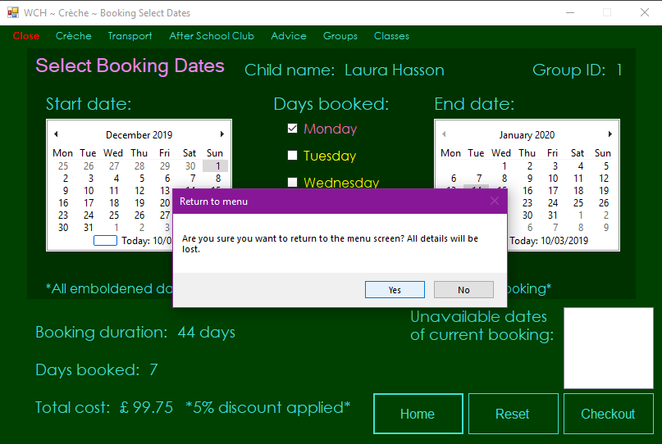

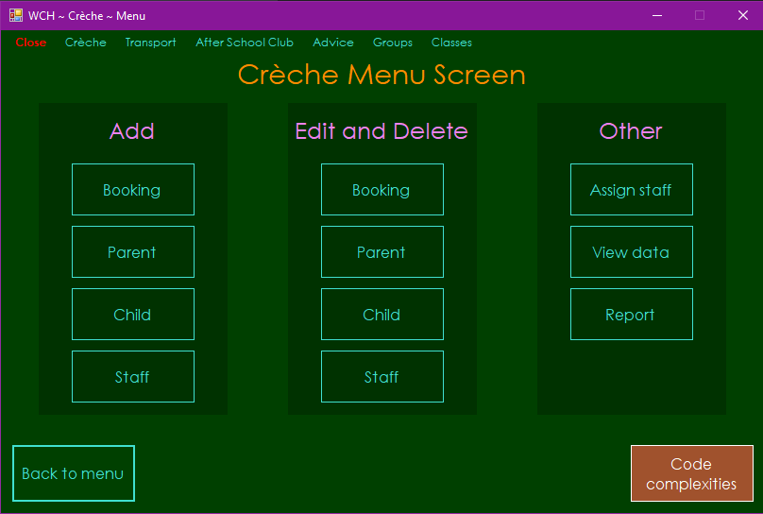

Test 60

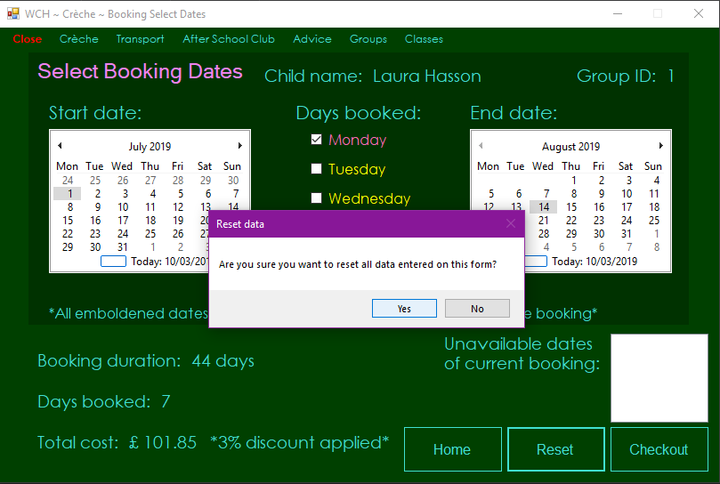

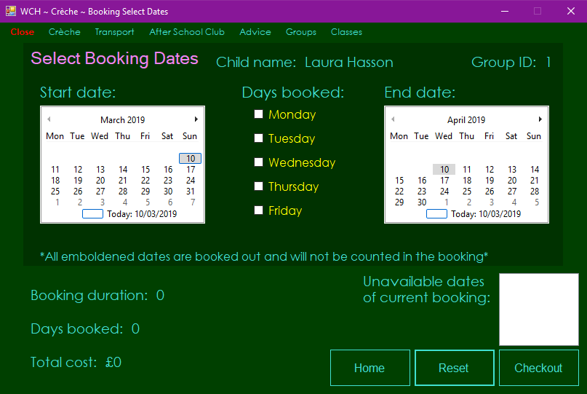

Test 61

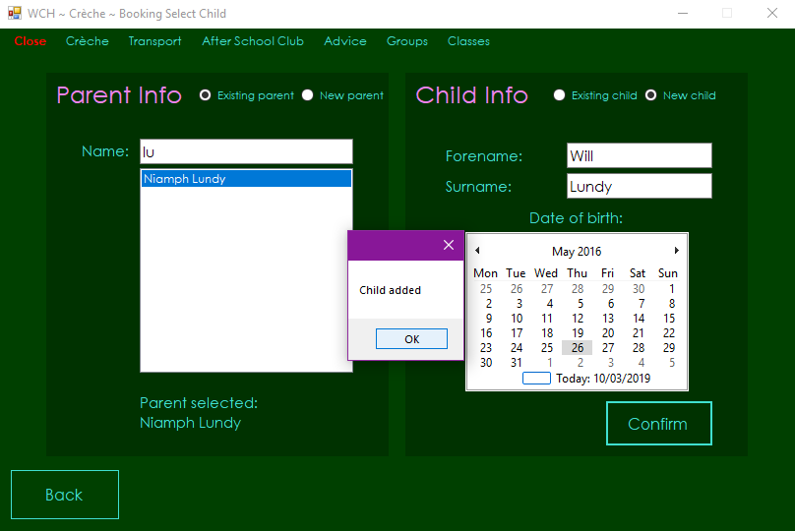

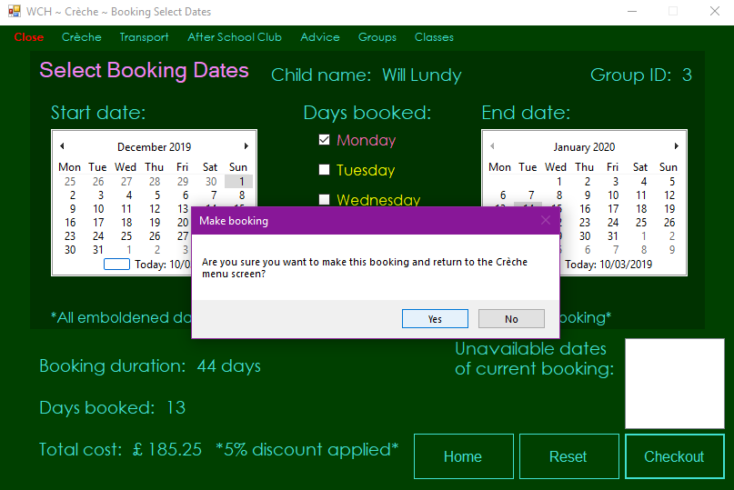

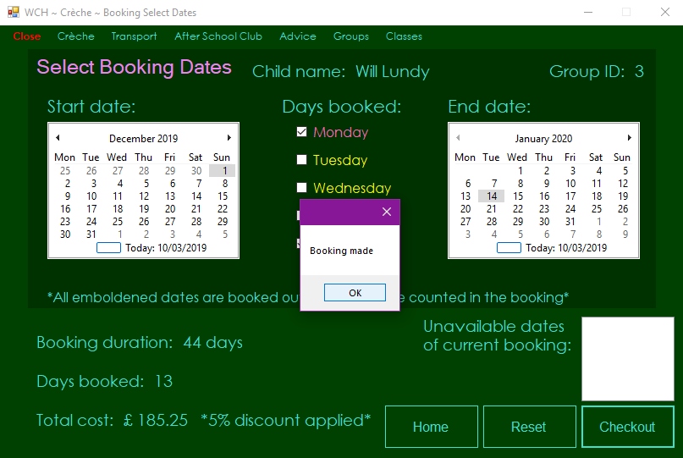

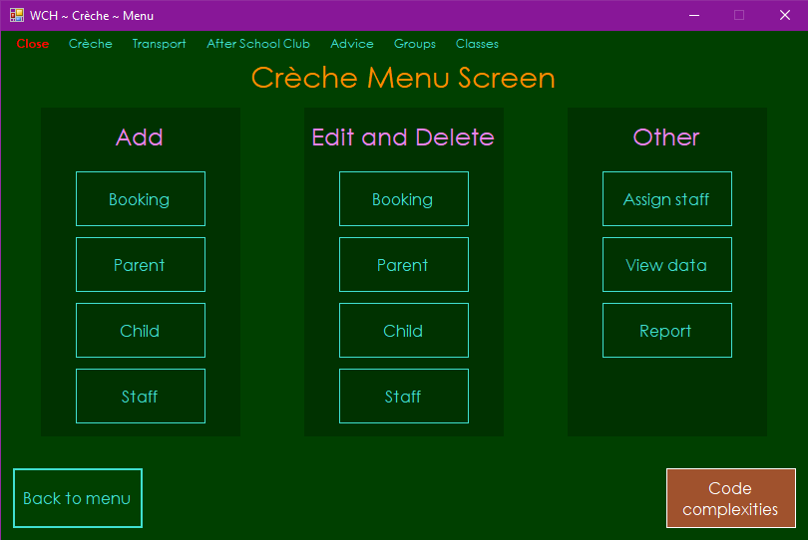

Test 62

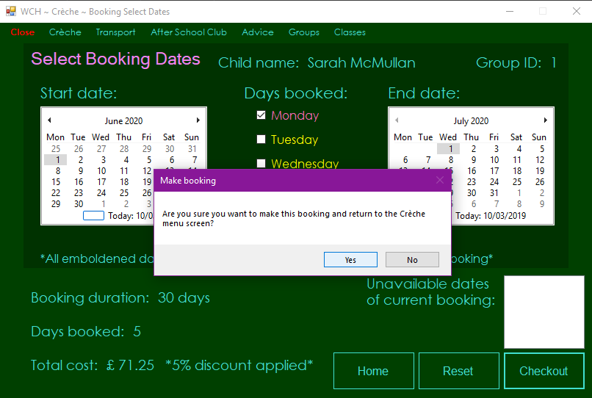

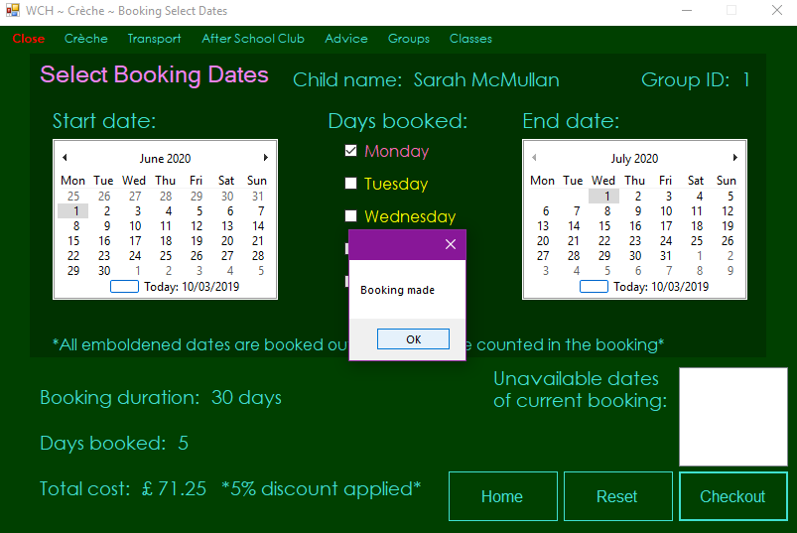

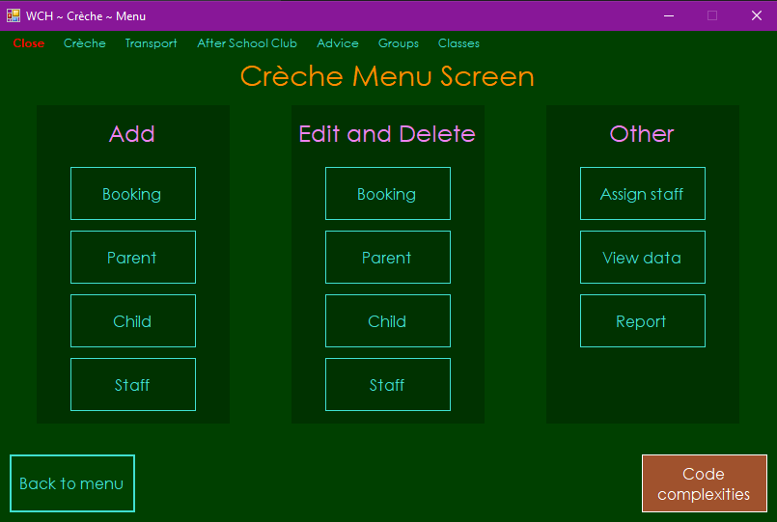

Test 63

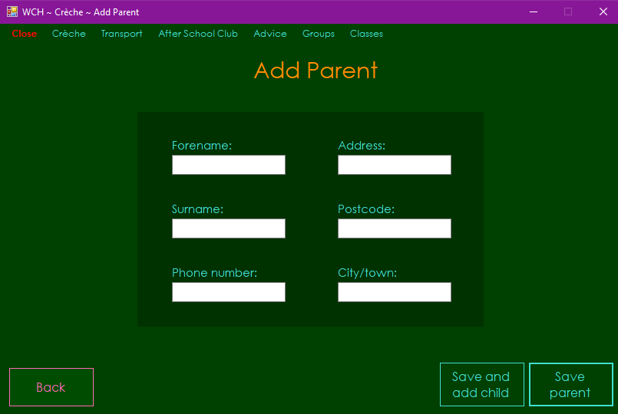

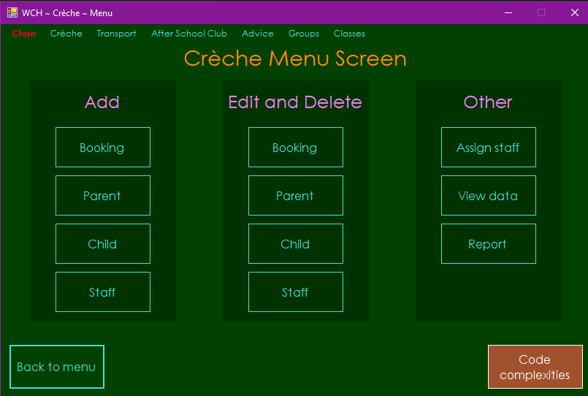

Test 64

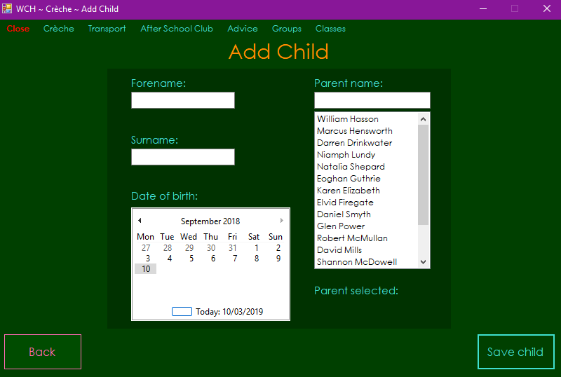

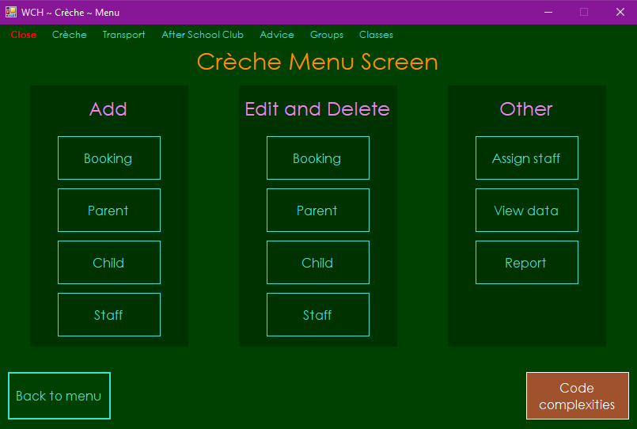

Test 65

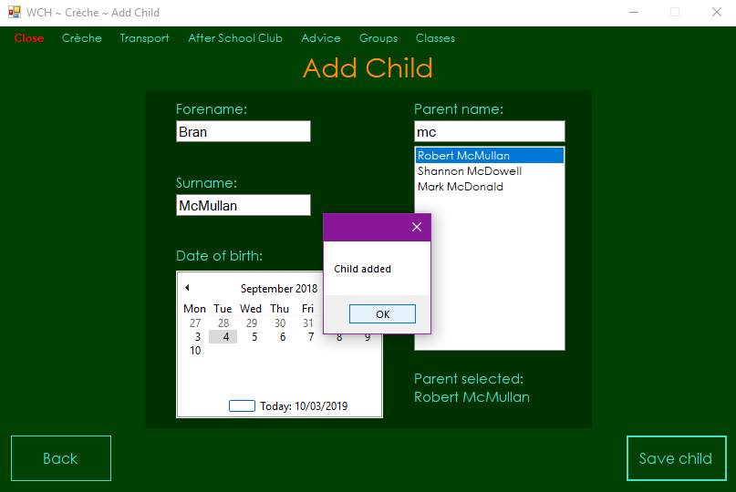

Test 66

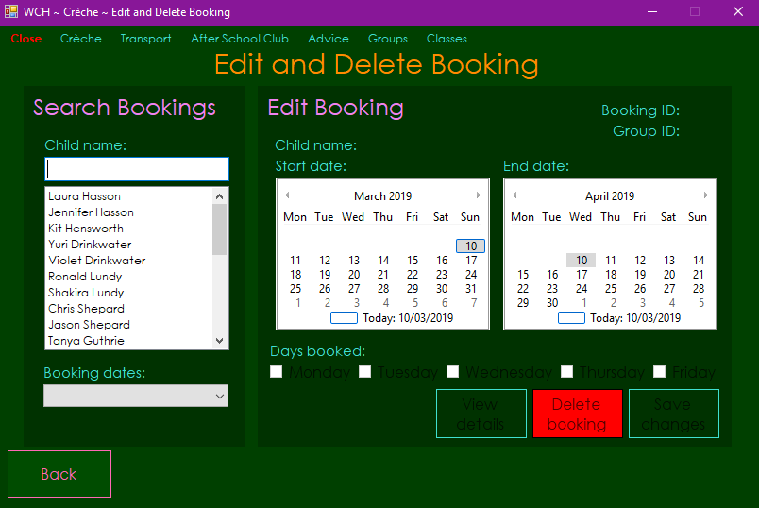

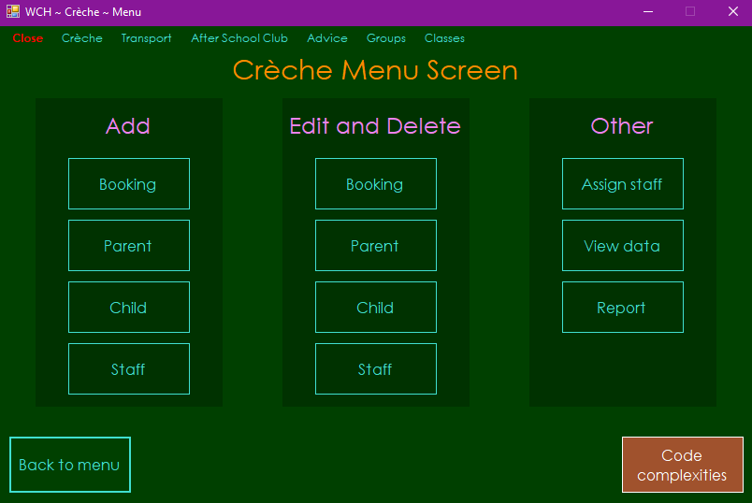

Test 67

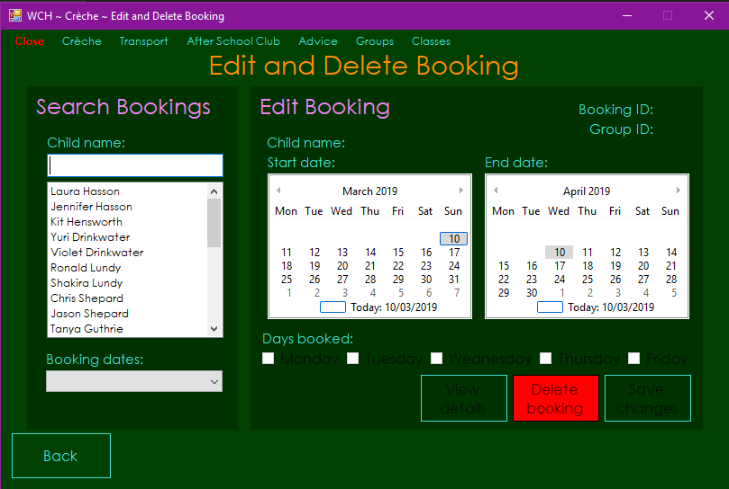

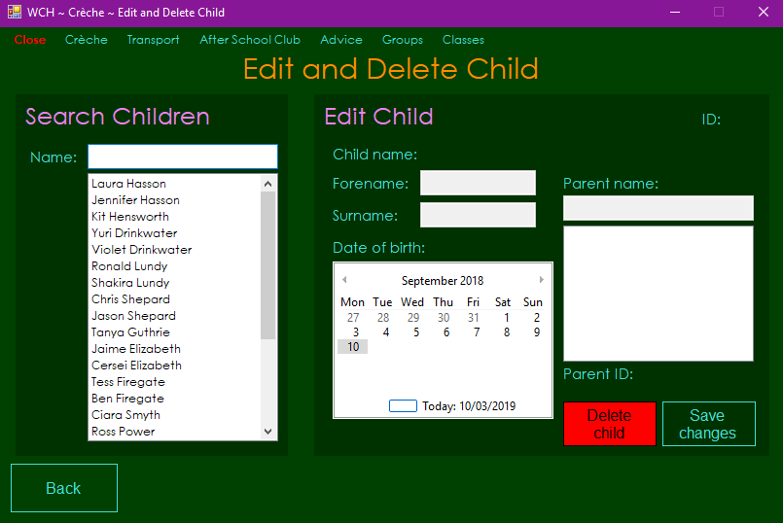

Test 68

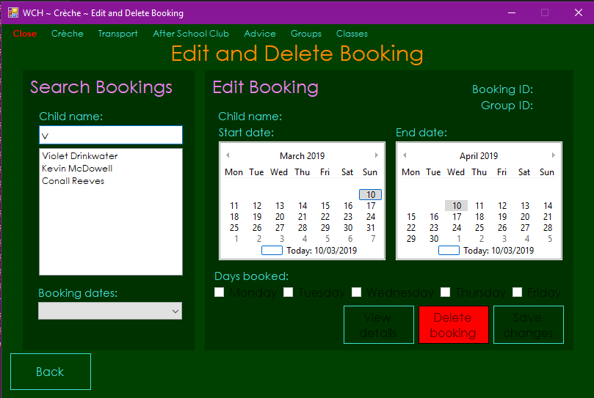

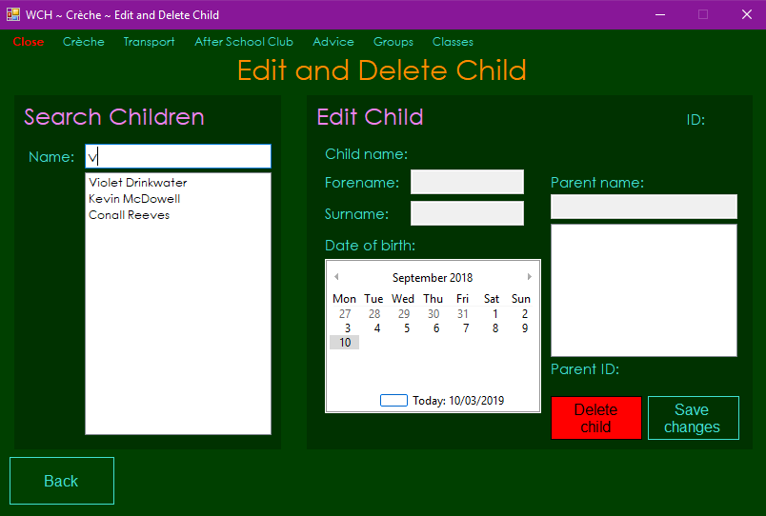

Test 69

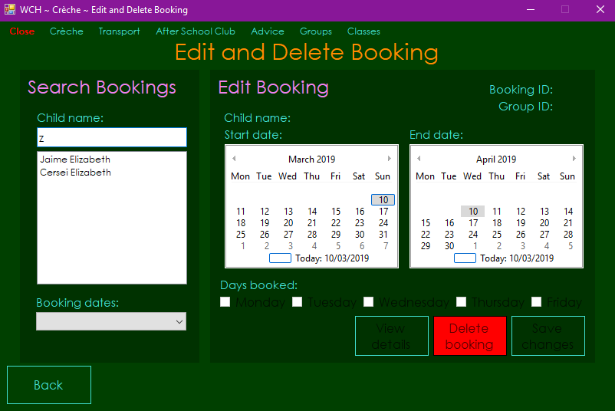

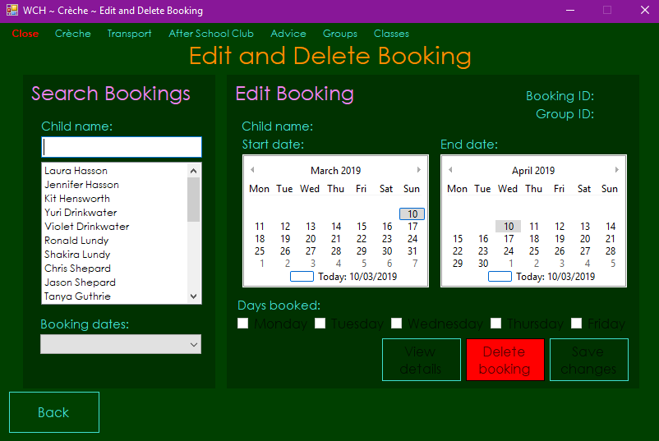

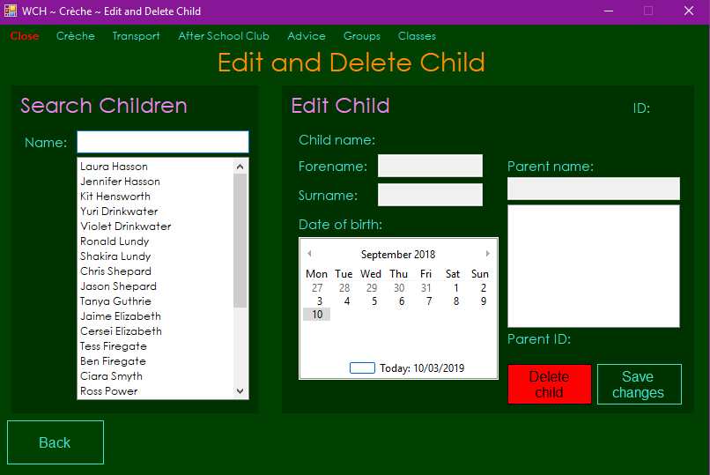

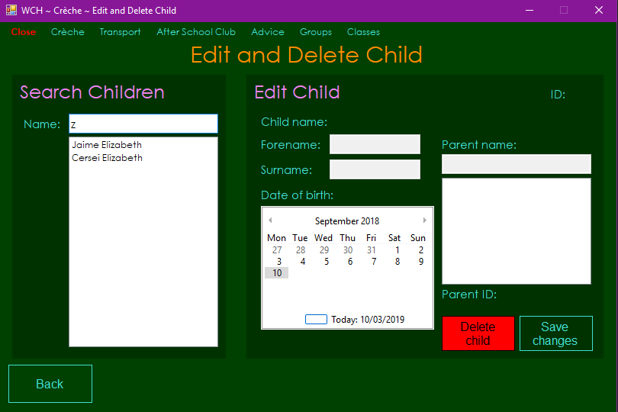

Test 70

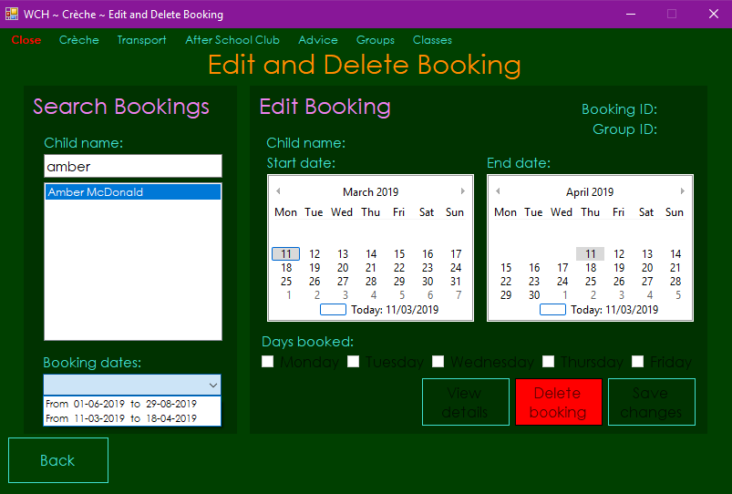

Test 71

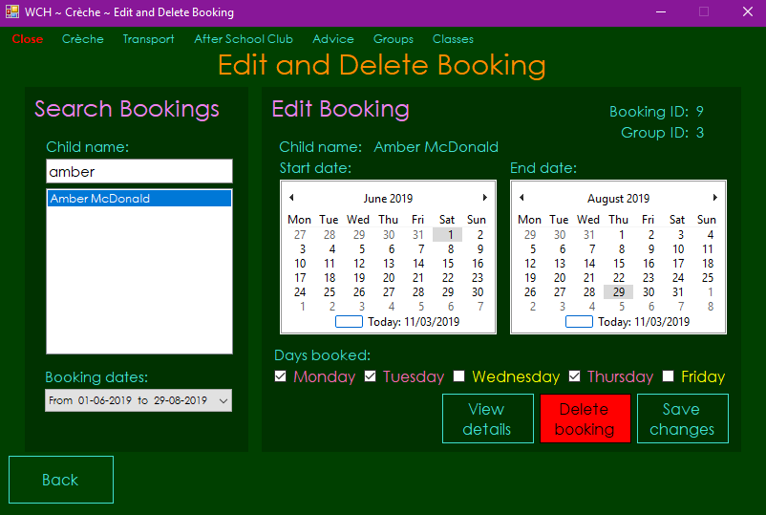

Test 72 - Failed

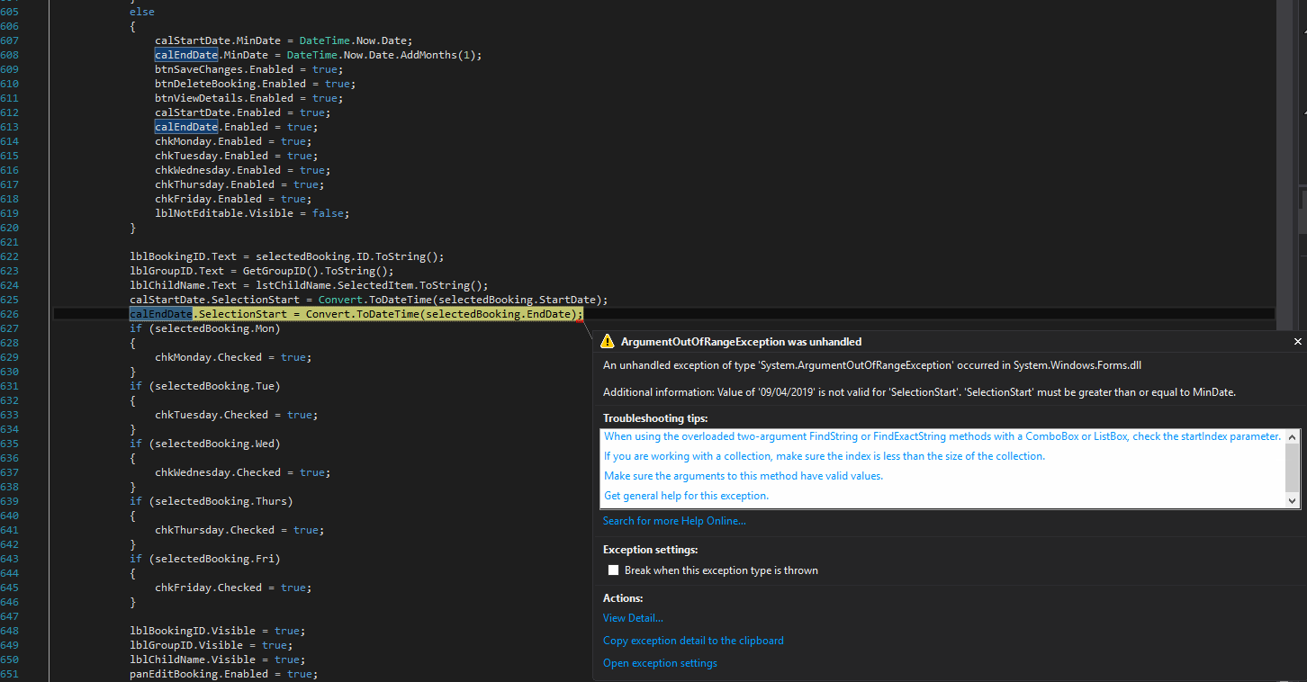

Test 72 - Fixed

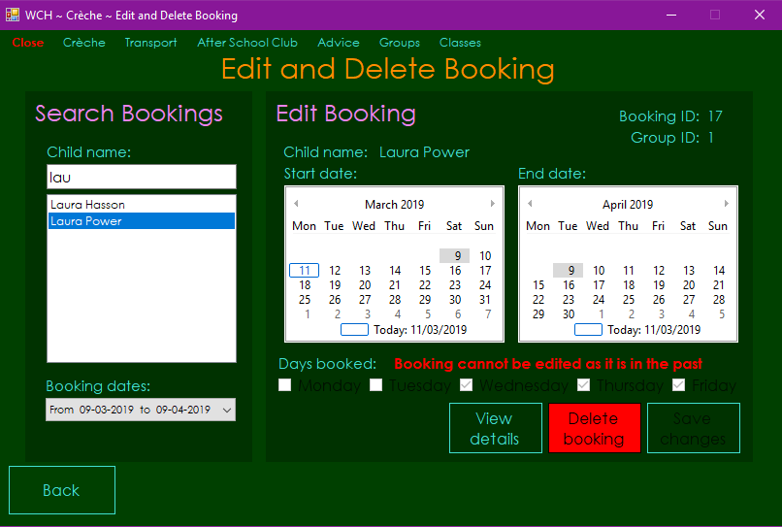

Test 73

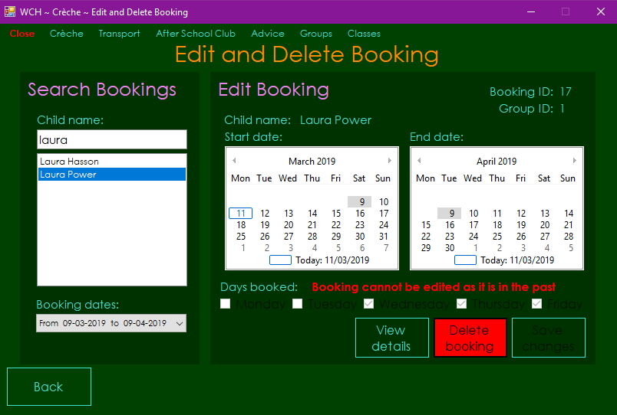

Test 74

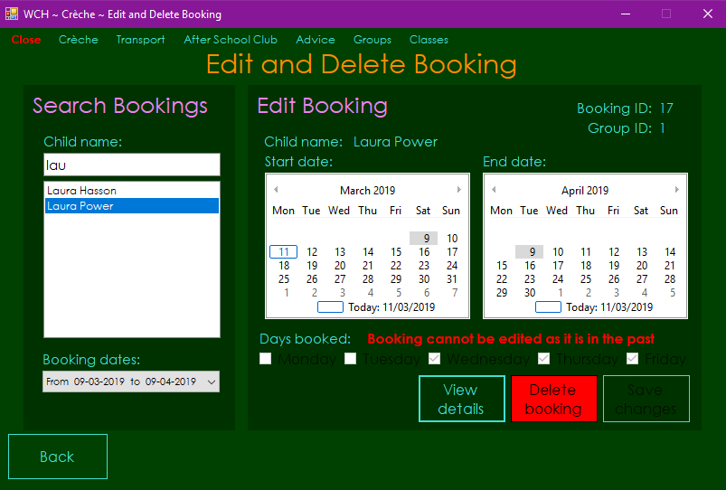

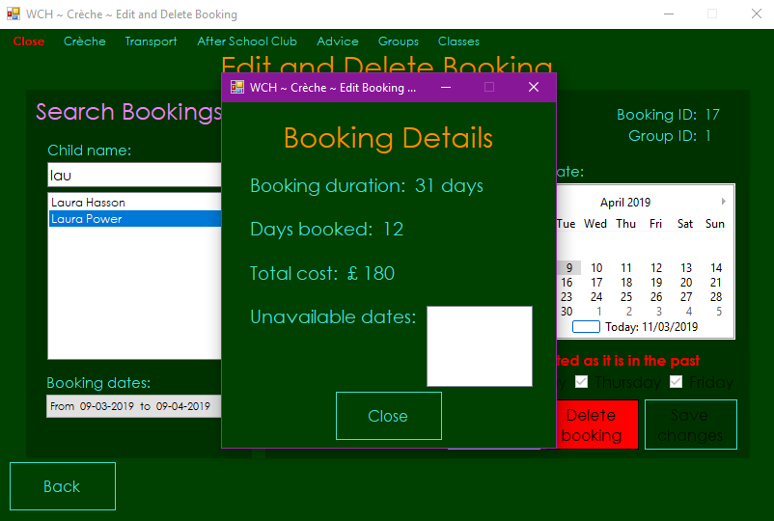

Test 75

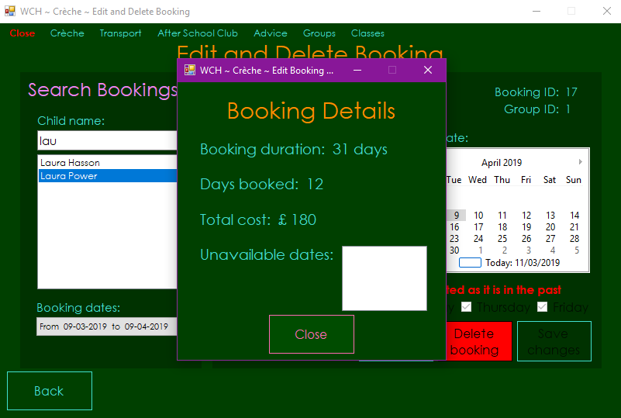

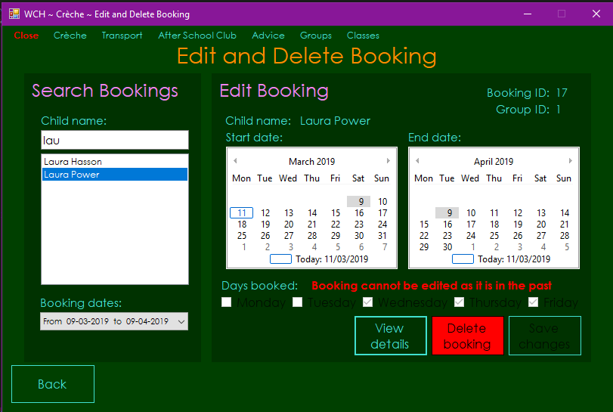

Test 76

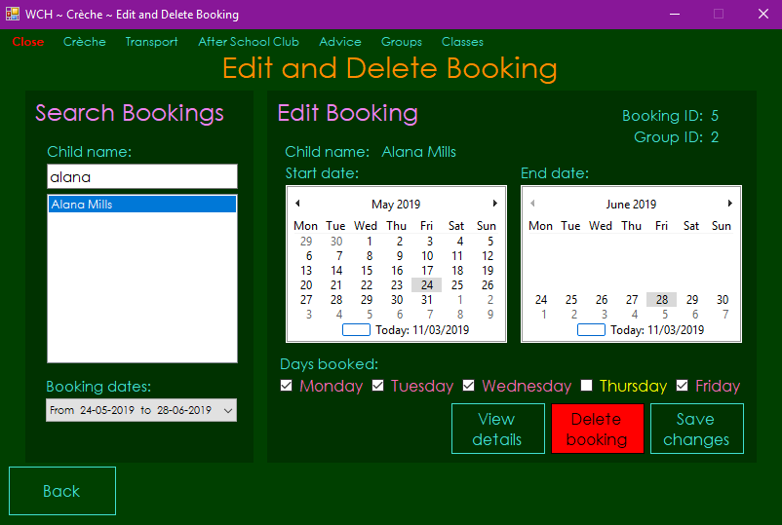

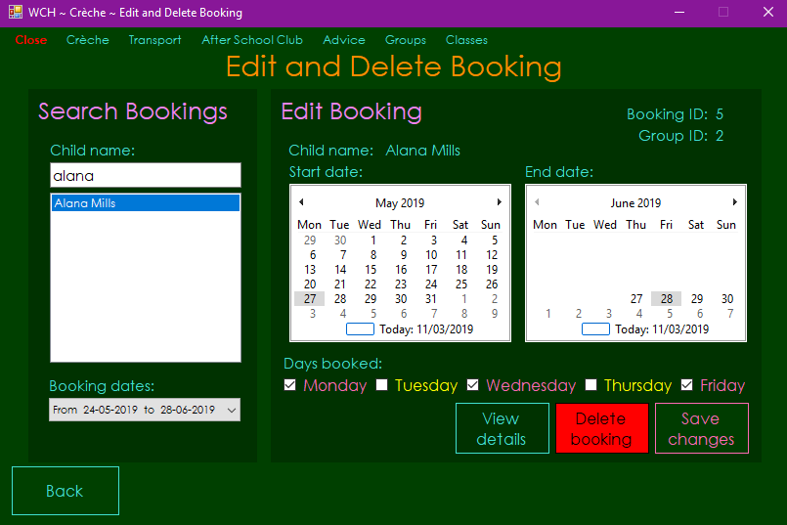

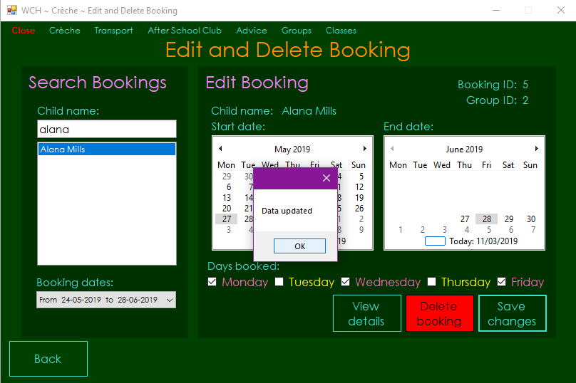

Test 77

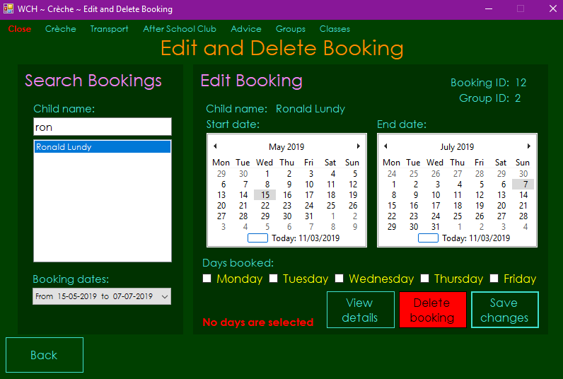

Test 78

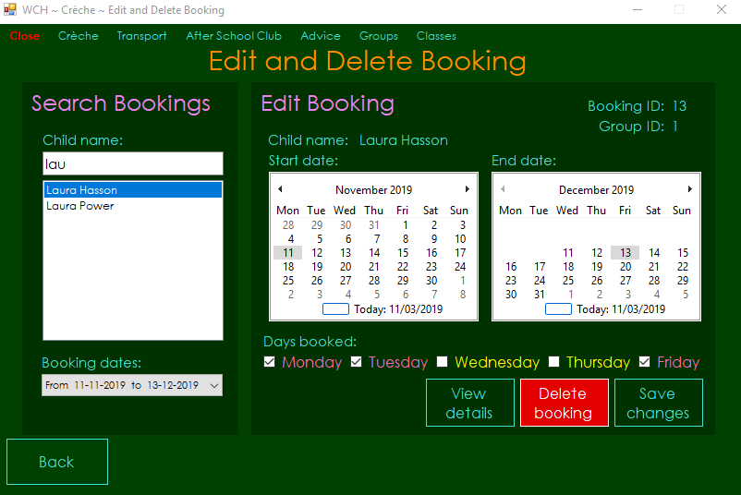

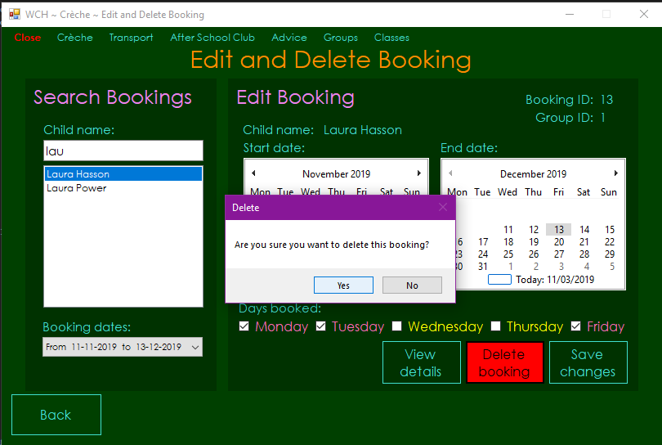

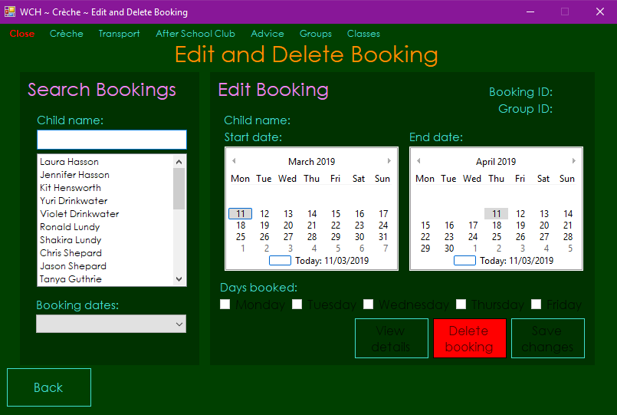

Test 79

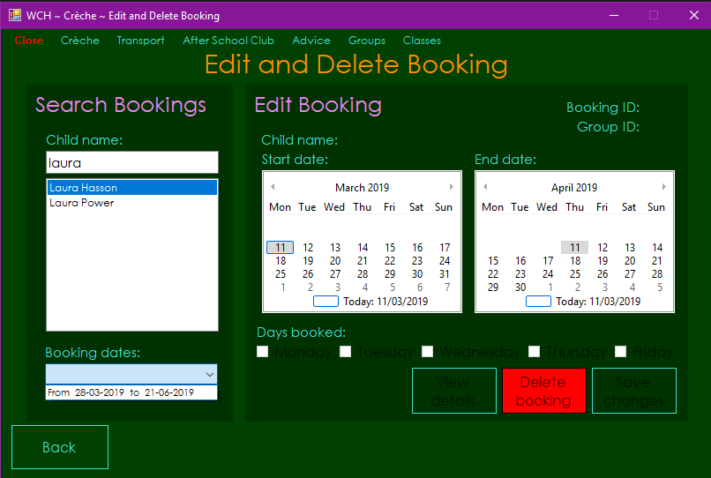

Test 80

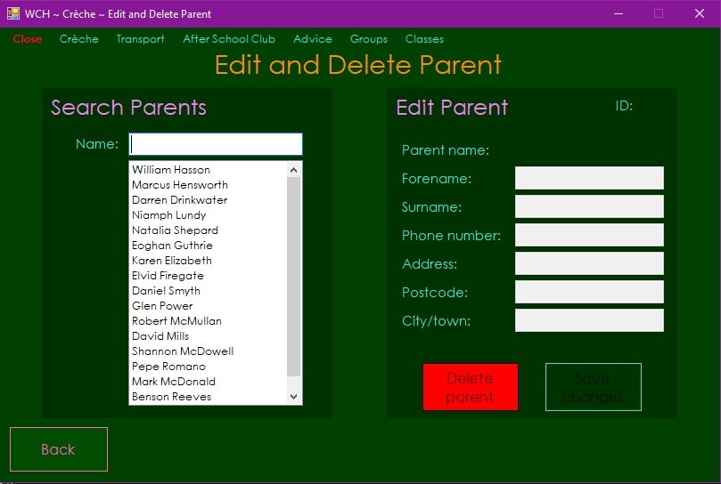

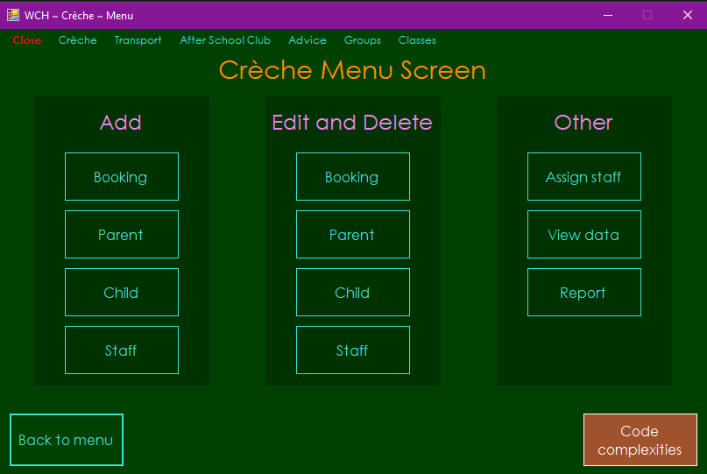

Test 81

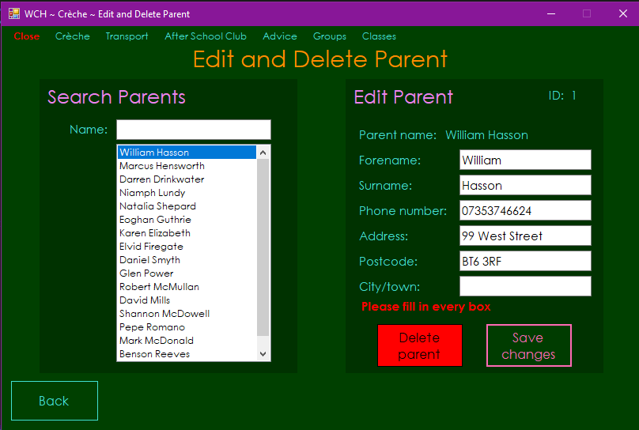

Test 82

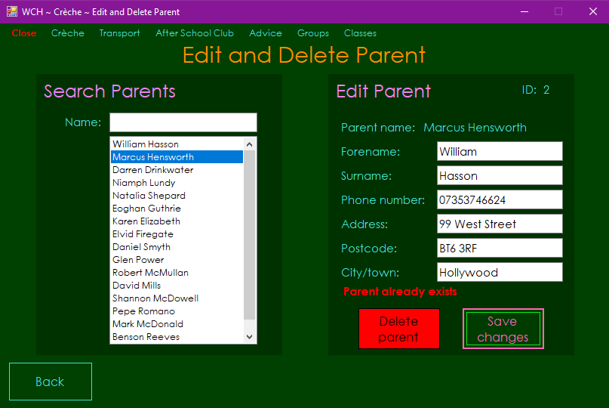

Test 83

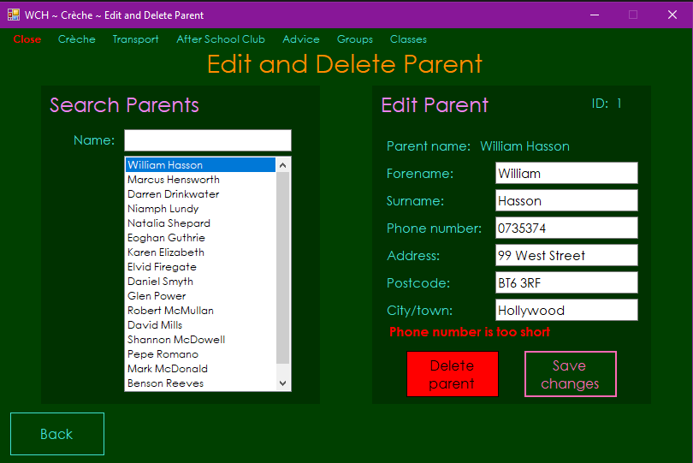

Test 84

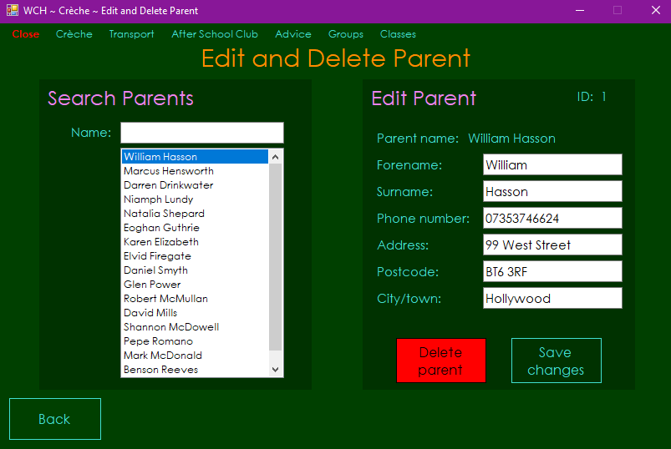

Test 85



Test 86

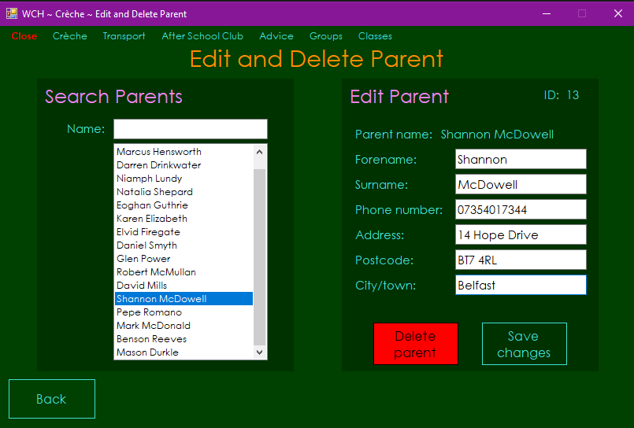

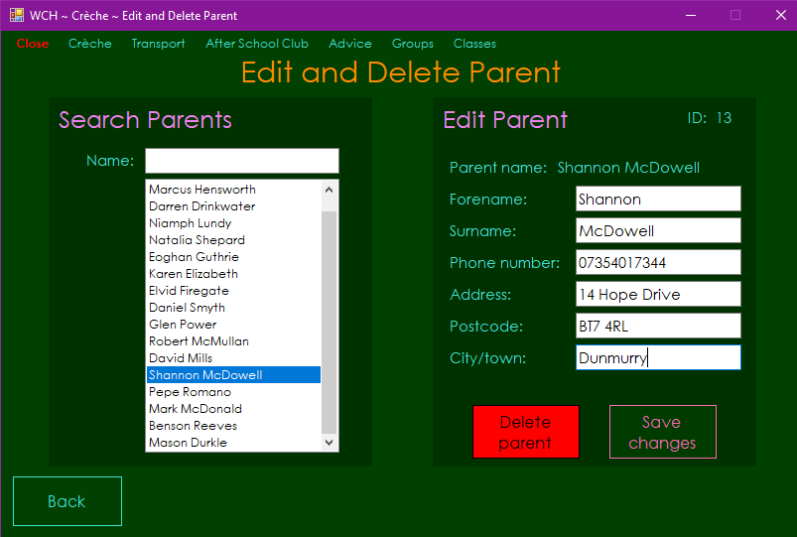

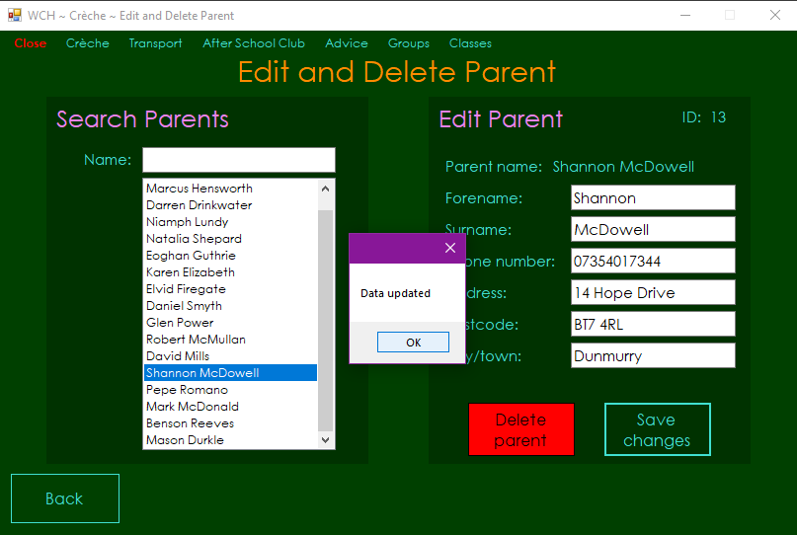

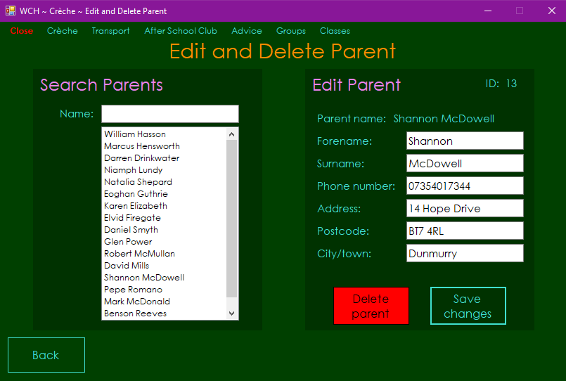

Test 87

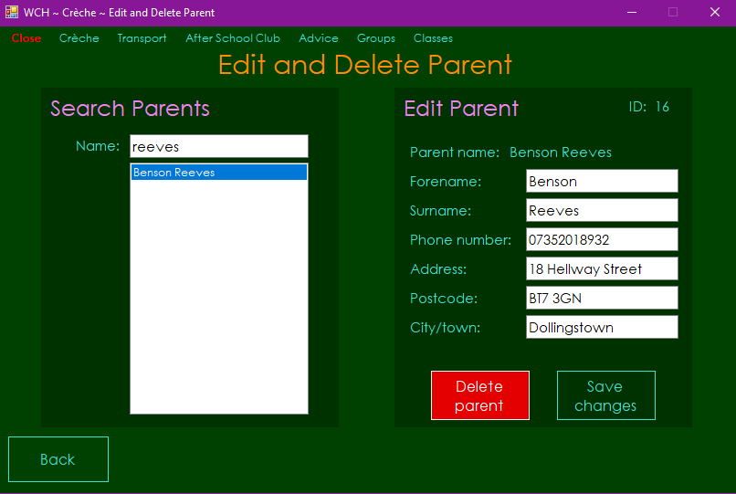

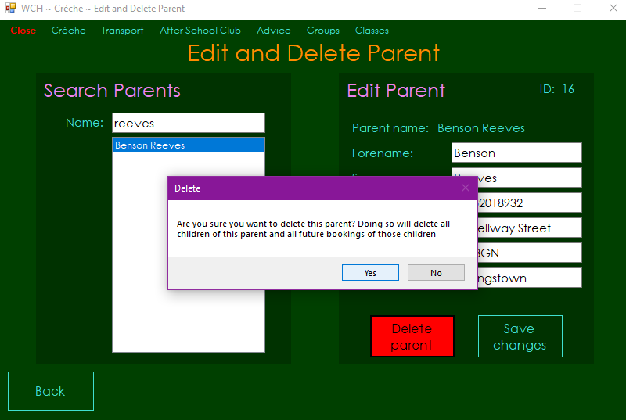

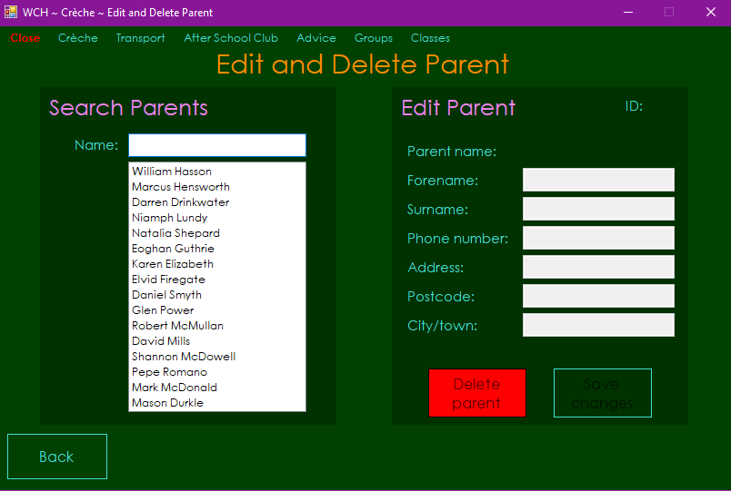

Test 88

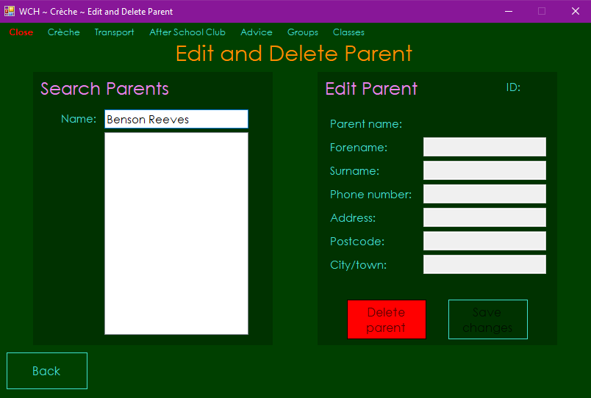

Test 91

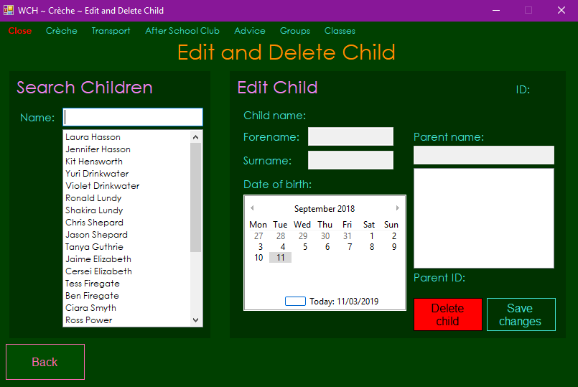

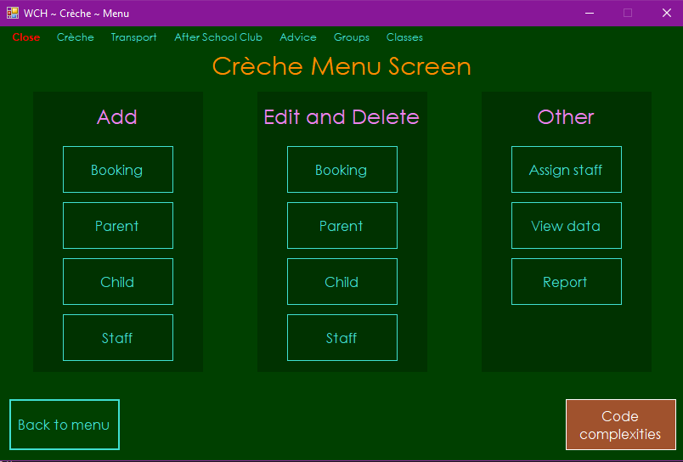

Test 92

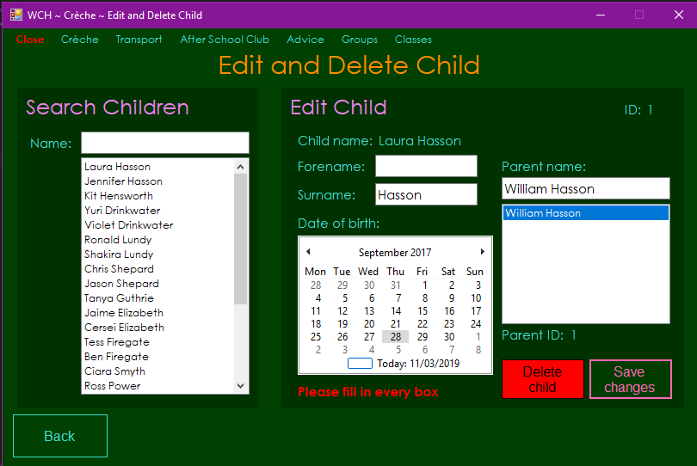

Test 93

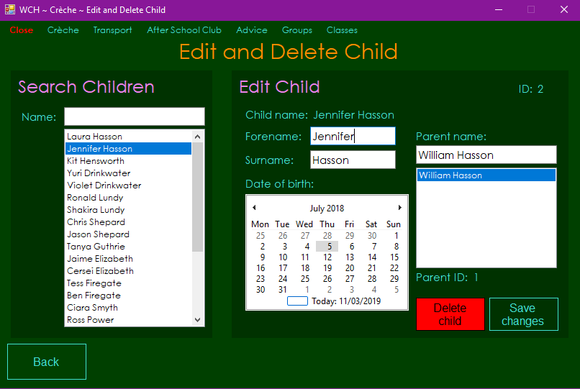

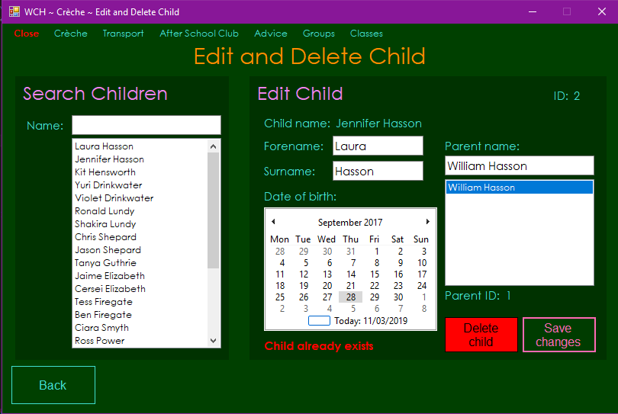

Test 94

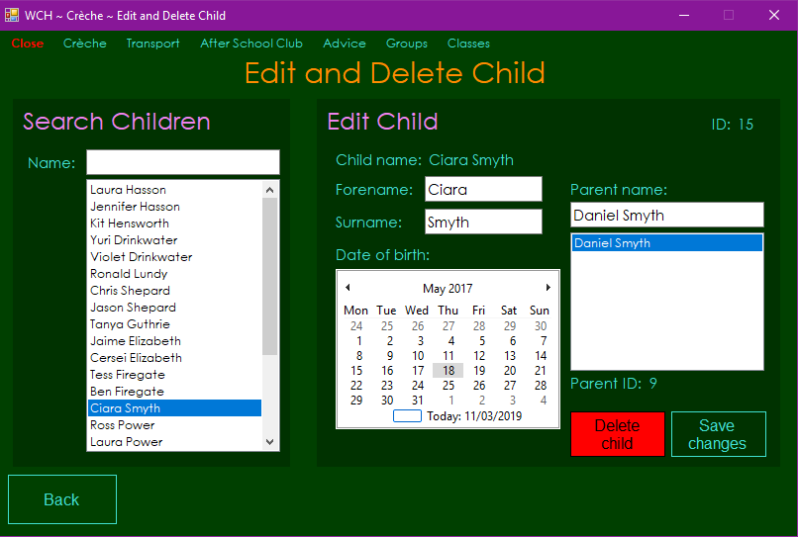

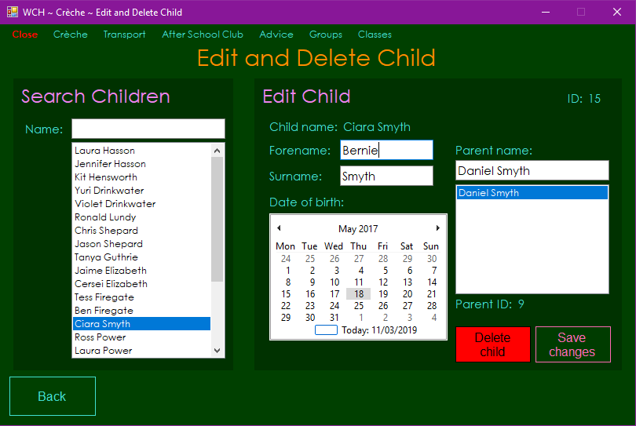

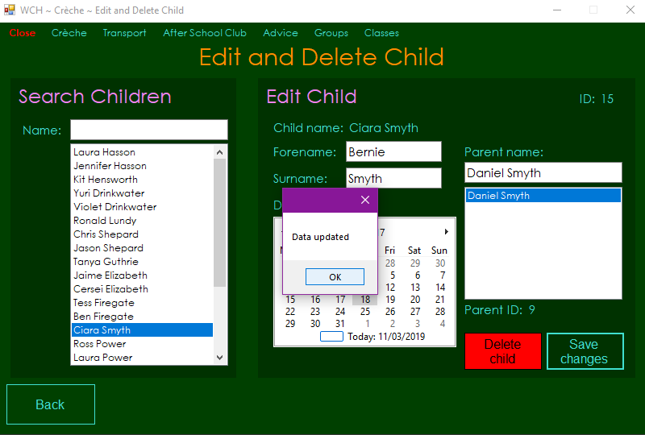

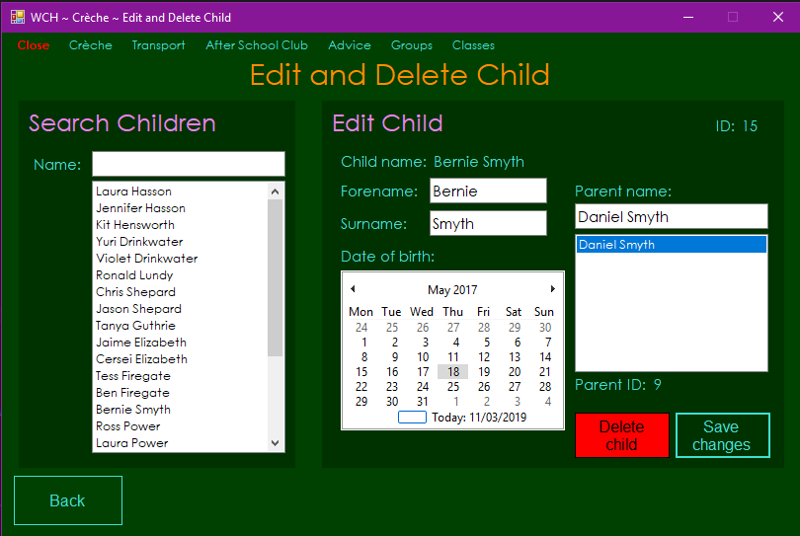

Test 95

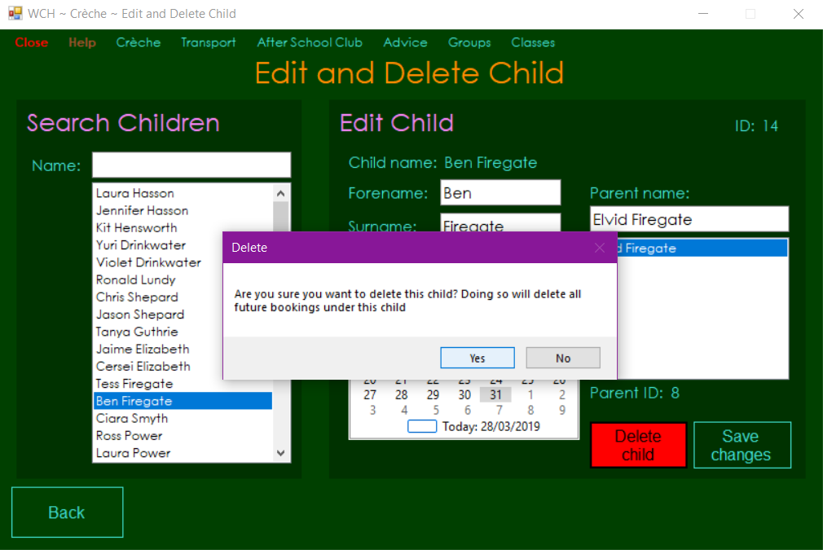

Test 96

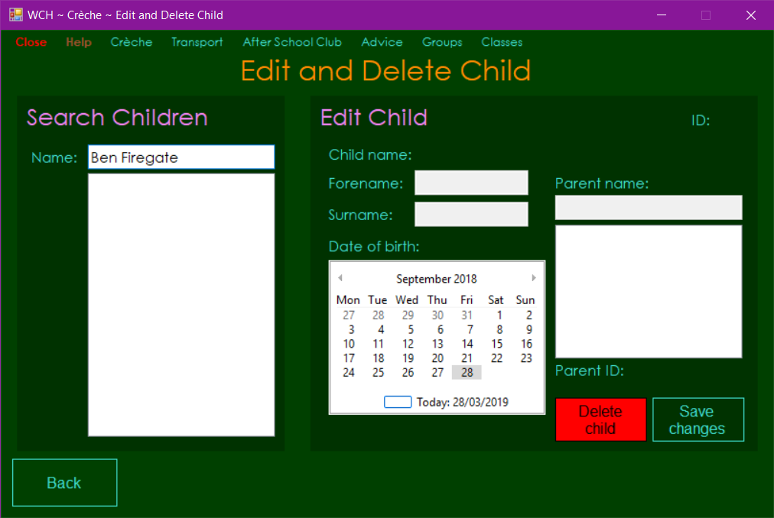

Test 97 - Failed

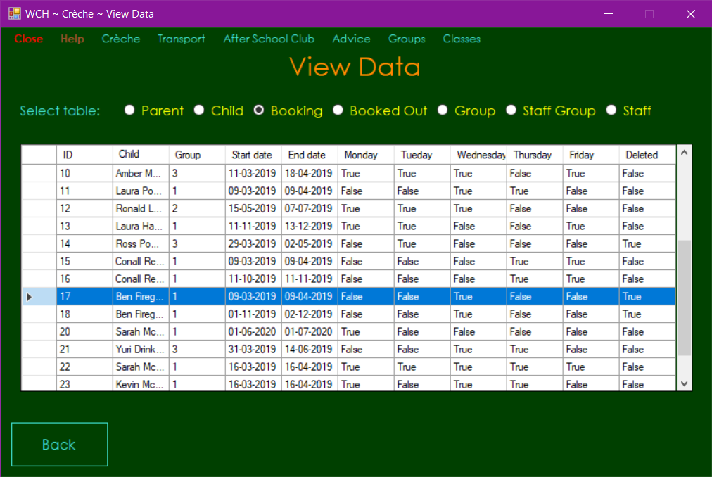

Test 97 - Fixed

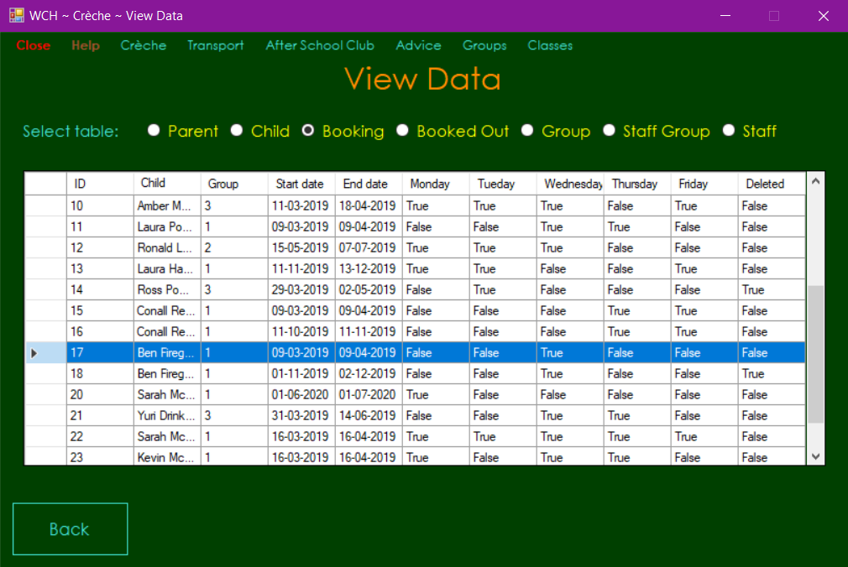

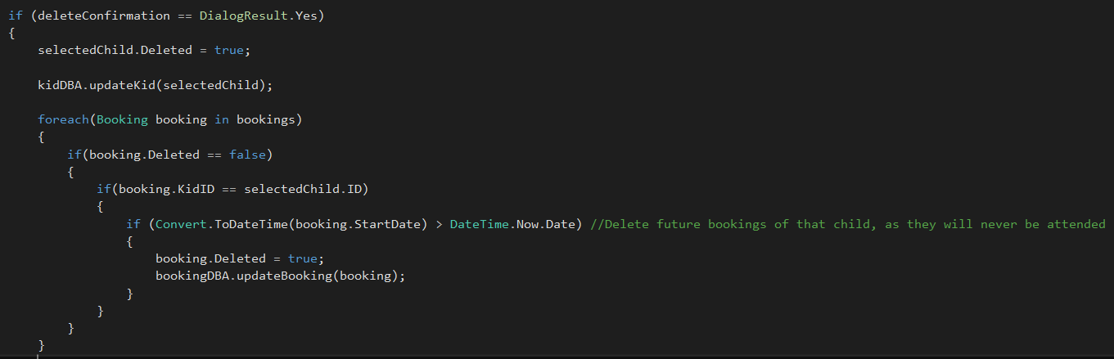

Test 98

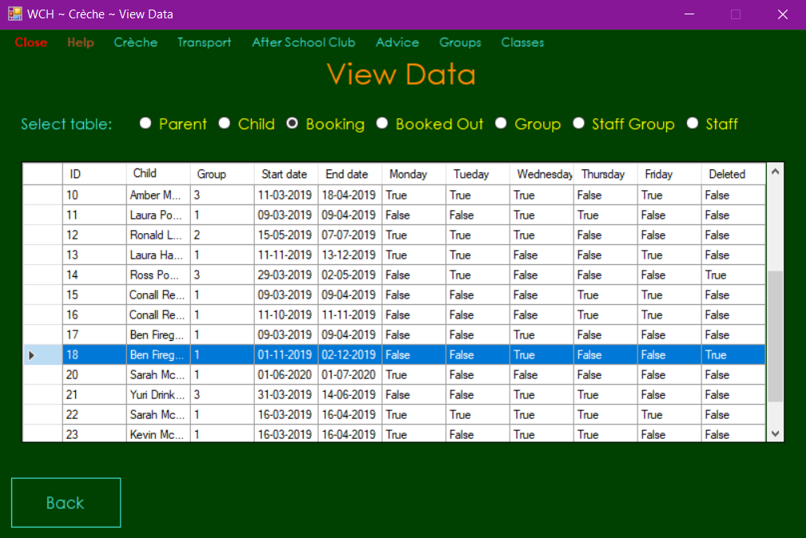

Test 99



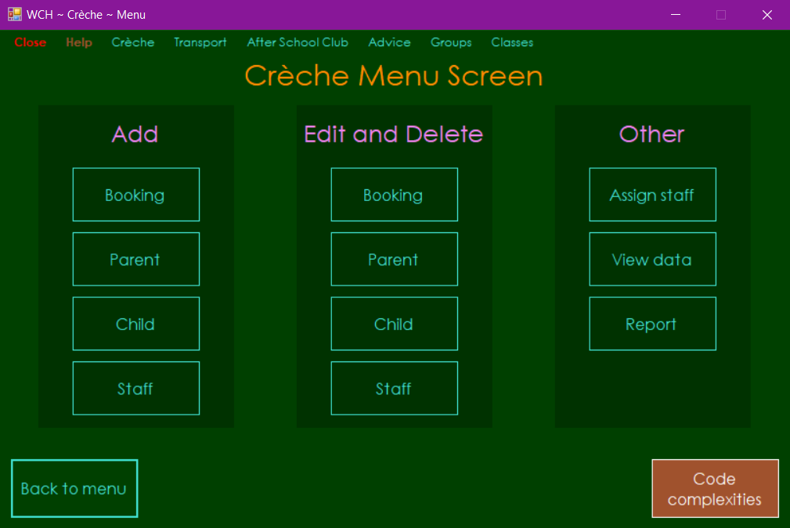

Test 100

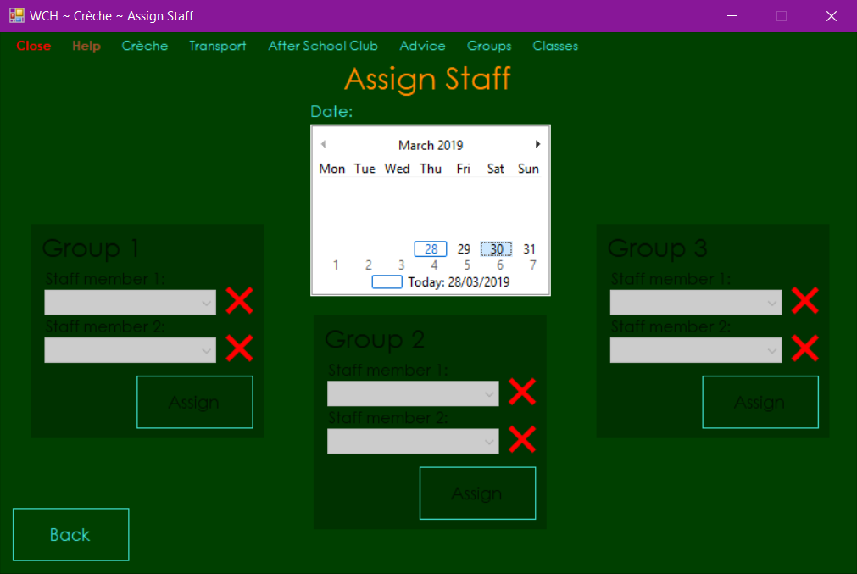

Test 101

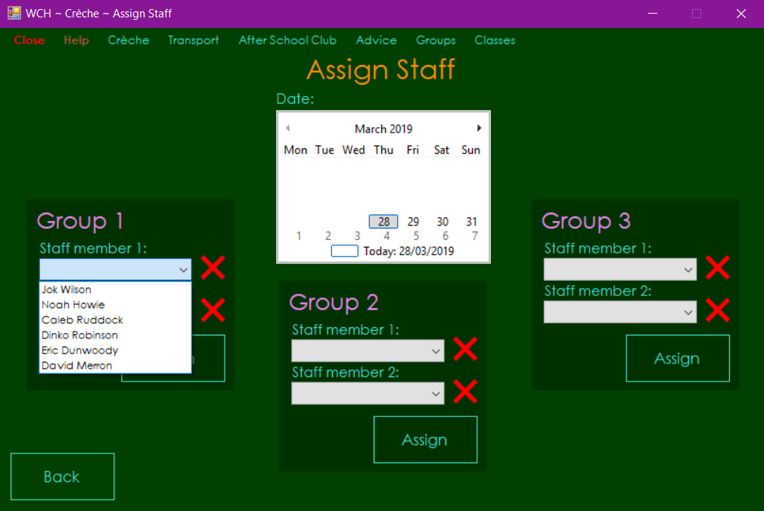

Test 102

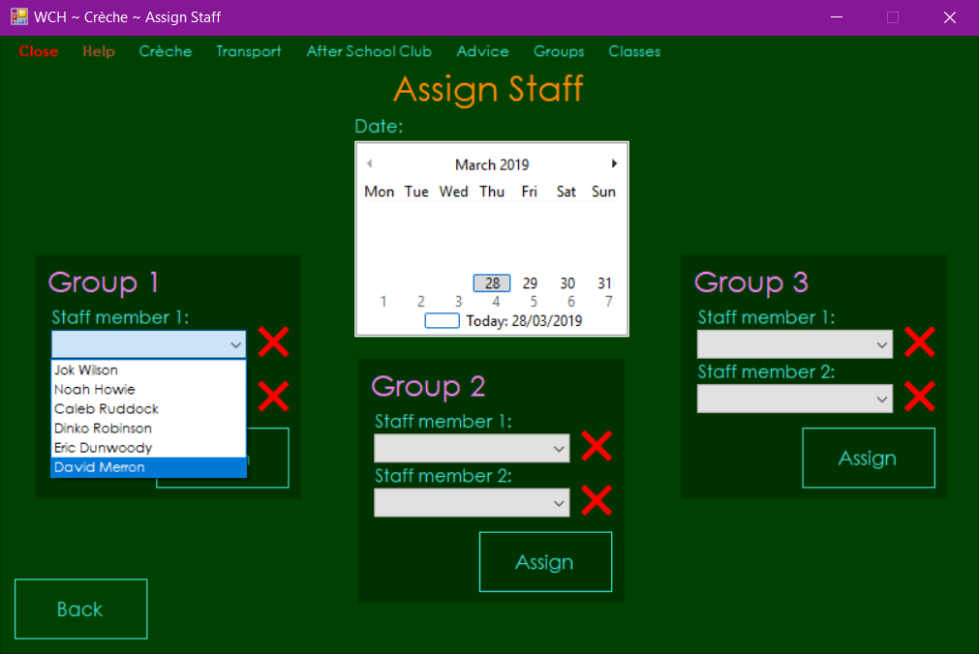

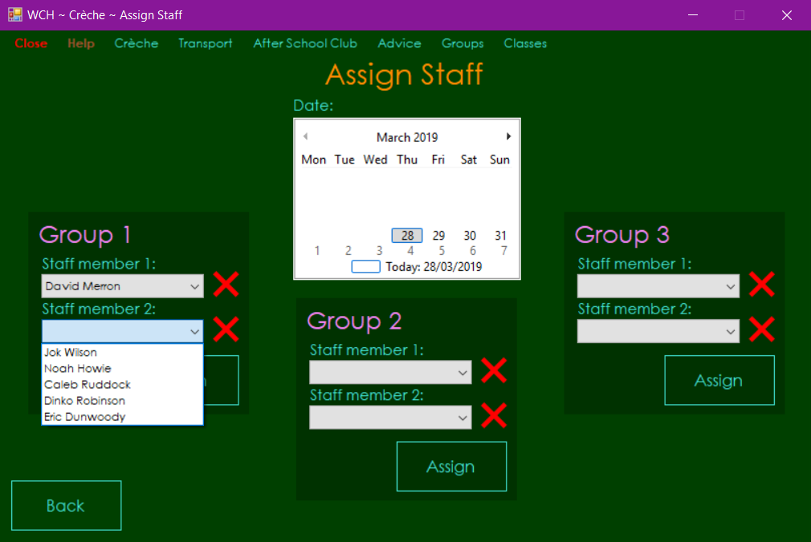

Test 103

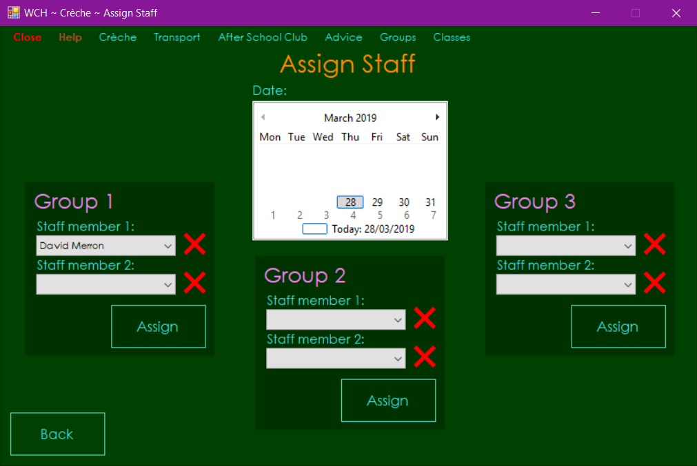

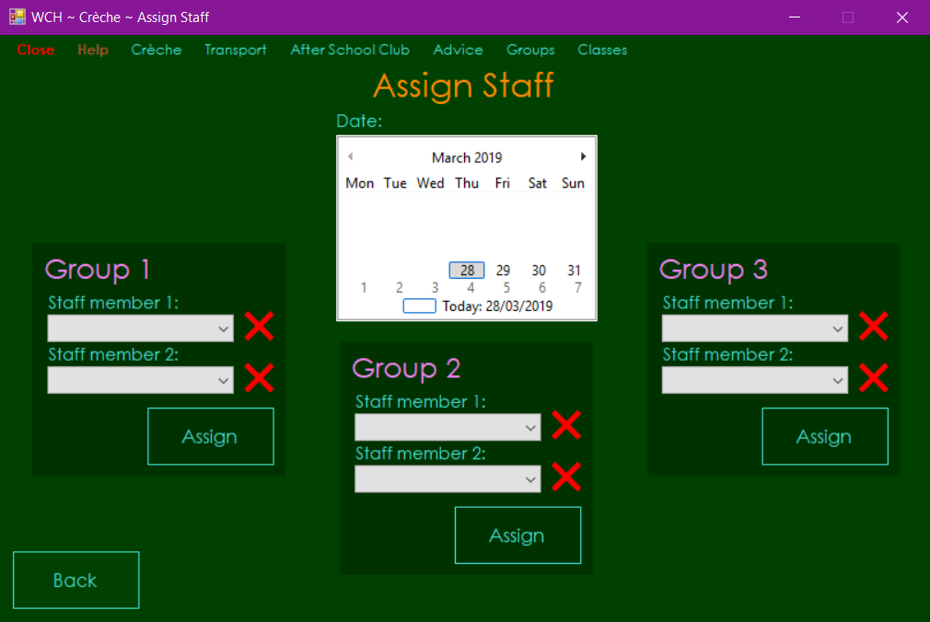

Test 104

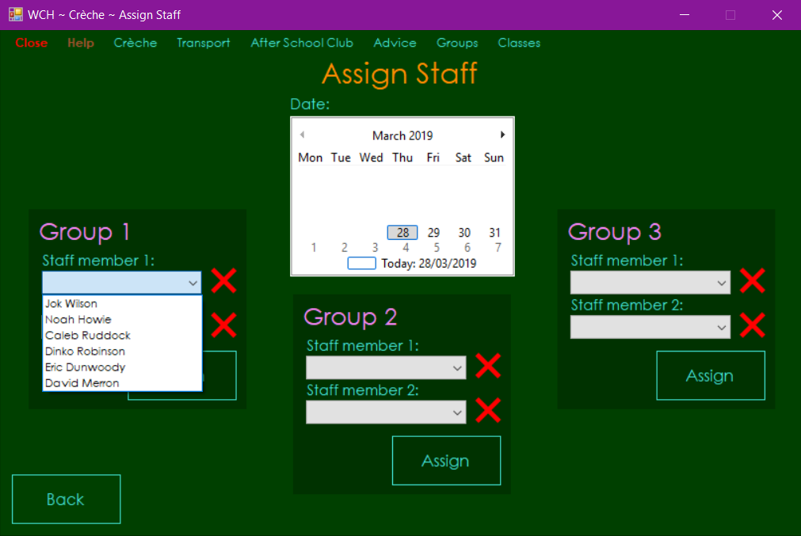

Test 105

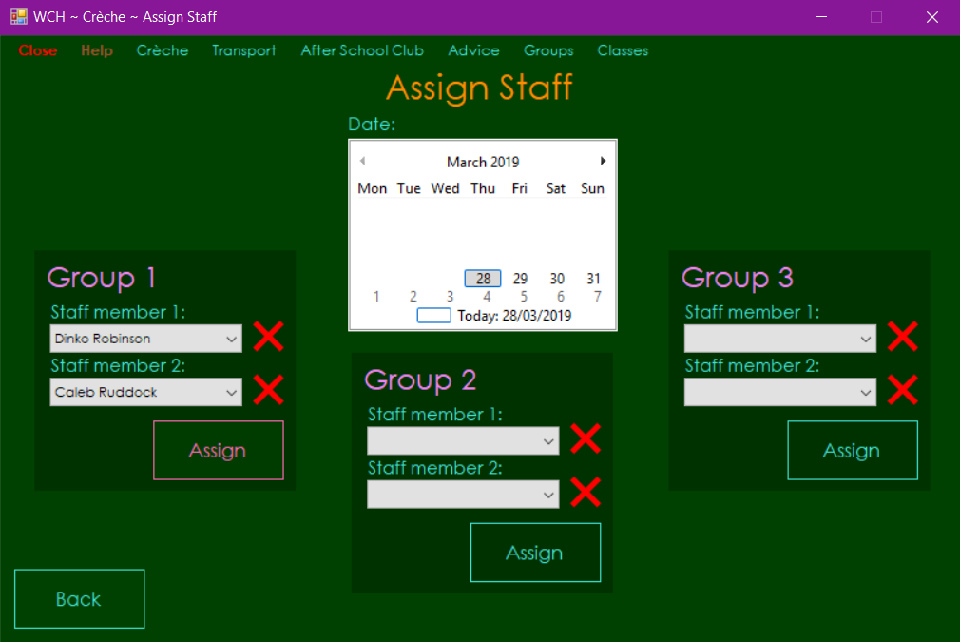

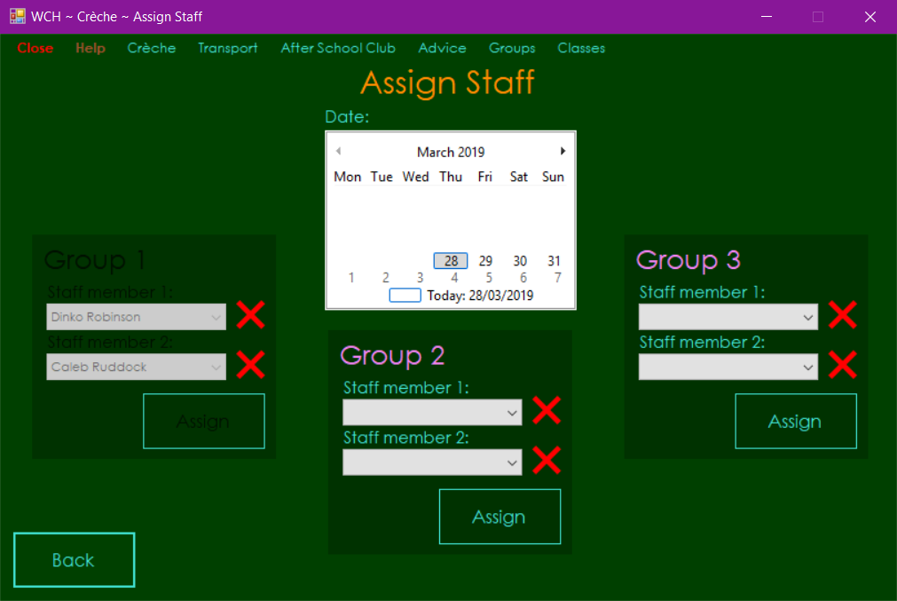

Test 106



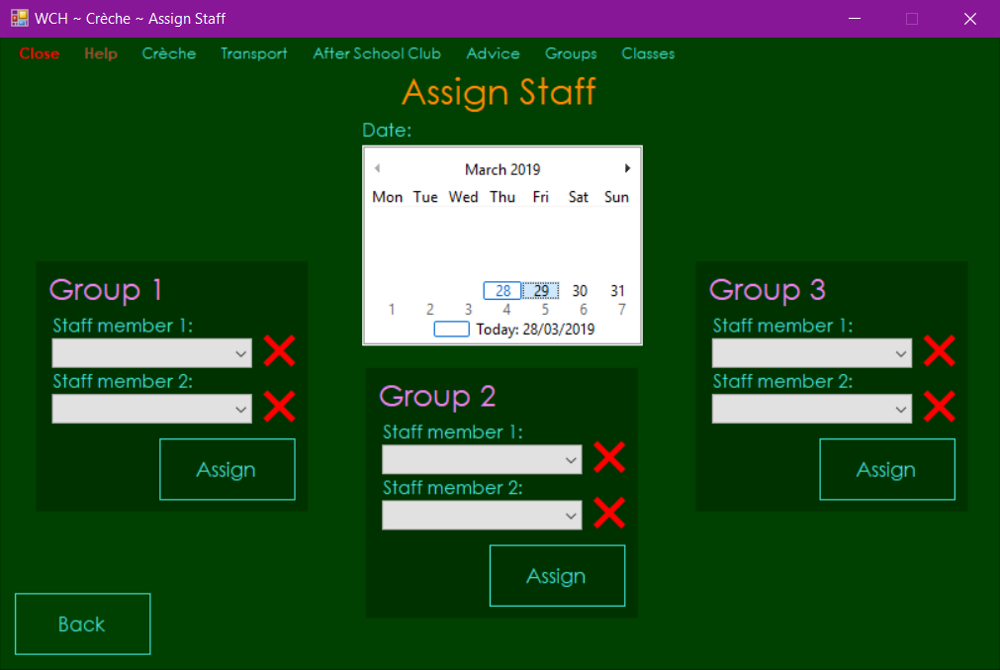



Test 107



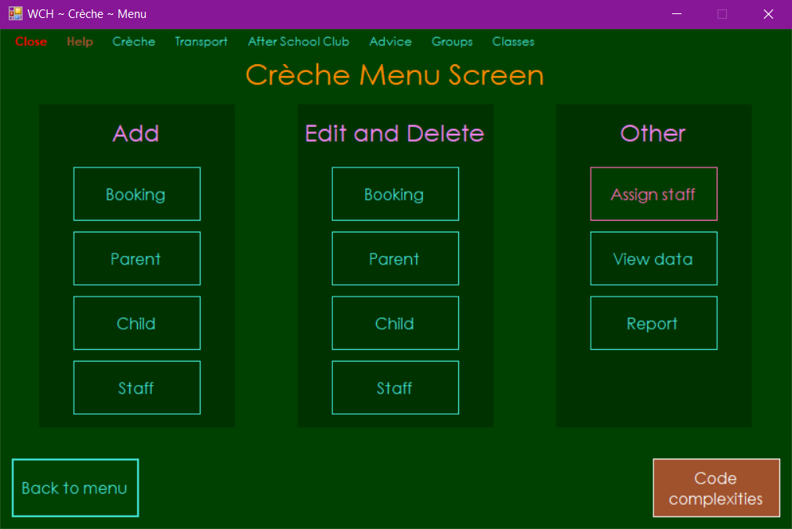



Test 108

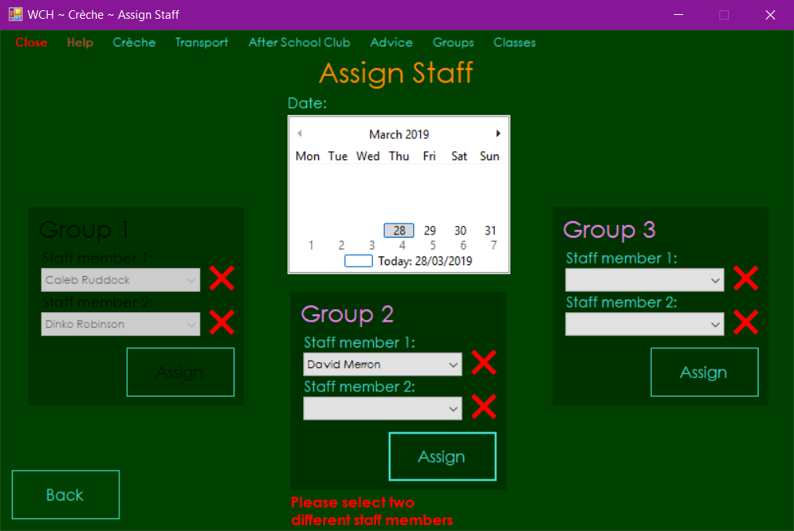

Test 109





Test 110

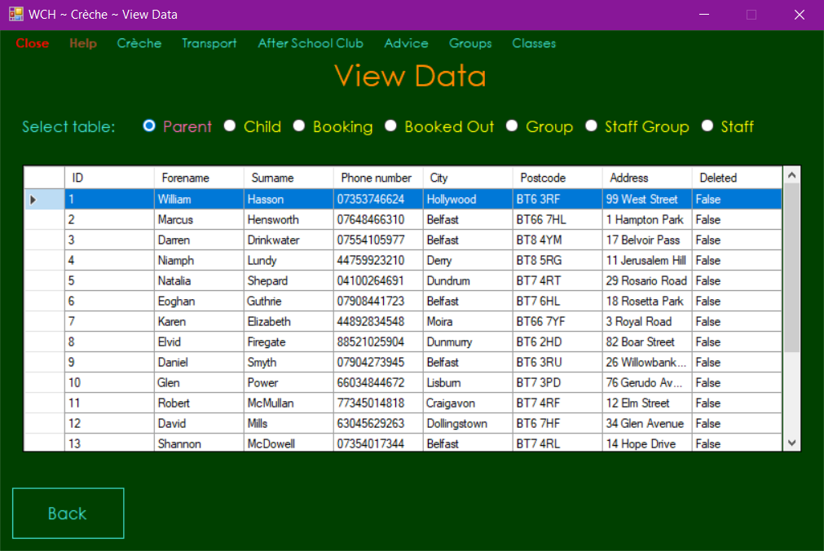

Test 111

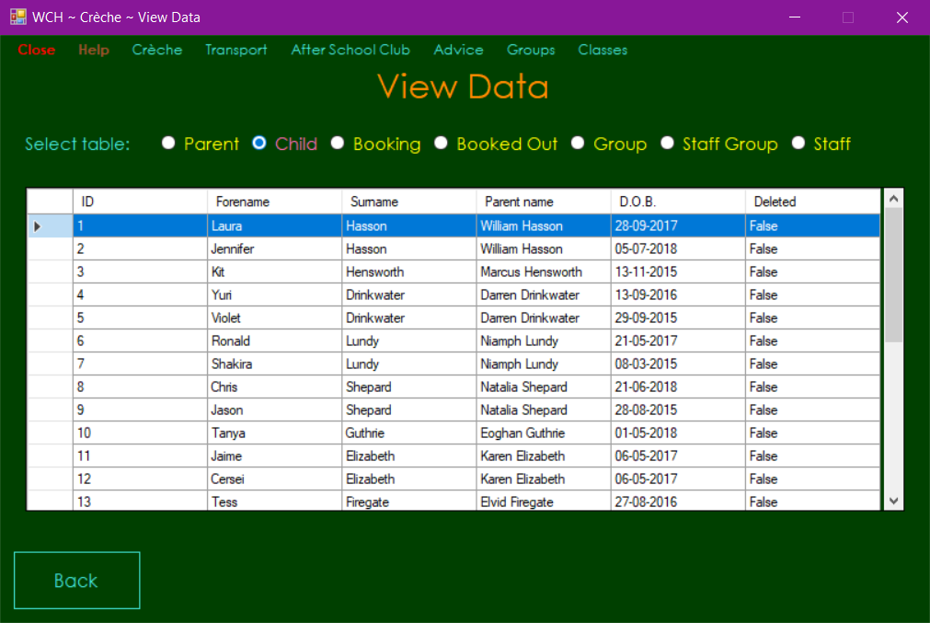

Test 112

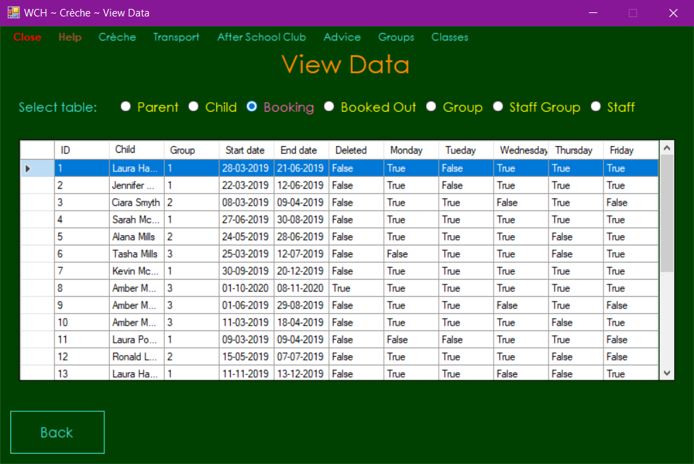

Test 113

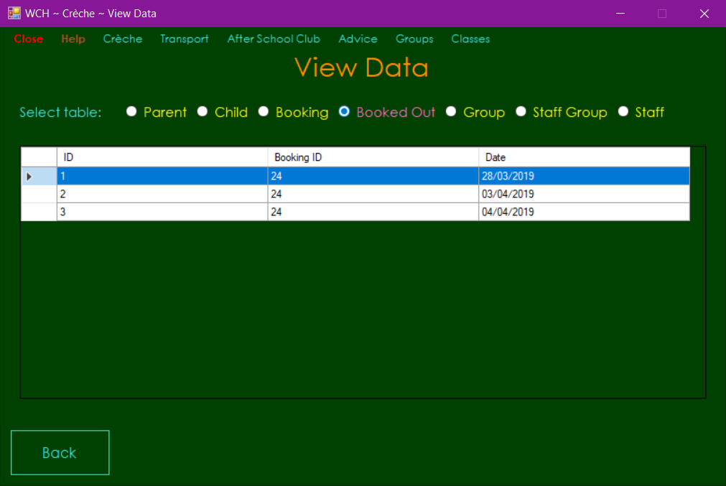

Test 114

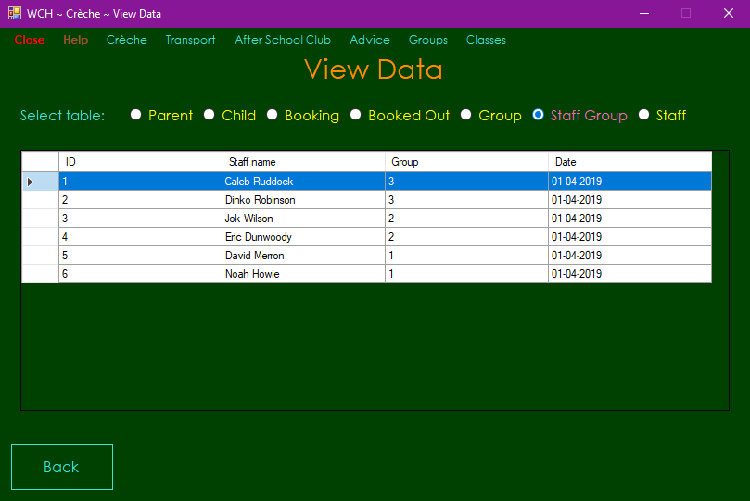

Test 115

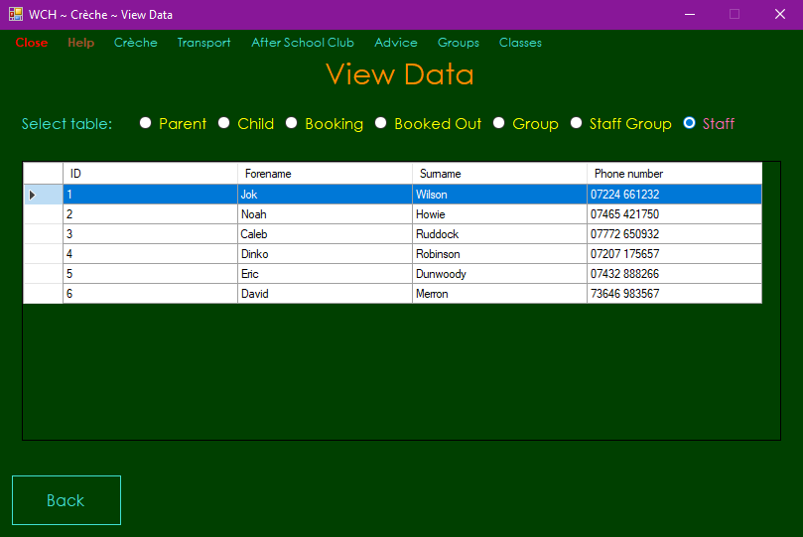

Test 116

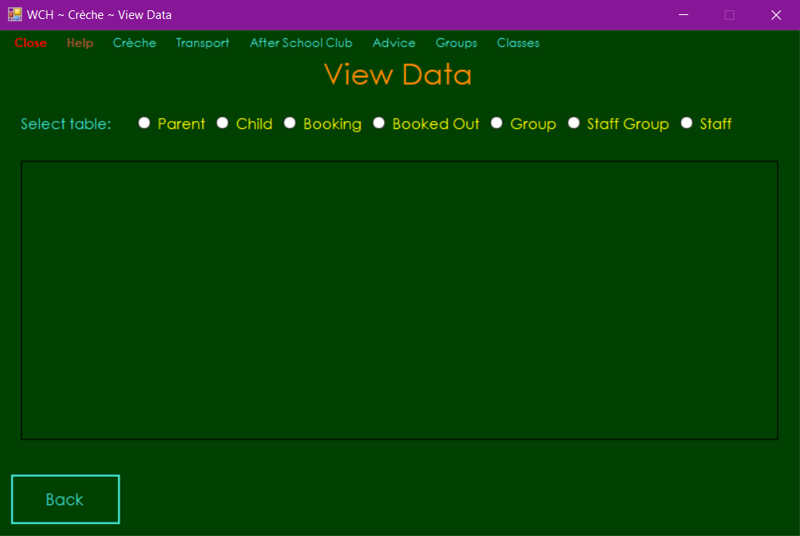



Test 117

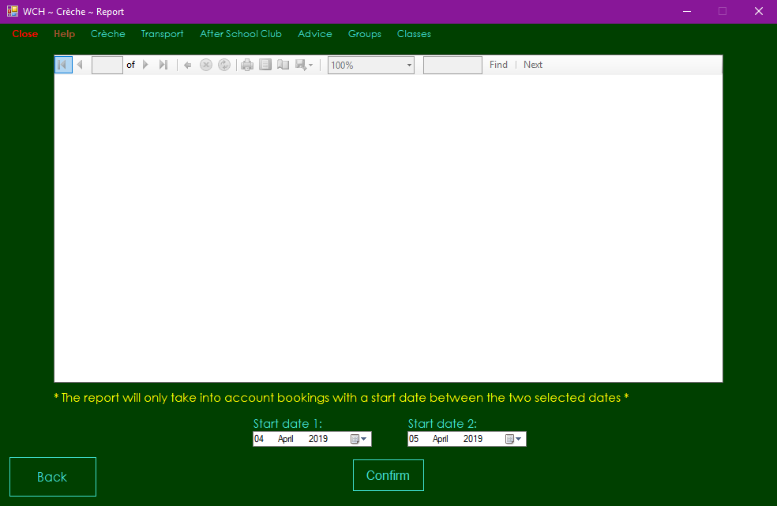

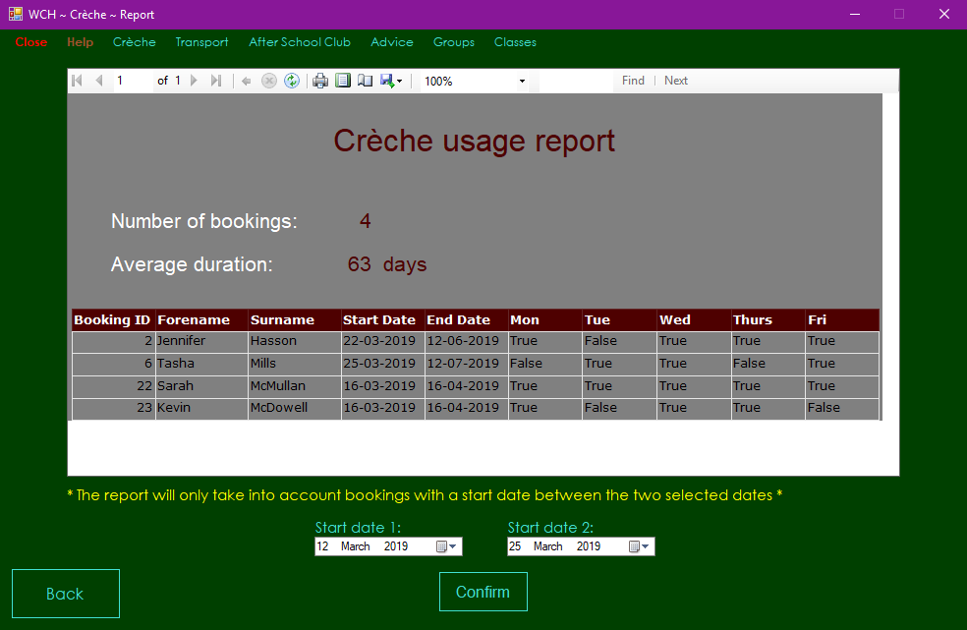

Test 118



Test 119



Test 120



# **Evaluation**

## **Evaluation of User Requirements**

1. *The user should be able to add, edit and delete parents*

I have fulfilled this requirement as the user can add parents in Booking Select Child Form and Add Parent Form and they can edit and delete parents in Edit and Delete Parent Form. This is seen in tests 35, 36, 86 and 87.

1. *The user should be able to add, edit and delete children*

I have fulfilled this requirement as the user can add children in Booking Select Child Form and Add Child Form and they can edit and delete children in Edit and Delete Child Form. This is seen in tests 36, 37, 65, 94 and 95.

1. *The user should be able to add, edit and delete bookings*

have fulfilled this requirement as the user can add bookings in Booking Select Dates Form and edit and delete children in Edit and Delete Booking Form. This is seen in tests 61, 62, 76 and 78

1. *When adding a child, the user must be able to select the parent by searching their name, as well as browsing a list of all parents*

This requirement has been met as search parent functionality is found in Add Child Form. I implemented this search functionality six times throughout my system (once in Booking Select Child Form, once in Add Child Form, once in Edit and Delete Booking Form, once in Edit and Delete Parent Form and twice in edit and Delete Child Form), which makes the user experience a lot more efficient than if I were just to implement it in Add Child form. A reflection of identical functionality can as this requirement be found in tests 31 to 34.

1. *Bookings must be able to be made, with the ability to select which weekdays are booked and which aren’t*

This requirement could be seen as the back bone for the most important functionality in the entire program. I met this requirement as when making a booking, the user must select the weekdays they wish to book via the Monday to Friday check boxes on Booking Select Dates Form. The booking cannot be made unless at least one weekday is selected. This requirement is assessed in tests 48, 61 and 62.

1. *Bookings should not be able to be made with an admission time of less than one month*

This has been fulfilled as the minimum date value for the end date calendar is set to be exactly one month after the earliest selectable start date on Booking Select Dates Form. When the user selects a different start date, the minimum date value for the end date calendar automatically changes to one exactly one month after the selected start date. Test 46 proves this.

1. *A discount of 5% is applied if the booking is made six months in advance and a discount of 3% is applied if the booking is made three months in advance*

I met this requirement in Booking Select Dates Form, where the correct discount is applied to the total cost of the booking automatically if the user selects a start date which is at least three months in the future. The user is informed, as beside the cost it will say either, ‘*5% discount applied*’ or ‘*3% discount applied*’, depending on the discount. I showed this in tests 57 and 58.

1. *Children must be automatically placed in a group based on their age*

This requirement was accomplished as the selected child’s date of birth is compared against the current date to place them in the suitable group, as displayed to the user via a label in Booking Select Dates Form, tested in test 45.

1. *Children must be automatically moved up in group once they become too old for their current group*

This requirement was fulfilled by default after meeting requirement *h* because the selected child is placed in a group every time Booking Select Dates Form is loaded, meaning that the child will automatically be placed in the next group if they become too old for their previous one. For this reason, test 45 also houses the test for this requirement.

1. *There should be a maximum of: six children in the six to eighteen month group, ten in the eighteen to thirty month group and nine in the thirty months to four years group*

I fulfilled this requirement with the immensely complex booked out dates system in which dates which have been booked out for the selected child’s group are identified and emboldened in both the start date and end date calendars. This requirement links with the booked out date functionality because if six bookings are made for a single day in group 1, ten bookings are made for a single day in group 2 or nine are made for a single day in group 3, the date becomes identified as booked out and will be emboldened. This is seen in test 50.

1. *The user must have the ability to assign staff members to each group, with two members of staff assigned to each group on each day*

This requirement is met in Assign Staff Form, where staff members can be assigned to each group on any week day. It is tested in tests 105 and 106.

1. *Access must be provided to the user to view parents, children, bookings, staff members and groups*

I fulfilled this requirement through View Data Form, in which the user can view data from every table in the database. Because of the understandable lack of technical knowledge on the client’s part, the Booked Out and Staff Group tables are also part of the database, so they are viewable in View Data Form also, exceeding the original requirement. Tests 110 to 116 show this requirement.

1. *The program should be easy to navigate, with no ambiguity concerning the function of each button*

Although this is a qualitative requirement which I cannot test, I believe my system very much fulfils it. I designed every form so that even the most clueless user would be able to understand each form based on the buttons and labels alone. Not too much information is given to the user at once on each form, making the application understandable and easy to navigate. The exceptions might be Booking Select Dates Form and Edit and Delete Booking Form, where the abundance of controls on the screen may confuse the user, however I still believe there is sufficient guidance from the labels in those forms.

1. *There should be a crèche menu screen in which the user can navigate to all areas of the system*

I fulfilled this requirement, with Crèche Menu Form being the main menu for the subsystem which I implemented. I believe my execution of this form was overall very good, as the colour scheme gives it a professional feel while the easily understandable layout make navigation through the system simple for all users, helping accomplish requirement *m*. This is seen in tests 21 and 22.

1. *Deleted parents, children and bookings should still be viewable on the view data screen in case a record of them is needed*

This requirement was met by adding a boolean ‘Deleted’ field to the Parent, Child and Booking tables and setting it as ‘True’ to act as a way of deleting the entity. Parents, children and bookings with a deleted field of ‘True’ do not cannot be used or viewed anywhere other than View Data Form. This requirement is tested in tests 110 to 116.

1. *A menu bar must be in place at the top of the program at all times, giving the user instant access to every screen in the program*

I implemented a menu toolbar in every form except for Booking View Details Form, which acts as more like a pop up box than a proper form. This menu toolbar adds a great level of convenience to the application, allowing the user instant access to every function the program has to offer from any point in the program. The toolbar also allows the user to exit the program and open the user guide.

1. *The program should be aesthetically pleasing, with no clashing colours making text difficult to read*

I believe I have met this qualitative requirement with my program’s unique yet functional colour scheme. I carefully chose every colour which is present in my system so that it both communicates a high quality and luxurious product and also makes it easy for the user to read every piece of text. I did this by using darker colours in the background and colours that stand out without being so pungent that they are unsightly in any way.

1. *The colour scheme must be consistent, with dark green as the background colour and text colour mostly being turquoise, orange, violet and black*

As discussed in the previous requirement, I believe the colour scheme of the system is one of its strong points. I did indeed meet the quantitative aspect of this requirement, using the colour scheme outlined by the client. The colour scheme is without doubt consistent, using the same colour palette in each form, only occasionally adding another colour like yellow to make the program look more interesting to the user.

1. *Each screen must be approachable and easy to understand, with a good mixture between a clean and a functional aesthetic, avoiding a clutter*

I believe I have met this requirement with most forms in my system, however Booking Select Dates Form and Edit and Delete Booking Form do not fully fulfil this requirement in my eyes. This is because a lot of information has to be displayed to the user on a form that is perhaps not big enough, leaving many of the controls close together and giving the impression that the two forms are cluttered. However, this is not the case for the other forms in the system in my opinion because on the other forms the controls are spread out well and there is not so much information on the screen that would make it likely for the user to get confused.

## **Strengths**

On a professional level, I believe that my program’s greatest strength is its general ease of use. From Crèche Menu Form, the user can instantly access every aspect of the program without having to navigate through any sub-menu forms. This allows the user to quickly and effectively navigate through the application without tedium; a vital trait of a program which is used at a professional level. I was able to achieve this by placing the buttons (all but ‘Back to menu’) on Crèche Menu Form onto three different panels: ‘Add’, ‘Edit and Delete’ and ‘Other’. This gives the user a general idea of the main functions of the system without them having to be explicitly shown. This strength is furthered by the menu strip at the top of every form, which essentially acts as a quickly accessible Crèche Menu Form. From this the user can enjoy the functionality of Crèche Menu Form in a bitesize form factor.

Moreover, I see the intuitive nature of my system to be an important factor that might separate it from other systems with similar functionality. I feel that each form gives the user enough information for them to do anything they want without needing to refer to the user guide. For example, when designing Booking Select Child Form, I was faced with the dilemma of allowing the user to create and select a new parent or child directly on the form as well as allowing them to select existing parents and/or children while also keeping the experience uncluttered simple to follow for a new user. I ended up implementing a complex panel system in which the contents of the ‘Parent Info’ and ‘Child Info’ panels changes based on what radio button is selected, leaving the form free of clutter, only displaying the information the user needs. This made the form highly intuitive, as the minimal number of controls displayed on the screen at once is kept as low as possible, making it easy for the user to see everything they need to, without too much unnecessary information getting in the way.

Another strength of my program is the search functionality. This is found in five forms and it is a highly effective way of allowing the user to select a parent or child without having to scroll through a long list until you see their name. It works by the list box displaying the full name of every non-deleted parent or child in the database, with the user able to select any one. However, when the user inputs text into the text box above, the list box becomes populated only by parents whose names contain the text in the text box, allowing the user to search for the parent or child they wish to select by typing their name. This is a dynamic process; the search results are updated every time the user changes the text in the text box. If the user removes all text from the text box, the list box will return to its original state in which it displays every non-deleted parent or child. I view this functionality in such high regard because of the convenience it adds to my system; with this highly complex feature, the application would be usable in a professional environment in which high numbers of parents or children could be stored on the database without making it any more difficult to select the specific one you are looking for.

I could not discuss the strengths of my application without mentioning perhaps the most complex piece of functionality found in the entire system; how booked out dates are identified and displayed to the user. The dates which cannot be booked are displayed in bold on the start date and end date calendars on Booking Select Dates Form, and if the user’s current booking overlaps with any booked out dates, they will be displayed in a list box, informing the user that their child will not be booked in for those days. Every time a booking overlaps with a booked out date, the ‘BookedOut’ table is updated with the specific booked out date and the booking ID of the booking it overlaps with, ensuring that a record is kept of which days are not included in each booking that they would otherwise be included in if they were not booked out.

Finally, I feel that the colour scheme of my application is a major strength. I think that the luxurious green background, dark orange headings, violet subheadings, turquoise text and dark green panels give my program a distinct yet professional feel and set it apart from other aesthetics. This is very important, as often systems with great functionality are held back by subpar or simply uninspiring aesthetics, and I believe that my carefully thought out colour scheme was vital in ensuring that my crèche system did not suffer from the same problem. There is no text that is difficult to read as every piece of text contrasts well with its background colour, adding to the high quality feel and polish of my system.

## **Weaknesses**

Even though I am content with the system which I have created due to its many strong assets, I recognise that there are a number of weaknesses which will inevitably be found in a highly complex application created in such a short space of time.

To begin, I believe the most detrimental weakness of my crèche system is that of the approach to bookings which I took. Although it seems like the only realistically doable approach I could have taken to the booking system at the level I am at, the fact that parents can only book their children into the crèche for the same days each week between the start date and the end date does pose an obvious limitation in that parents cannot book the exact dates they want their children to be booked in for and they don’t want their children booked in for in all cases. For example, a parent couldn’t book their child in for Monday, Tuesday and Wednesday one week but only Monday and Tuesday the next week. This is highly inconvenient, and it may would be seen as a major drawback to the crèche facility in Woodside Community Hub, as it does not provide a high level of flexibility.

Another drawback of my system is that Booking Select Dates Form and Edit and Delete Booking Form display so much information to the extent to which they could be considered cluttered. In Booking Select Dates Form there is a lot of text, meaning that none of it jumps out to the user at first glance, and they are unlikely to have a good enough idea of what the form does without reading each label. The same is true for Edit and Delete Booking form, however the form is cluttered more by buttons and other controls rather than labels. This stands out negatively compared to the rest of the forms in the application, as the overwhelming nature of these two forms contrasts with the highly intuitive nature of the other forms.

A weakness in my system which I was unable to fix despite spending a lot of time looking into the problem is that the order in which the columns are displayed on View Data Form occasionally changes when the user selects a different table to view. For example, the ‘Deleted’ column on the ‘Booking’ table moves from the rightmost position to the position six columns from the right after you select another table then select the ‘Booking’ table again. While this may not be a detrimental weakness, it certainly could be a point of frustration for the user at Woodside Community Hub; if the order of the columns is inconsistent then the user must check the order of every column when they go to view data, something that would take away from the usability of the application in a professional environment. Not only this, but it is a minor problem that may communicate a lack of polish to the user, giving them negative preconceptions that the rest of the program is not high in quality.

## **Future Development**

Due to heavy timing constraints dictated by the nature of A2 level coursework, I was only able to develop the crèche subsystem for Woodside Community Hub. In the program’s future development, I would implement the other five subsystems. A complete system would be necessary for professional use at Woodside Community Hub, and it would enable the business to grow with its newly effective way of managing bookings and more.

In the crèche system, I would start by increasing the size of the forms, removing the problem of clutter found in Booking Select Dates Form and Edit and Delete Booking Form, as the controls would be more spaced out and less overwhelming to the user. Doing so would also allow me to explore the possibility of merging Booking Select Dates Form and Edit and Delete Booking Form, improving the overall simplicity of the program.

If I had more time to develop the system, I would implement the three pieces of functionality in the crèche system which I decided not to implement due to not having enough time and having already shown the same skills elsewhere, namely adding staff, editing staff and deleting staff. While it was unnecessary to implement these functions as I would simply have to repeat the same skills I used to create the other add, edit and delete forms, I would most certainly have to implement them if the application were to be used as the only means of managing data at Woodside Community Hub. It must be noted that the assign staff functionality which I did implement required a very different approach to be taken, so I tested myself in different ways when programming and designing Assign Staff Form.

If I had more time to develop my system, I would implement customised exceptions to the validations on the adding parents and children functionality. I did not implement customised exceptions because of time constraints, however I know that I have the ability to do so after having implemented complex customised exceptions in my system at AS level. Despite the fact that the user will not have any way of knowing whether or not the program has customised exceptions, I feel that they would add an additional layer of complexity to the system and so I would undoubtedly implement them if I had more development time.

Finally, if I had more time I would ensure that I fix the problem of some columns changing position in the tables on View Data Form. While I spent a lot of time attempting to get to the root of the problem without success, I believe that it is an issue which subconsciously conveys to the user a lack of polish in the application, which is of course not the case. I do not like to create anything other than the highest quality products which give the user the satisfaction of having a tool that they can rely on without fear of encountering any problems. While I believe my program is of this standard, the presence of a small issue acts as an oxymoron as such, standing out in a system which otherwise has a high level of polish. I would be willing to dedicate a lot of time into researching and fixing the problem in order to ensure that the user of my system does not encounter any difficulties which could make their experience in any way cumbersome.

## **Peer Feedback**

Ultimately, my final solution is an amalgamation of feedback from my peers and self-assessment, bringing both together to create what I see as the best system I possibly could have under the heavy time constraints that I faced.

The feedback that I garnered from my peers subtly influenced the design of my system; occasionally I would ask for opinions on the colour scheme or the layout of a form, which greatly helped me gather a general opinion on what approach would be most likely to please the user. This was greatly beneficial, as the subjective nature of design choices can often lead a program into demise; the personal taste of the developer may be so abstract that the design of the system is seen as displeasing to the average user. It is for this reason that I placed an emphasis on accumulating the opinions of my peers when it came to design choices.

I also used peer feedback to drive the intuitiveness of my program; because I was the one creating the forms, it was very difficult to gauge how intuitive the forms were to a new user. Instructing peers to (for example) make a booking, and then observing how easy or difficult it was for them to figure out how to do so was vital in the development of my system, ensuring that I didn’t create an application which the average user found too difficult to follow.

Some users who were testing my program for me even found bugs which I had previously not known about. This was extremely helpful because users using the program for the first time are likely to try things that the developer does not, finding errors in the process. The peers who found bugs in my system were greatly beneficial as I was able to polish the system to a greater level than before by fixing the bugs, making the final program better than it otherwise would have been.

The feedback I received from my peers was largely similar to my views on the strengths and weaknesses of my system. I had one user comment, “design looks professional” and another stating that it is, “easy to get the hang of”. These go hand in hand with some of the strengths which I outlined in the ‘Strengths’ section, as I stated that the design and ease of use were positive aspects of the program. While the feedback was nearly all positive, one user underlined that the booking system did not seem suitable for professional use, saying, “Booking system not suitable for professional use”. I assume that this is referring to the restrictive nature of the days system, in which you cannot book different days for different weeks in a booking.

Overall, the peer feedback I received on my system helped be grow my understanding of the perspective of a new user using the system, allowing me to create the most user-friendly application I could have.

## **Evaluation of Approach to Development and Design**

I made the decision to use the waterfall approach to develop and design my system for Woodside Community Hub for a number of reasons. I believe that this was an effective approach to take for a project like this; when taking into consideration the limitations faced by an A2 level student, it becomes apparent that not many methodologies would be realistic to use, which makes the best suited approach that of Waterfall.

Without the ability to keep in touch with a client and garner feedback on the current system, it was necessary to follow the linear waterfall approach. The requirements set by the user before development made the development and design of my program simple and approachable. I could plan out exactly how to design a system which fulfils every requirement without the worry of having to alter something at the user’s command at a later date. This allowed me to focus on creating a high quality system for Woodside Community Hub, while also giving me the freedom to implement my own features that I knew would add to the user experience. This may not be possible with another approach, as I would have to create the system exactly how the client wanted, possibly holding back the potential of new ideas. The requirements helped me understand how much progress I had made and roughly how much work I still needed to do, which helped me plan out development and set realistic goals for myself, reducing the stress caused by not knowing how much more work needed to be done.

As an individual programmer who undertook this project by my own means, I found the only appropriate methodology for me was Waterfall. This approach was very effective for me as it allowed me to oversee the entire process, breaking it up into chunks and doing each section one at a time, getting closer to completion one step at a time. This was greatly advantageous and overall made the waterfall approach the best suited to this project.

Despite the fact that the waterfall approach was the best for my project, there are plenty of drawbacks which are found when compared to other methodologies. One such disadvantage is the fact that there is a lack of flexibility in taking such a linear approach; once the requirements have been set by the user, they cannot go back and change them. This could hold the program back by limiting it to only have the functionality that the client thought of before development. If the requirements were adaptable at a later stage, the system would benefit from having everything that the client could think of, making it richer in functionality. Additionally, there is a lot of risk in not having regular meetings with the client, as they will only be able to experience the system when it has been completely developed. This means that there is nothing the client can do to change the system if they do not like it, which would mean a lot of time and money had been wasted. This is not a problem with agile methodologies, where feedback is constantly being given by the client, allowing them to have a system which perfectly suits their needs and is worth the money.

Although these drawbacks can be detrimental in a professional environment, that does not change the fact that I had little choice in the matter of selecting a methodology, as I had no choice but to abide by the limitations posed by the nature of A2 level coursework.

## **Evaluation of Project Plan**

My project plan served as a method of keeping myself on track throughout the creation of the project. I outlined each task, the resources I would need to complete it and the length of time it would take to do. This gave me a clearer view of the process of creating the project, which helped me articulate how I would fit in the time to work on my other A level subjects as well. The plan also helped motivate me to hit every deadline I set myself, and I never found myself leaving work to do last minute because of the constant striving to stick to the plan.

The plan greatly increased my efficiency in completing tasks; the dependencies clearly outlined at what stage I could start each task, allowing me to work on more than one task at once at some stages, which helped reduce the tedium to a minimum, always changing up what task I was working on before it got too boring. It also ensured that I was never at a stage where I had nothing to work on.

Overall, I stuck to the plan well, without ever falling too far behind any single task. This was very important because if I ever fell too behind my planned deadline then the project plan would become useless as I would no longer be able to stick to it.

However as expected, the duration of some tasks was misjudged, with the testing taking up more time than I had planned, as well as the programming of the system. The testing deadline was missed due to a mere underestimation of the length of time it would take to explain the user action for each test, as well as how long it would take to take and crop each screenshot. The deadline for the completion of the system was overshot because I greatly underestimated the sheer complexity of the assign staff form, reaching nearly on thousand lines of highly elaborate code, none of which could be taken from other areas of the system. In the end, it ended up being nearly as the booking and booked out dates system.

Loosing time on the testing and program was made up for in part by me completing the evaluation a lot quicker than I predicted in the plan, meaning that I only overshot the final deadline by a matter of days.

The resources which I outlined in the plan were all accurate, with every resource mentioned being used to complete the task it was assigned to. I forgot, however, to include Stack Overflow to be used in the programming of the system, simply because I did not think to include it. The resources column of the project plan table was useful, as I knew exactly what software I needed for the project and was able to prepare to do some tasks by downloading or familiarising myself with the resources which I had not used before.

To conclude, I am happy with the plan I created, and I would not think it realistic for me to have been expected to have made a more accurate plan. In future projects, I will leave more time for the programming section, as many unexpected problems are likely to arise.

## **Evaluation of Testing**

My testing was driven by my testing strategy, which I typed before I started my test plan. This greatly helped me decide the route I would take through my program, and what order I should test the forms in. Without doing the testing strategy, I fear my test plan would lack the structure and consistency that it ended up with.

The test plan I created after goes into great detail on how to test every aspect of the system in a sequential order of forms. Although there are many tests, I feel that the sequential approach I took in my test plan makes it easy to follow. To cut down on repeated tests, I merged many tests into one, which often led to ponderously large chunks of text in the ‘User Action’ column. For example, test 35 gives three different descriptions on how to add a new parent, as a new parent can be added in both Booking Select Child Form and Add Parent Form, with there being two different ways of doing so in Add Parent Form. Although this approach cuts down on repeated tests, the long winded nature of the instructions in this column may make it daunting for some to follow, making it a slightly harder approach for the tester to follow than if there was a separate test for each repeated piece of functionality. This approach does however, go into such great detail that it leaves the tester in no doubt as to exactly what to do to perform the test, which I believe make it overall more advantageous than disadvantageous.

Many of the tests were done in Booking Select Child Form due to the sheer number of things that the user can do, all of which needed to be tested. Booking Select Dates Form also housed many tests, but these were mostly based off the calculations made by the system rather than the number of different things the user can do. Add Parent Form and Add Child Form were both simple enough to test, although the validations did mean that many tests had to be done to ensure that the forms functioned completely as they were supposed to. Edit and Delete Booking form had many tests due to the complexity of the booking system in comparison to that of the parents and children. Edit and Delete Parent Form and Edit and Delete Child Form were simple enough to test, however a lot of validation had to be tested on top of the complexities that come with editing and deleting. Assign Staff Form was tested thoroughly, and I believe that all of that form’s complexity was shown off well in the form of simple tests that are not complex for the tester to carry out. The test plan was rounded off by View Data Form and Booking Form, which were both a matter of ensuring that the data displayed is correct.

By thoroughly going through every form in my program and putting every test I could think of onto the test plan, I feel that I have covered every possible scenario and so the program is polished to a very high standard.

## **Evaluation of Solution**

As is to be expected from a system developed by an A2 student, my solution would not be completely optimal for a prestigious company due to the nature of individual development driven by the waterfall methodology. Despite this, I am completely satisfied with the outcome of my solution, and I believe I pushed the boundaries of my development capabilities throughout its creation, achieving a final product which houses multiple instances of greatly complex functionality that comes together in a high quality package. This is a major improvement over the application which I created last year, which was a polished piece of software that unfortunately lacked the feeling of a professional tool that could be used comfortably as a day-to-day product, not just something that was created for school.

The strengths of my program which I mentioned in the ‘Strengths’ section make my system an overall well-rounded product; with high-class visuals by virtue of a pleasing colour scheme, complex and effective functionality such as the booked out system and an intuitive layout, the solution is strong on various fronts. This would be beneficial for Woodside Community Hub, as an application which is good on some fronts but fails on others could be detrimental for the smooth running of the hub.

Although I am satisfied with my program on the whole, it has notable weaknesses which make it apparent that it was developed by an A2 student with tight time constraints, not by a team of experienced programmers who are able to keep in contact with the client to optimise the system for their needs. The issue of the changing column positions in View Data Form, as discussed in ‘Weaknesses’ section, is unfortunate as it goes against the polished feel I was aiming to achieve, hence the emphasis on fixing it in the ‘Future Development’ section. While the other weaknesses mentioned are certainly notable, neither go against my development philosophy as much as the column changing error.

Overall, I am extremely happy with the outcome of my system against the requirements set out by the client; each requirement is fulfilled by the program, with the exception of requirement *s*, which I believe is violated only in part by two forms in the entire application. I feel that the client will be very satisfied by the system which I have created as it does everything they wanted it to, while going even further than the outlined requirements in some cases such as in requirement *d*.

## **Evaluation of Personal Performance**

While this project was possibly my greatest ever undertaking in my school career, I am overall highly satisfied with the end product. The process gave me more experience than any other past project has given me, pushing me to the limits in terms of juggling important deadlines of this project and the heavy workload of my other subjects at the same time; I now have a greater understanding of the stress of working with important deadlines in a professional environment, which will hopefully mentally prepare me for a future career in software development.

The completion of A2 Software Systems Development coursework required a wide range of skills to be used, forcing me to learn something new nearly every time I approached the next stage of the project. This benefitted me as I now have a more well-rounded knowledge of the different aspects of planning and designing a software system, learning skills such as normalisation and how to create ER diagrams, neither of which were aspects of AS level Software Systems Development coursework.

After not doing so in last year’s coursework, I placed an emphasis on file management, taking the “Rule number one is to clear your working area” approach which I was taught from an early age. This made the management of the project simple as everything was named appropriately and located in the correct folder, which ensured that I never encountered any difficulties on that front. I created regular backups of the project, placing them in the A2 SSD backup folder on both the hard drive of my PC and my USB stick. Although I never lost any data and had to resort to any of the backups made, I am pleased with my discipline in backing up the project so regularly.

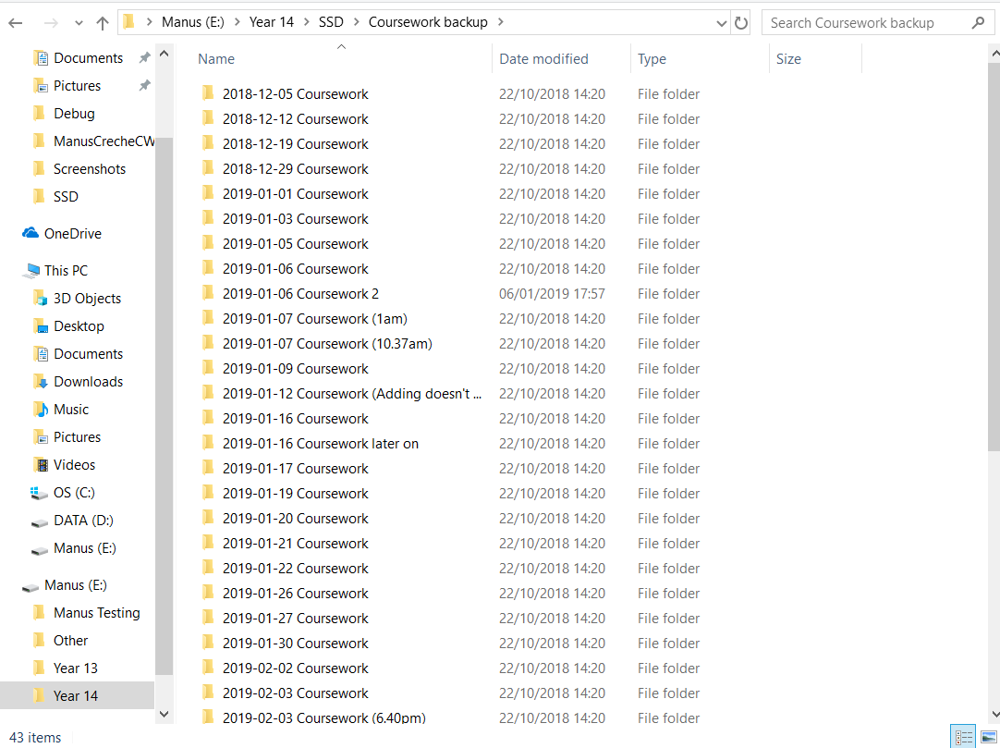

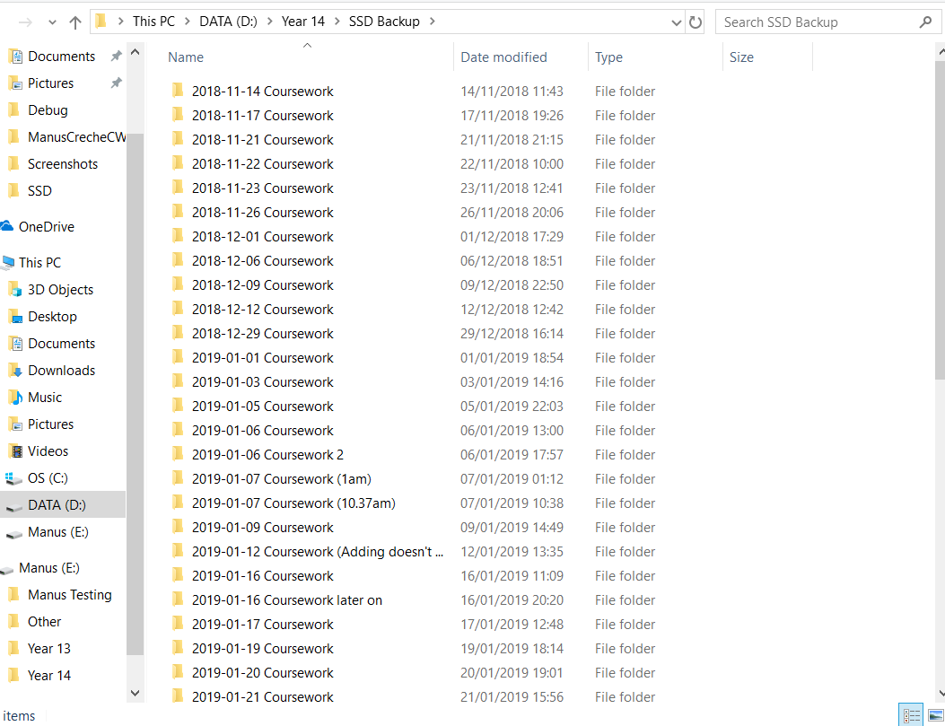

This year I also made sure that the code of every form in the program was split up into regions. This made programming so much more efficient, as I could always find the method I was looking for simply by looking in the correct region. I also commented my code as much as I could to make it easier for someone else to understand. I now feel that I am more prepared to program at a professional level because I am now practiced in programming in a more structured fashion, something which is necessary at the workplace.

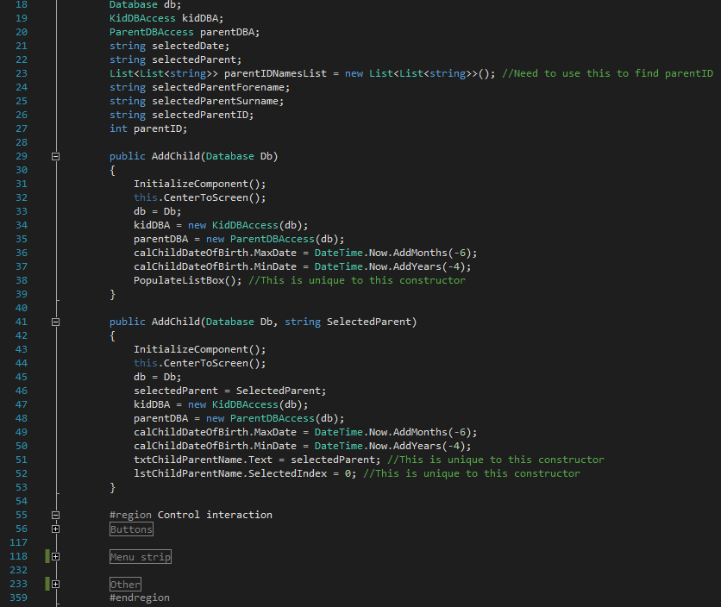

Overall, I am thankful for the experience I gained in creating this project, and I am highly satisfied with my personal performance due to the sheer range of skills that I had to utilise to a high standard so as to end up with high quality work.

## **Complex Functionality**

Throughout my system, there are numerous examples of complex functionality, many of which may go unnoticed to the user. For this reason, I have created a document to highlight the examples of complex functionality to the examiner so that they are aware of everything which either is powered by impressively complex code or simply demonstrates my complex thinking when creating the program. A button in the bottom right corner of Crèche Menu Screen will open the code complexities document, so I have deemed it unnecessary to repeat it here.